

SCHOOL *of* BUSINESS AND TECHNOLOGY

Department of Engineering and Aviation Sciences

**THE DESIGN FOR A DEBRIS CLEARING VESSEL**

**Hafeez Shittu**

**Mohsin Mehmood**

Advisor: Dr. Lei Zhang

Feb. 27th , 2019

Project Title

THE DESIGN FOR A DEBRIS CLEARING VESSEL

By

Hafeez Shittu, Mohsin Mehmood

Submitted to the Department of Engineering and Aviation Sciences in partial fulfillment of the requirements for the degree of Bachelor of Science in Engineering at the

UNIVERSITY OF MARYLAND EASTERN SHORE

Date Feb 27st 2019

The author hereby grants the University of Maryland Eastern Shore permission to reproduce and distribute publicly, paper and or electronic copies of this document in whole or in parts.

Authors Hafeez Shittu, Mohsin Mehmood, …

Signature Hafeez Shittu; Mohsin Mehmood

Date feb 27th 2019

Department of Engineering and Aviation Sciences

Certified by

List of Contents

List of Contents 4

List of Figures 2

List of Tables 4

Abstract 5

1. Introduction 6

1.1 Backgound/Motivation 6

▪ Unwanted Migration: 6

▪ Chemical Contamination: 6

▪ Marine Mammals: 6

1.2 Objective 7

1.3 Design Requirements 7

1.4 Design Constraints 7

Design Method (Approach) 7

Standards 8

2. Project Description 9

2.1 System Description 9

2.2 System Diagram 9

2.3 System Functions 10

3. Implementation Plan 11

3.1 Tasks 11

3.1.1. Task 1. Research Basic Boat design 11

3.1.2. Task 2. Preliminary boat design 11

3.1.3. Task 3. Weight Calculations 11

3.1.4. Task 4. Hydrostatic study 11

3.1.5. Task 5. Fluid dynamics 12

3.1.6. Task 6. CAD simulations 12

3.1.7. Task 7. Build a Prototype 12

3.1.8. Task 8. Image recognition system 12

3.1.9. Task 9. Navigation System 12

3.1.10. Task 10. Assemble the prototype 12

3.2 Team Organization 14

3.2.1. Responsibility of Team Member 1. 14

Responsibility of Team Member 2. 14

3.3 Timeline/Milestones/Delivery Plan 14

4. Implementation 16

4.1 Implementation of Task 1. 16

4.1.1. Implementation of Subtask 1- Reasearch 16

4.1.2. Implementation of Subtask 2- 17

4.2 Implementation of Task 2- Preliminary boat design 18

4.2.1. Implementation of subtask 1- Hand drawing 19

4.2.2. Implementation of Subtask 2- Compare and contrast 21

4.3 Implementation of Task 3- Weight Calculation 28

4.3.1. implemtation of subtask 1- Calculate volume 31

4.3.2. Implementation of Subtask 2- Calculate mass 31

4.4 Implementation of Task 4- Hydrostatic study 39

4.4.1. Implementatiion of subtask 1- Calculate bouyant force 39

4.4.2. Implementatiion of subtask 3- Calculate displacement 39

4.4.3. Implementation of Subtask 4- Calculate the center of mass 42

4.4.4. Implementation of subtask2- Calculate the center of bouyancy 43

4.4.5. Implementation of Subtask 5- Calculate metacentric height 44

4.4.6. Implementation of Subtask 6- Stability of the boat 46

4.5 Implementation of Task 5- Fluid dynamics 47

4.5.1. Implementation of Subtask 1- Calculate drag 47

4.5.2. Implementation of Subtask 1- Calculate lift 47

4.6 Implementation of Task 6- CAD simulation 48

4.6.1. Implementation of Subtask 1- Flow analysis 48

4.6.2. Implementation of Subtask 2- FEA Stress analysis 48

4.7 Implementation of task 7- Building the prototype 86

4.8 Implementation of Task 8: 93

4.8.1. Implementation of Subtask 1-Setting up the image recognition API 93

4.8.2. Implementattion of Subtask2-Research on Convolution Neural Network 97

4.8.3. Implementation of Subtask 3-Training the model 102

4.8.4. Implementation of Subtask 4-Result 109

4.8.5. Implementation Runtime for Image Recognition Unit 111

4.9 Implementation of Task 9- Navigation System 112

4.9.1. Implementation of Subtask 1- Research on pixhawk configuration 112

4.9.2. Implementation of Subtask 2- Layout of the Navigation System 117

4.9.3. Implementation of Subtask 3- Runtime of the Navigation System 119

4.10 Implementation of Task 10- Assemble the prototype 120

5. Conclusion (Discussion and Future Plans) 120

Acknowledgment 121

Appendix 122

A. Component Specs 122

2. Specs of Arduino Due 122

3. Specs of Raspberry Pi 122

B. Source Code. 122

1. Source Code of Graphic User Interface 122

2. Source Code of Robotic Arm 122

REFERENCES 123

List of Figures

Figure 1 Banana Boat 16

Figure 2 Hydrofoil Boat 17

Figure 3 Catamaran boat 17

Figure 4 Pink foam Pontoon boat 18

Figure 5 First design 19

Figure 6 Earlier Design 2 20

Figure 7 Pontoon 20

Figure 8 3D earlier design 2 21

Figure 9 Earlier design 3 22

Figure 10 Collection box, mesh, Pontoon 22

Figure 11 Earlier Design 3 24

Figure 12 Paddle wheel design 24

Figure 13 Solidworks Final design 25

Figure 14 PVC 26

Figure 15 Pink Foam 28

Figure 16 Volume of a rectangle 29

Figure 17 Buoyancy Principle 30

Figure 18 Height of un-displaced pontoon. 40

Figure 19 Center of mass cone 42

Figure 20 Half cylinder COM 43

Figure 21 Center of Buoyancy 44

Figure 22 COM, COB 44

Figure 23 COB 45

Figure 24 Metacenter 46

Figure 25 Stability of ship 47

Figure 26 Resistance in boat 48

Figure 27 Displaced part of vessel 49

Figure 28 Setting up wizard 49

Figure 29 Project setup menu 50

Figure 30 Drag Force 51

Figure 31 Flow analysis iteration chart 51

Figure 32 Absolute max 52

Figure 33 water flow around vessel 52

Figure 34 Flow trajectories 53

Figure 35 Flow trajectory 2 53

Figure 36 Fixed constraints 55

Figure 37 materials 56

Figure 38 Forces 57

Figure 39 Mesh settings 57

Figure 40 Pressure 58

Figure 43 Selected faces 63

Figure 45 Pressure 2 65

Figure 62 pi graphic interface during update 88

Figure 63 overview 91

Figure 64 pictorial representation of CNN 91

Figure 65 neural network modification methods 92

Figure 66 edge detection 93

Figure 67 Example of an Inception Neural Network Image Processing 93

Figure 68 finding the error&Figure 69 optimized process 95

Figure 70 installing tf 12.0 & Figure 71 failed installation 97

Figure 72 successful installation 97

Figure 73 jypiter script tensorflow active 99

Figure 74 dataset of pictures used to train the system 100

Figure 75 image labelling 101

Figure 76 file generated 101

Figure 77 label map 102

Figure 78 training interface 102

Figure 79 image recognition start up interface 103

Figure 80 Successful Trial 1 104

Figure 81 Successful Trial 2 104

Figure 82 2s battery&Figure 83 image recognition set up 105

Figure 84 power connection layout for raspberry pi 105

Figure 85 pixhawk 105

Figure 86 mission planner interface 107

Figure 87 connection to mission planner through port 107

Figure 88 Select the right firmware 108

Figure 89 motor and servo control set up 109

Figure 90 navigation layout 110

Figure 91 power connection for microcontrollers 112

Figure 92 power connection for motors 112

List of Tables

Table 2. Table 1 Total Volume table 38

Table 3. Table 2 Total Mass table 39

Table 3 New Material property 41

Table 4. Table 4 X, Y, Z coordinates 44

Table 6. Table 5 Physical properties 60

Table 7. Table 6 General objective 60

Table 8. Table 7 Mesh settings 60

Table 9. Table 8 Materials 63

Abstract

The principle objective of this project is to design an autonomous marine vessel, and use machine learning and target recognition to collect floating plastic bottles in ponds, lakes and streams. The motivation behind this project is to find a cheaper and more efficient solution for clearing certain water bodies (lakes, ponds, streams). This project design encompasses 3 main design structures such as the navigation, mechanical and electrical design. When brainstorming about the navigation design, we aimed at having a vessel which has autonomy and smart capabilities. This gave birth to the use of an autopilot microprocessor called a pixhawk for the autonomy, and by setting waves points on a software called mission planner, the pixhawk can be configured to move from one point to another depending on the area of collection by controlling the servos attached to the rudder and the Electronic Speed Controller (ESC) to move along the path set by the wave point. Although this delivered a level of automatic operation and decreased human intervention, it wasn’t ideal enough because the vessel was able to move unmanned on a fix path but couldn’t locate the bottle and for this reason, intelligence was introduced through implementing target recognition. Setting up the target recognition was the main focus of the project which involves 2 major aspects which is training a Convolution neural network to identify a bottle by employing a transfer learning method and setting up a target recognition on an application programming interface (API). Raspberry pi 2 is selected as the most ideal API because it was affordable and capable enough to run the recognition system but due to its lower capability, a relatively less accurate but fast CNN with the least amount of parameters is used for recognition called Mobilenet SSD and with the aid of tensorflow, the neural network was optimized to recognize a bottle. The mechanical design stages of any floating body consists of “Imagining and Analyzing”, “Concept Design”, “Principle Design and GA Drawings”, and “CAD Design and Analysis”. The majority of time spent in each task will be spent on research. Mechanical design will require the weight calculations, Hydrostatics study, Flow analysis, and FEM analysis using a CAD software (Solid Works). This will further help improve our design. The goal for Mechanical design is to ensure the body will float and will be stable under applied force. The goal of the Electrical design is to create an environmentally friendly skimming tool which eliminates the use of fossil fuel as a source of energy. Two 2s lipo batteries are utilized in powering the Electrical system. The first one is used for powering the microcontrollers which are the raspberry pi2 and the pixhawk and the other is used for the motors. 2 batteries are used to aim in troubleshooting incase an problem arises and also for weight distribution for the sake of stability of the vessel

1. Introduction

This project is based on the design and building of a bottle collection vessel which operates in lakes and pond. On this vessel which we implement image recognition and autonomy to make it perfectly unmanned and efficient.

## Backgound/Motivation

Plastic never goes away, and it's increasingly finding its way into [our oceans](http://www.biologicaldiversity.org/programs/oceans/index.html) and onto our beaches. In the Los Angeles area alone, 10 metric tons of plastic fragments — like grocery bags, straws and soda bottles — are carried into the Pacific Ocean every day. Today billions of pounds of plastic can be found in swirling convergences making up about 40 percent of the world's ocean surfaces. Plastic waste in lakes, ponds and smaller water bodies accumulate differently than plastic waste in oceans. Plastics can end up in a different place from where the plastic originated due to the pattern of lake currents. It is likely that some cities pollute with more plastic than what ends up on their own shores. Though plastics that enter a lake may disappear from view, much of the waste can be seen and has many effects on the lives around it. Some of the reasons supporting the control of plastic waste in lakes and ponds include the following:

* Unwanted Migration:

Migration has been in occurrence for as long as the existence of living things on the planet. Although migration is essential for survival, it has proven to be a major source of biological pollution in man and animals. Migration can have a profound effect on the immunity of animals. When animals migrate together to the same place, they are exposed to the body fluids and waste of one another, and superior species are exposed to the genetically inferior species; contact with the waste of an inferior species might lead to an explosion in illness or even death. Biological contamination due to migration has led to the extinction of some species of animals.

* Chemical Contamination:

When fertilizers and pesticides are used for agricultural purposes, they exhibit the benefits of chemical advancements by improving yield, but unfortunately, these chemicals are a major source of pollution. When rain falls, the fertilizers and pesticides are swept by flood into the water bodies and this has a detrimental effect on the lives of aquatic animals and plants. When pesticides meant to kill off pests flow into the water body, they become harmful to the fish in the lakes or ponds which can lead to death in aquatic life. Fertilizers that flow into the water bodies can increase the fertility of the water and cause a large growth of algae. In turn, this creates a canopy on the water surface which deprives the plants and animals of sunlight and oxygen.

* Marine Mammals:

Marine mammals ingest and get tangled in plastic. Large amounts of plastic debris have been found in the habitat of endangered Hawaiian monk seals, including in areas that serve as pup nurseries. Entanglement deaths are severely undermining recovery efforts of this seal, which is already on the brink of extinction. Entanglement in plastic debris has also led to injury and mortality in the endangered Steller sea lion, with packing bands the most common entangling material. In 2008, two sperm whales were found stranded along the California coast with large amounts of fishing net scraps, rope and other plastic debris in their stomachs.

## Objective

The objective of this project is to design a Catamaran (Dual Hull) marine vessel capable of detecting 500 ml plastic bottles within a 1 meter radius and collect the water bottles using machine learning.

## Design Requirements

The design requirements specified for this objective are as following

1. The main frame of the vehicle should be able to support up to 60 lbs. of total load, which includes the payload of up to 20 lbs., 25 lbs. of vehicle itself, and an additional 15 lbs. for the motors and components.

2. The motors should drive the vehicle with the velocity of 5 miles per hour.

3. The design must be cost efficient.

4. The vehicle should recognize floating plastic bottles using machine learning.

5. The vehicle should recognize the target (Volume 500ml, height 23.50cm, diameter 6.58, max weight .40g) and function intelligently.

6. Based on the size of the collection chamber, the vehicle should be able to collect up to 35 empty water bottles.

## Design Constraints

In this system design, the design constraints are as following:

1. The main frame of the boat should be within 4ft * 3ft * 2ft (L*W*H).

2. Due to lack of funding, the overall budget for the design should be under $100.

3. There are limited resources available.

4. The vehicle must be easy to assemble.

## Design Method (Approach)

For this marine vessel, the design methods include mechanical and electrical design. First, we will identify all the mechanical methods required and that will be used in this design. The mechanical design methods are as follows:

`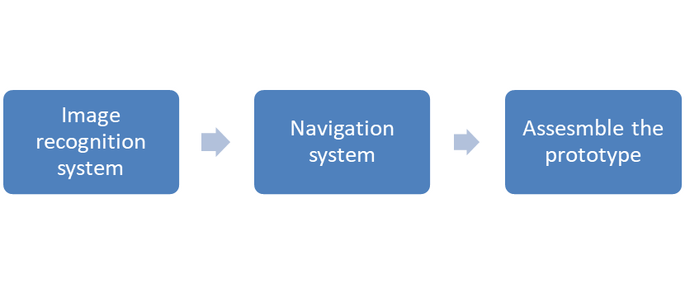

1. Project Description

## System Description

The project is an integration of electrical and mechanical implementation. The simplified idea of the vessel is very similar to a boat. For propulsion, the vessel will require 2 DC motors that will be selected based on a number of factors such as energy consumption, water resistivity, rpm, torque and ability to withstand resistance from weight of debris. Those motors will be controlled by an Electronic Speed Controller (Esc). This regulates the amount of power supplied into the motors; it is the link between the motors, power supply and receiver or any micro- controller from which the signal is coming; and this system will make use of two microcontrollers. In this system, two concepts are being implemented to execute the intelligence and the autonomy. The Pixhawk, which is the primary controller of the system, will be the microcontroller responsible for autonomous motion. This will be executed by setting wave points or paths to follow by using a software called the mission planner. The second microcontroller is the raspberry pi2, and it is the micro controller responsible for implementing the intelligence aspect of the system by analyzing images or video captured through the use of a camera.

## System Diagram

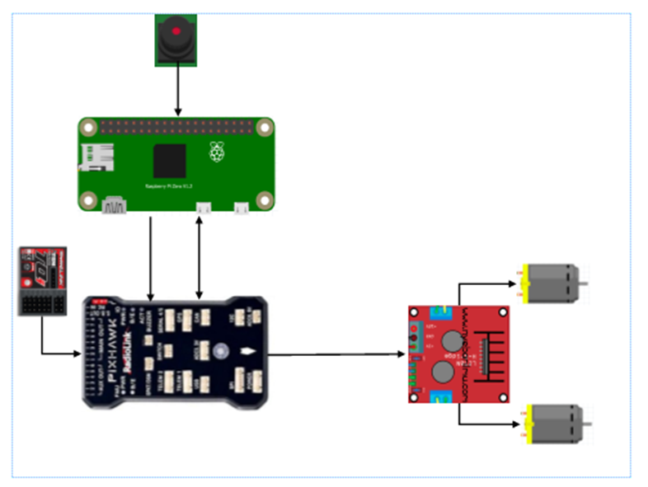

Illustration of the basic navigation system.

## System Functions

The above diagram shows an ideal system which will implement both autonomy and intelligence. The diagrams consists of 2 dc motors controlled or regulated by a motor controller, which will receive signal from the pixhawk. The motion of the vessel is primarily controlled by the pixhawk. A pixhawk is a high-performance autopilot-on-module suitable for fixed wing, multi rotors, helicopters, cars, boats and any other robotic platform that can move. It is targeted towards high-end research, amateur and industry needs and combines the functionality of the PX4FMU + PX4IO.When the raspberry pi detects a debris through target recognition, the objective of this methodology is to make the raspberry pi communicate with the pixhawk in real time for collection. This will involve finding a way to make the 2 microcontroller compactible using the MAV link or sending 1 and 0 signals to the pixhawk for maneuvering.

1. Implementation Plan

## Tasks

The design methods used in this process are converted into main tasks and their sub-tasks. Since this is a group project, there will be tasks based on mechanical design and then the electrical designs. They are as following:

### Task 1. Research Basic Boat design

#### Subtask 1. Research

The first main subtask is to research various boat designs and how they work.

#### Subtask 2. Identify suitable boat design

The second subtask is to identify a design based on research Subtask 1.

### Task 2. Preliminary boat design

#### Subtask 1. Hand drawing

Draw basic design which was identified using Task 1 and come up with different designs to choose from.

#### Subtask 2. Compare and Contrast

Compare and contrast all the design. Learn about their pros and cons and based on those, choose the most effective design.

### Task 3. Weight Calculations

#### Subtask 1. Calculate volume

Calculate the volume of each part so we calculate the mass of each part and then the whole system.

#### Subtask 2. Calculate mass

Calculate the mass using the volume from the subtask above and the density of each parts.

### Task 4. Hydrostatic study

#### Subtask 1. Calculate the bouyancy force

Use the volume and the mass to calculate the buoyant force of the floating ship.

#### Subtask 2. Calculate the center of buoyancy

Use the area submerge to find the center of the buoyant force

#### Subtask 3. Calculate displacement

Calculate the volume of the water displaced.

#### Subtask 4. Calculate the center of mass

Identify and calculate the center of mass of the whole system.

#### Subtask 5. Calculate the meta centric height

Find the meta centric height based on the COM and COB

#### Subtask 6. Calculate stability

Identify the stability of the ship using the angles 0-15 degrees to ensure the boat will not tip over and the system will be stable.

### Task 5. Fluid dynamics

#### Subtask 1. Calculate drag

Calculate the drag of the vessel in fluid

#### Subtask 2. Calculate lift

Calculate the lift of the vessel in fluid.

### Task 6. CAD simulations

#### Subtask 1. Flow analysis

Simulate the boat in fluid using computer aided design software. In this case Solid works was employed

#### Subtask 2. FEA Stress analysis

Simulate the boat stress analysis to identify if the system will fail or not.

### Task 7. Build a Prototype

#### Subtask 1. Ordering components

#### Subtask 2. Build the boat

### Task 8. Image recognition system

#### Subtask 1. Set up the image recognition API

Configure the raspberry pi microprocessor, and install all dependencies required to perform target recognition.

#### Subtask 2. Research on CNN

This task involves comprehending how a convolution works, and building, manipulating and training a network. It also requires selecting the best model for this process.

#### Subtask 3. Training the model

This task involves the training of the neural network with our dataset.

#### Subtask 4. Result

Upload our trained model into the raspberry pi and test to obtain results.

### Task 9. Navigation System

#### Subtask 1. Research on Pixhawk configuration

Look into how a pixhawk works and how it can be configured to adapt to sailing.

#### Subtask 2. Layout of the Navigation system

Deliver a pictorial representation of the system to aid adequate comprehension, and explain the communication pattern between the raspberry pi and pixhawk.

#### Subtask 3. Runtime of the whole system

Illustrate the power connection and how long the vessel can be operational for

## Team Organization

As identified previously, this project is split into two equal parts: the mechanical design and the electrical design. The mechanical design will be the responsibility of Team Member 1 and the electrical design will be the responsibility of Team Member 2.

### Responsibility of Team Member 1.

❖ Task 1

❖ Task 2

❖ Task 3

❖ Task 4

❖ Task 5

❖ Task 6

❖ Task 7

### Responsibility of Team Member 2.

❖ Task 1

❖ Task 2

❖ Task 7

❖ Task 8

❖ Task 9

## Timeline/Milestones/Delivery Plan

Please prospect the timeline to deliver the results of each task/subtask.

Please schedule your project to no more than 22 weeks from now.

1. Project Timeline and Delivery Plan

|  |  |  |  |
| --- | --- | --- | --- |
| **Time** | **Task** | **Comments** | **Responsible Personnel** |
| Week 1-4 | Choosing topics | Week 1 through 4 were spent looking for the topic. | Mohsin Mehmood, Hafeez Shittu |
| Week 5 | Finished task 1.1  Started subtask 8.3 | Research  Setting up the API | Mohsin Mehmood  Hafeez Shittu |
| Week 6 | Finished Subtask 1.2  Finished subtask 8.1 | Identify suitable boat design  Setting up the API | Mohsin Mehmood  Hafeez Shittu |
| Week 7 | Finished Subtask 2.1  Started subtask 8.1 | Hand drawings  Training the model | Mohsin Mehmood  Hafeez Shittu |
| Week 8 | Started Subtask 2.2  Finished subtask 8.5 | Compare and contrast  Runtime for the raspberry pi3 | Mohsin Mehmood  Hafeez Shittu |
| Week 9-11 | Finished Subtasks 3.1,3.2,3.3  Finished subtasks 8.4, 8.3. | Calculate volume, mass, displacement  Training the model /Results | Mohsin Mehmood  Hafeez Shittu |
| Week  12-15 | Finished Subtasks 4.1-4.6  Started subtask 9.1 | Calculate displacement, center of mass, MC height, stability  Research on Pixhawk configuration | Mohsin Mehmood  Hafeez Shittu |
| Week 16 | Finished Subtask 5.1,5.2  Finished Subtask 9.1 | Calculate drag and lift  Research on Pixhawk configuration | Mohsin Mehmood  Hafeez Shittu |
| Week 17 | Finish Subtask 6.1  Finish Subtask 9.2 | Flow analysis  Layout of the navigation system | Mohsin  Hafeez |
| Week 18- | Finish subtask 6.2  Finish Subtask 9.3 | Fem analysis  Runtime of the whole system | Mohsin  Hafeez |
| Week 19-32 |  |  |  |

1. Implementation

## Implementation of Task 1.

### Implementation of Subtask 1- Reasearch

When it comes to designing a boat, there are countless ways to design it. This is based on the functions of the boat itself. Accordingly, the first step for this subtask was to research and understand the capabilities of different types of boats, and which design and its capabilities is most suitable based on our design requirements.

“A boat is a small vessel which has been specifically designed for navigating in near-shore areas or inland waterways.” Though there appears to be just a thin line separating a ship from a boat, in actuality t[here are quite a few differences which set both of them apart.](https://www.marineinsight.com/types-of-ships/7-differences-between-a-ship-and-a-boat/) Boats can be classified into three main sections as follows:

1. Unpowered or man-powered (like rafts, gondolas, kayaks, etc.),
2. Sailboats (sail-propelled)
3. and Motorboats (engine-powered)

Because our vessel is required to move slowly through the water I order to achieve its intended purpose, this greatly reduced the list of possible boats to research. The boat designs considered were the following:

**Banana Boats**

As the name suggests, this boat is banana-shaped. It is an inflatable boat and it easily floats on water. It does not have an inbuilt motor system. A banana boat has a capacity to seat between approximately three to ten people.

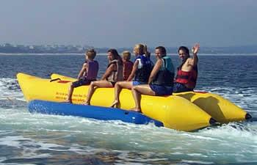

Figure 1 Banana Boat

The reason for this design consideration was its ability to carry heavy payloads. With the addition of the right electrical motors, this passenger boat design could be modified into a debris collecting vessel.

**Hydrofoil boats:**

The hydrofoil system of boats incorporates the use of wings or lifts (pontoons) to raise the boat from the surface of the water and move forward.

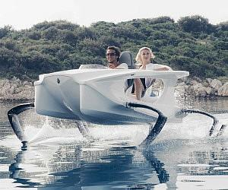

Figure 2 Hydrofoil Boat

The reason for this design consideration was solely because of the empty cavity in the front, which could be turned into the collection bin for the vessel.

### Implementation of Subtask 2-

Catamaran Boats:

According to the Google Definition: “A catamaran (/ˌkætəməˈræn/) (informally, a "cat") is a [multi-hulled](https://en.wikipedia.org/wiki/Multihull) [watercraft](https://en.wikipedia.org/wiki/Watercraft) featuring two parallel [hulls](https://en.wikipedia.org/wiki/Hull_(watercraft)) of equal size. It is a geometry-stabilized craft, deriving its stability from its wide [beam](https://en.wikipedia.org/wiki/Beam_(nautical)).”

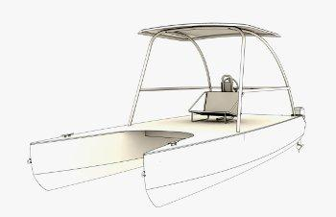

Figure 3 Catamaran boat

The catamaran maintains its stability primarily due to equal sized hulls on each side. A catamaran boat with three hulls is also plausible in real life, but for this design purpose, the two hull catamaran design best suited the vessel’s design and purpose.

**Pontoons and its advantages:**

As noted previously, the design specifications require the collection and holding of at least 25 pounds. Accordingly, after review of all possible boat design options, it was determined that the pontoon boat design best met the vessel design requirements due to its many advantages. Some of the advantages are as following:

**Ease of Use/Maintenance**

Pontoons can be made from any light materials. Aluminum is the ideal material used for industrial pontoons. The intended material for the debris collecting vessel is pink insulation foam, which is then be reinforced using fiberglass sheets and Epoxy resin. Working with pink foam is easy and the pink foam is very easy to maintain.

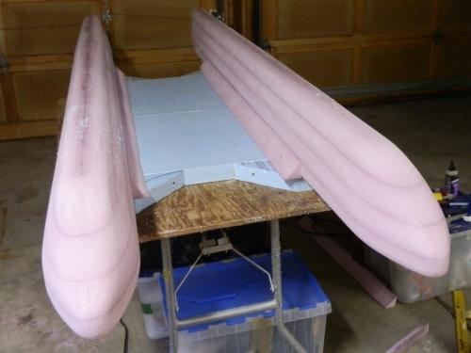

Figure 4 Pink foam Pontoon boat

**Longevity:**

Longevity is one of the most important factors in deciding to use pontoons. Pontoons built using pink foam can last longer and are very easy to maintain. These boats can be left in the water for long periods of time and can still function without any problems.

**Building Cost and Storage:**

Building cost for pontoons using pink foam is very low, and is estimated to be approximately $80 dollars for this vessel. This amount includes the pink foam, epoxy resins, and the fiberglass sheets. Pontoon boats are also known for their storage capabilities. Using pontoons will provide an empty area already existing in the overall pontoon design, and this empty area will function as the collection bin for the water bottles collected.

## Implementation of Task 2- Preliminary boat design

### Implementation of subtask 1- Hand drawing

**Designing the Vessel:**

To initiate the project, we began with the major component of the build, which is Task 1, Subtask 1. This Subtask includes a rough 3-D diagram of the parts of the system, as well as the entire 3-D design of the vessel itself. Working on the rough design first requires identification of all of the dimensions, sizes, and materials, which satisfy the design requirements.

Subtask 1 was an especially challenging task in the project due to needing to constantly challenge ourselves and improve upon the earlier designs. The following are some of the initial designs upon which we constantly strove to improve:

**First Design:**

The first design for the boat was a rough, hand-drawn sketch based on our initial idea. Although this first design was rudimentary and we were able to improve upon it, most of the later designs as well as the final design follow the same pattern of design. The first design was as follows:

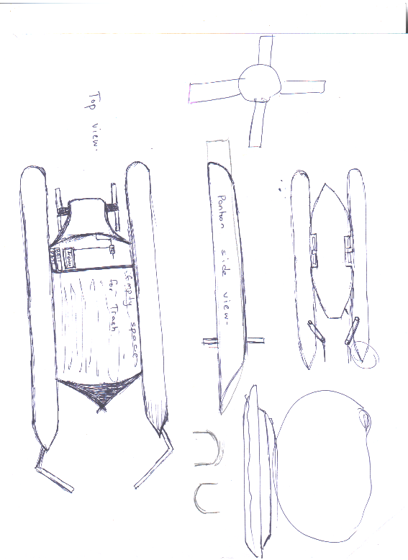

Figure 5 First design

Earlier Design 2:

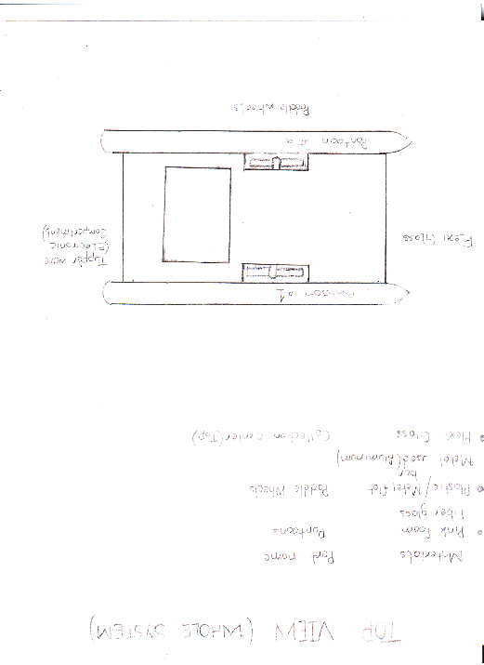

Figure 6 Earlier Design 2

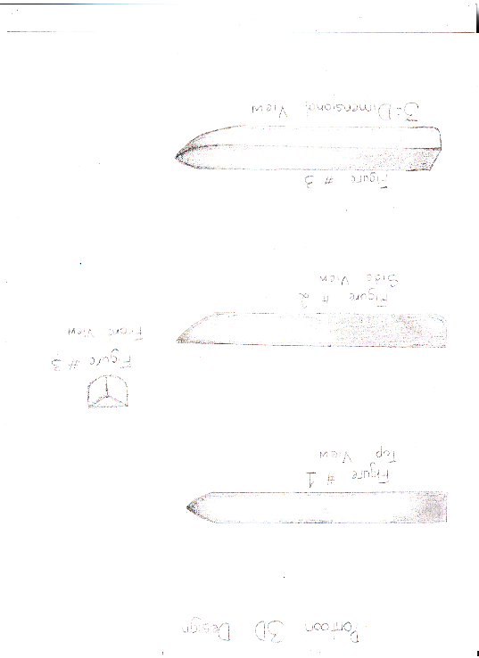

Figure 7 Pontoon

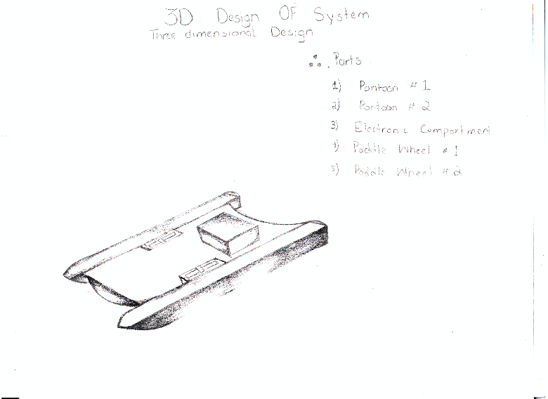

Figure 8 3D earlier design 2

### Implementation of Subtask 2- Compare and contrast

**Cons for Earlier Design 2:**

The first design appeared to meet all but two design requirements. The two design requirements not met were:

1: Required storage space:

Due to lack of storage space, this design could not hold more than 16.6 pound of weight.

2: Shallow ends collection:

The second reason for this design failure was its inability to collect debris from the shallow ends of bodies of water, which is one of the most important design requirements.

Earlier Design 3:

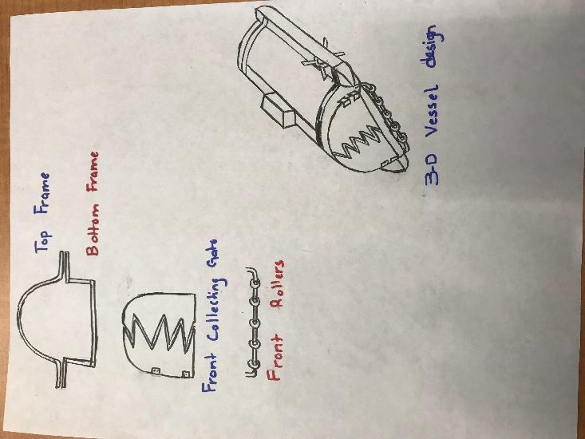

Figure 9 Earlier design 3

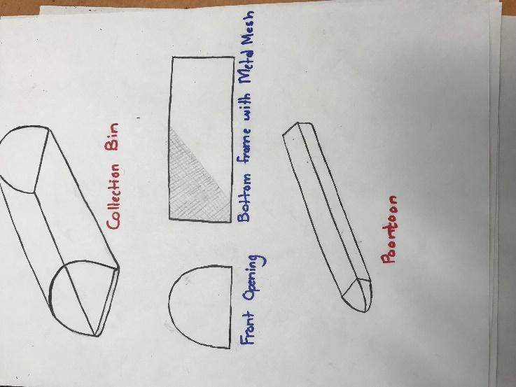

Figure 10 Collection box, mesh, Pontoon

**Cons for Earlier Design 3:**

This was a valid basic design and met all of the design requirements. However, this design was determined to be too similar to boat designs already in production. Accordingly, additional changes were made to the design in order to make the project more unique and innovative, and less similar to boats already in existence.

Earlier Design 3:

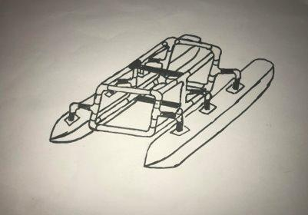

Figure 11 Earlier Design 3

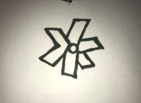

Figure 12 Paddle wheel design

**Cons for Earlier Design 3**

This design had concerns with efficiency due to weight and collection limitation

**Pros for “Earlier Design 3”**

The pros for the final design are as following:

1: The frame is very light.

2: The pontoons are also very light.

3: This is cost-efficient.

4: The parts can be re-assembled for storage.

5: Malleable parts.

**Final Design:**

The final design, as seen in Figure 15, was finally developed based upon consideration of all of the completed research as well as continuous trial and error in designing the vessel. This final design meets all of the design requirements. In addition, the design style is sleek and innovative, and while recognizable as a boat, it features a contemporary design that is unique to the project idea.

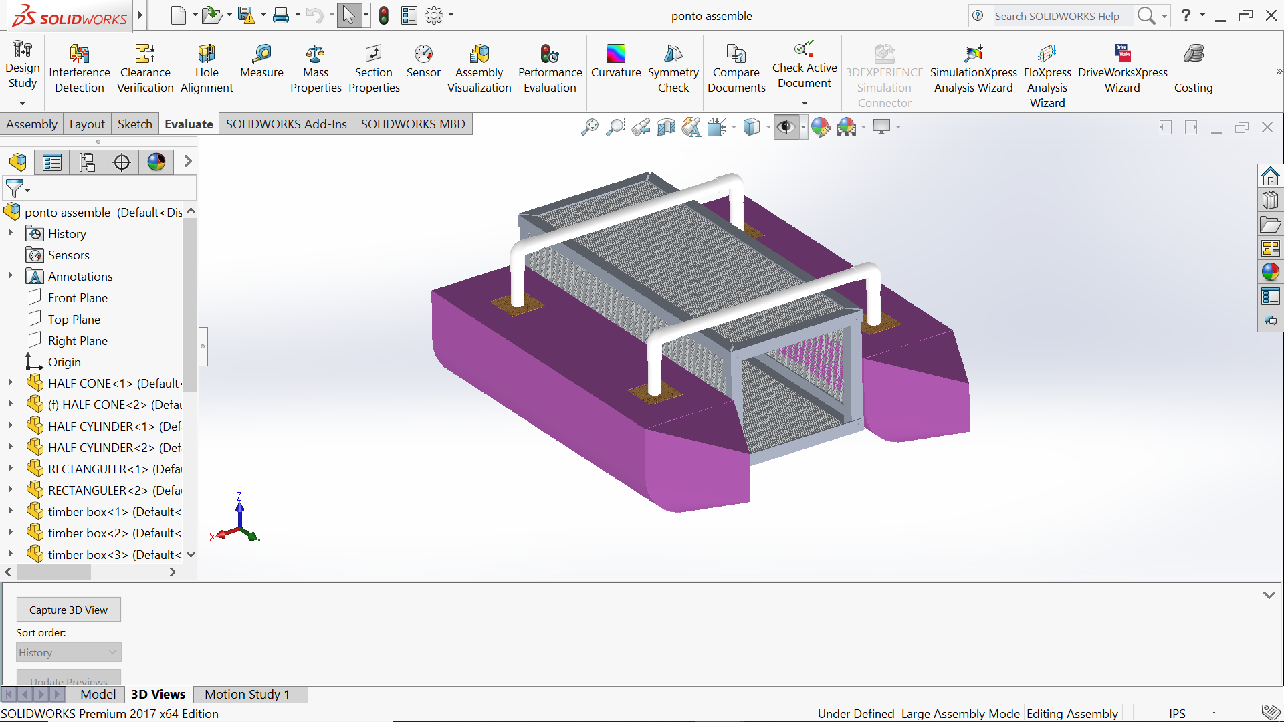

Figure 13 Solidworks Final design

**Final Design:**

A significant portion of time was spent researching the best possible materials to be used for this build. The following are the characteristics sought after in deciding on the appropriate materials:

1: Light-Weight:

The material should be lightweight, which will assist in making the vessel easy to use and operate. Being lightweight will ensure that less force is required to move the vessel around.

2: Strength:

Strength is a big factor when considering materials as well, since the vessel should be able to hold 25 pounds or more of debris without the system sinking. Because many lightweight materials are not strong, this required the testing of materials through trial and error.

3: Cost efficient:

The overall purpose of this vessel is to clean bodies of water in a cost-efficient and economic manner. Accordingly, the materials used must to be cost efficient in order to meet the intended effects of lowing costs and saving money.

4: Ease of access:

Consideration was also given to the accessibility in acquiring necessary materials for college students. All materials must be easily found in local hardware stores.

**Materials:**

Based on all the factors above, the following materials were identified for the final design:

1: PVC Pipes

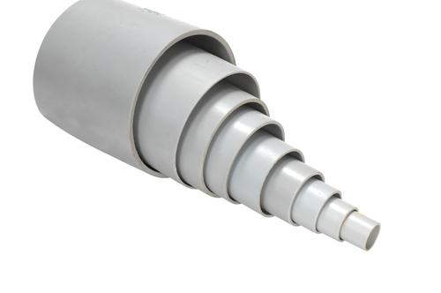

Figure 14 PVC

**Pros:**

The pros for using PVC pipes are following:

* Superior corrosion resistance
* Cheap
* Good heat resistance
* Strength
* High pressure resistance
* Inert to most mineral acids, bases and salts.
* Ease of access
* Choice of size

**2: Pink foam**

The pontoons of the vessel will be built using pink foam or polyurethane panels:

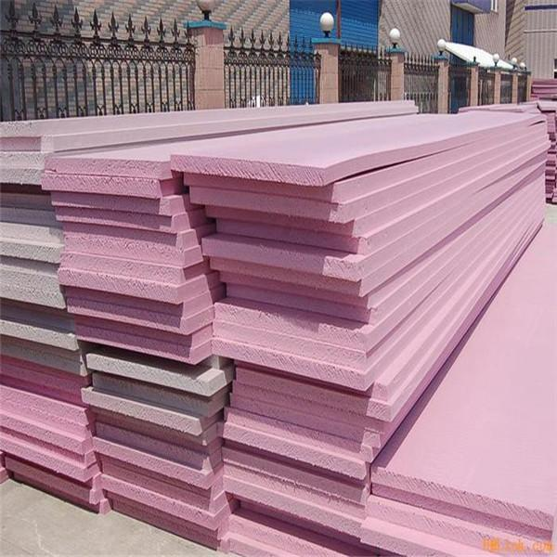

Figure 15 Pink Foam

**Pros for Pink foam:**

Some of the pros of using Pink foam are as following:

1: Thermal conductivity

2: Moisture sensitivity

3: Compressive strength

4: Ease of installation

5: Durability - resistance to degradation from compression, moisture, decomposition, etc.

6: Ease of replacement at end of life

7: Cost effectiveness

## Implementation of Task 3- Weight Calculation

In order to approach this task, we must identify the formulas used:

**Formulas Used:**

Different shapes have different volume formulas. The following shapes were utilized to determine volume for each part of the boat:

**1: Rectangular prism**

This formula was used to determine the volume for rectangular parts of pontoon.

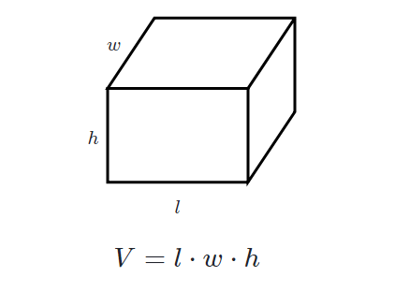

Figure 16 Volume of a rectangle

**Density Formula:**

Formulas used:​

* Density = Mass / Volume​

Or​

* d = M / V​
* Volume of Cylinder: Pi * r^2 * h

Key-Terms​

* P = represents density
* m = represents mass
* v = represents volume

This formula is used to identify individual mass.

Buoyant force is the upward force exerted on objects submerged in fluids. When examining why fluids exert an upward buoyant force on submerged objects, it has been determined to be caused by differences in pressure between the bottom of the submerged object and the top of the object. Because the amount of pressure exerted increases as an object submerges deeper into a fluid, the force from the pressure exerted downward on the top of the body will be less than the force from the pressure exerted upward on the bottom of the body. That is why the buoyant force is necessary for a boat design:

$$(Fb=rho gh)$$

$$Buoyant force = ρgV​$$

Where:​

ρ is the density of the fluid​

g is the gravitational acceleration​

V is the volume of the fluid displaced

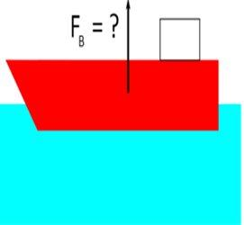

Figure 17 Buoyancy Principle

* Density of water = $62.42796529 lb/ft^3 >> 999.992061 kg/m^3$

​
* g = 9.81 m/s^2​

### implemtation of subtask 1- Calculate volume

### Implementation of Subtask 2- Calculate mass

**Finding volume and mass for each part:**

**Half Cylinder:**

Radius of half cylinder = 0.10160m

Density of foam = 21 kg/m^3

Height of the Half cylinder = 0.7154m

Volume of Half cylinder = ($pi*r^{2}*h)/2$

(3.14 * (0.1016^2) * 0.7154) / 2

= 0.011 m^3

To calculate for two cylinders = $Volume of 1 cylinder * 2$

= $(0.011m^3 * 2)$

= 0.022 m^3

Mass of one cylinder = Volume * Density

Density of Pink insulation foam = 21 kg/m^3

$$= 0.01153*21$$

= 0.24213 kg

To calculate mass for two cylinders = $Mass of 1 cylinder *2$

$$=0.24213*2$$

= .48426 kg

**Front cone half Volume and Mass:**

This includes the two half conic sections and the triangular sections on the pontoon.

Total volume = Volume of half cone + Volume of triangular pieces

**>> Half cone Volume**

Radius = 0.101m

Height + 0.203m

Volume of a half cone = $(\frac{1}{6}*(3.14)*{(0.101}^{2})*(0.203))$

= $1.083 *{10}^{-3} m^{3}$

**>> Triangular pieces**

Volume of Triangle $= (Area of triangle * Height)$

$$=((B*H*L)/2$$

= (0.203 * 0.203 * 0.101) / 2

= $2.08*{10}^{-3} m^{3}$

Volume for two of each piece because there are two pontoons

= $\left(\left(1.083*{10}^{-3}\right)+\left(2.08*{10}^{-3}\right)\right)*2$

= $0.00632 m^{3}$

Mass calculation for the above pieces = Volume * density

$$=\left(3.16*{10}^{-3}\right)*21$$

= 0.06636 kg

Mass for two of each part in consideration = $0.06636*2$

= 0.13272 kg

**Wooden Cubes**

**>> Volume of outer cube**

Volume = L * B * H

= 0.076 * 0.076 * 0.076

= $4.38*{10}^{-4} m^{3}$

**>> Volume of Inner circle**

Volume = $π*r^{2}*h$

$$=3.14*{0.0125}^{2}*0.025$$

= $9.81*{10}^{-5}$

Total volume = $\left(4.38*{10}^{-4}\right)-\left(9.81*{10}^{-5}\right)$

= $\left(3.39*{10}^{-4}\right)*2$

= $0.00678 m^{3}$

Mass = v*d

= $3.39*{10}^{-4}*680$

= 0.23052 kg

For 4 wooden cubes=

= 0.23052*4

= 0.92208 kg

**Rectangular Blocks * 2**

**>>Volume**

L*b*h = 0.711*0.203*0.101

=0.0145 m^3

Total volume= {volume of rectangular blocks – (volume of 2 3*3*3 blocks)} *2

= $0.145-\left(4.38*{10}^{-4}\right)*2$

=0.0272m^3

Weight = (0.0136*21)*2

=0.2856kg * 2

=0.5712kg

**PVC pipes 18.5 inches*2/ 4 inches*4**

Volume/mass for 18.5 inches:

$$V=pi \left(R^{2}-r^{2}\right)*h$$

$$=3.14*\left({0.0125}^{2}-{0.011}^{2}\right)*0.4699$$

$$=5.20*{10}^{-}5 m^{3}$$

So, to calculate the volume for 2 18.5 inch PVC pipes $=\left(5.20 * {10}^{-5}\right)*2$

= $0.000104 m^{3}$

**>> Mass Calculation (18.5 inch PVC)**

Using Density equation = $5.20*{10}^{-5}*1300$

= 0.0676 kg

For two PVC pipes (18.5 inch)

= 0.0676 * 2

= 0.1352kg

**>> Volume for PVC (4 inches)**

Volume = $π\left(R^{2}-r^{2}\right)*h$

$$=3.14\left({0.0125}^{2}-{0.011}^{2}\right)*0.101$$

$$=1.117*{10}^{-3}{ m}^{3}$$

For 4 pieces = $(1.117*{10}^{-3} m^{3}*4$

$$=0.004468 m^{3}$$

**>> Mass Calculation (4 inch)**

Mass = $1.117*{10}^{-3}*1300$

$$=0.0145 kg$$

For 4 Pieces = (0.0145 * 4)

= 0.058 kg

**Elbow PVC Volume and mass calculation**

**>> Volume Calculation**

Volume = $2*3.14*3.14\left(r^{2}-r_{1}^{2}\right)*R$

r = outer ring radius

$$r_{1}= inner ring radius$$

R = radius of curvature

$$=2*3.14*3.14\left({\left(14.5*{10}^{-3}\right)}^{2}\right)-{\left(12.5*{10}^{-3}\right)}^{2})*14.5*10^-3$$

$$=1.54*{10}^{-5}m^{3}$$

For 4 Pieces of PVC elbows = (1.54 *10^-5 m^3)*4

$$=0.0000616 m^{3}$$

**>> Mass Calculations (PVC Elbow)**

Mass

= $\left(1.54*{10}^{-5}\right)*\left(1300\right)$

=0.02002 kg

For 4 PVC elbows =

= 0.02002 * 4

= 0.08008 kg

**Volume and Mass Calculations (Aluminum Angle bar 28 inches)**

**>>Volume Calculations**

Volume = $\left(l_{1}*b_{1}*h_{1}\right)+\left(l_{2}*b_{2}*h_{2}\right)$

= $\left(0.03*3.18*{10}^{-32}*0.7\right)+\left(0.02*3.18*{10}^{-3}*0.7\right)$

$$=1.113*{10}^{-4} m^{3}$$

For 4*28 inches aluminum angle bar = $\left(1.113*{10}^{-4}\right)*4$

$$=0.0004452 m^{3}$$

**>> Mass Calculations**

Mass = Volume * Density

$$=\left(1.113*{10}^{-4}\right)\left(2700\right)$$

= 0.030051 kg

For 4 * 28 inches Aluminum angle bars

= 0.030051 kg * 4

= 0.120204 kg

**Volume and Mass Calculations for Aluminum angle bar (12 inches)**

**>> Volume Calculations**

$$Volume= \left(l_{1}*b_{1}*h_{1}\right)+\left(l_{2}*b_{2}*h_{2}\right)$$

$$=\left(0.03*3.18*{10}^{-3}\right)+\left(22.23*{10}^{-3}*0.3*3.18*{10}^{-3}\right)$$

$$=4.98*{10}^{-5}m^{3}$$

For four 28 inches aluminum angle bars =

$=4.98*{10}^{-5}m^{3}$*4

= $0.0001992 m^{3}$

**>> Mass Calculations**

Mass = ($4.98*{10}^{-5})*(2700)$

= 0.134 kg

For four 28 inches aluminum angle bars

$$=0.134*4$$

= 0.538 kg

**Mass and Volume calculations For Box aluminum bars**

**>> Volume Calculations**

Volume = Volume of outer cube – Volume of inner cube

$$=\left(l_{1}*b_{1}*h_{1}\right)-\left(l_{2}*b_{2}*h_{2}\right)$$

$$=\left(\left(25.4*{10}^{-3}*2504*{10}^{-3}*247.6*{10}^{-3}\right)-\left(19.05*{10}^{-3}*19.05*{10}^{-3}*247.6*{10}^{-3}\right)\right)$$

$$=0.069*{10}^{-3} m^{3}$$

For 4 pieces

$$=0.069*{10}^{-3}*4$$

= $0.000276 m^{3}$

**>> Mass Calculations**

Mass

= $0.069*{10}^{-3}*2700$

= 0.188 kg

For four pieces = 0.188 kg *4

= 0.752 kg

**Volume and Mass calculations for Aluminum Mesh**

**>> Volume calculations**

Total volume = Volume of whole body – Volume of displaced holes

$$={\left(25.4*{10}^{3}\right)}^{2}*\left(2.54*{10}^{-3}\right)-\left(1.524*{10}^{3}\right)*100$$

= $1.04*{10}^{-6}m^{3}$

**>>Mass Calculations**

Mass = $1.04*{10}^{-6}*1016$

= 2.85 kg

**Mass Calculations for the screws**

Standard weight for the screws used = 0.00585 kg

For 20 screws

= 0.00585 * 20

= 0.0117 kg

Total volume Table

|  |  |
| --- | --- |
| **Parts** | **Volume** |
| Half Cylinder | $$0.48426 m^{3}$$ |
| Front Cone | $$0.00632 m^{3}$$ |
| Wooden Cubes | $$0.000678 m^{3}$$ |
| Rectangular blocks | $$0.0272 m^{3}$$ |
| PVC 18.5 inch | $$0.000104 m^{3}$$ |
| PVC 4 inch | $$0.004468 m^{3}$$ |
| PVC Elbow | $$0.0000616 m^{3}$$ |
| Aluminum Angle Bar 28 inch | $$0.0004452 m^{3}$$ |
| Aluminum Angle Bar 12 inch | $$0.0001992 m^{3}$$ |
| Aluminum Box Bar 12 inch | $$0.000276 m^{3}$$ |
| Aluminum Mesh | $$1.04*{10}^{-6} m^{3}$$ |
| **Total Volume** | $$0.5241304 m^{3}$$ |

1. Total Volume table

**Total mass Table**

|  |  |
| --- | --- |
| **Parts** | **Mass** |
| Half Cylinder | 0.48426 kg |
| Front Cone | 0.13272 kg |
| Wooden Cubes | 0.92208 kg |
| Rectangular blocks | 0.5712 kg |
| PVC 18.5 inch | 0.1352 kg |
| PVC 4 inch | 0.058 kg |
| PVC Elbow | 0.08008 kg |
| Aluminum Angle Bar 28 inch | 0.120204 kg |
| Aluminum Angle Bar 12 inch | 0.538 kg |
| Aluminum Box Bar 12 inch | 0.752 kg |
| Aluminum Mesh | 2.85 kg |
| Screws | 0.117 kg |
| **Total Mass** | 6.760744 kg |

1. Total Mass table

## Implementation of Task 4- Hydrostatic study

### Implementatiion of subtask 1- Calculate bouyant force

### Implementatiion of subtask 3- Calculate displacement

Mass breakdown of the ship:

Total weight of the building materials = 6.760744 kg =>14.8736368 pounds

The mass of electronics = 10.17 pounds

Maximum Mass of the payload = 25 pounds

Total weight of the boat including dead weight and payload weight = 50 pounds => 22.72727 kg

Total Water Displacement

$$Total mass =22.72727kg$$

$$v =\frac{22.72727}{1000}$$

$$v =2.272727×{10}^{-2}m^{3}$$

Volume of Boat Base Parts







$$Volume of the semi-cylindrical parts$$

$$Volume of the cone shaped parts$$

$$Total bottom part$$

Total water displacement should be 0.0227 cubic meters.

But, 0.0227<V1+V2. Hence, both cylindrical and conical parts are not fully submerged in water due to the 22.727 kg weight.

$$Volume of excessively displaced water=0.025394-0.0227=0.002667 cubic meters$$

>> If height of excessively displaced water is h,









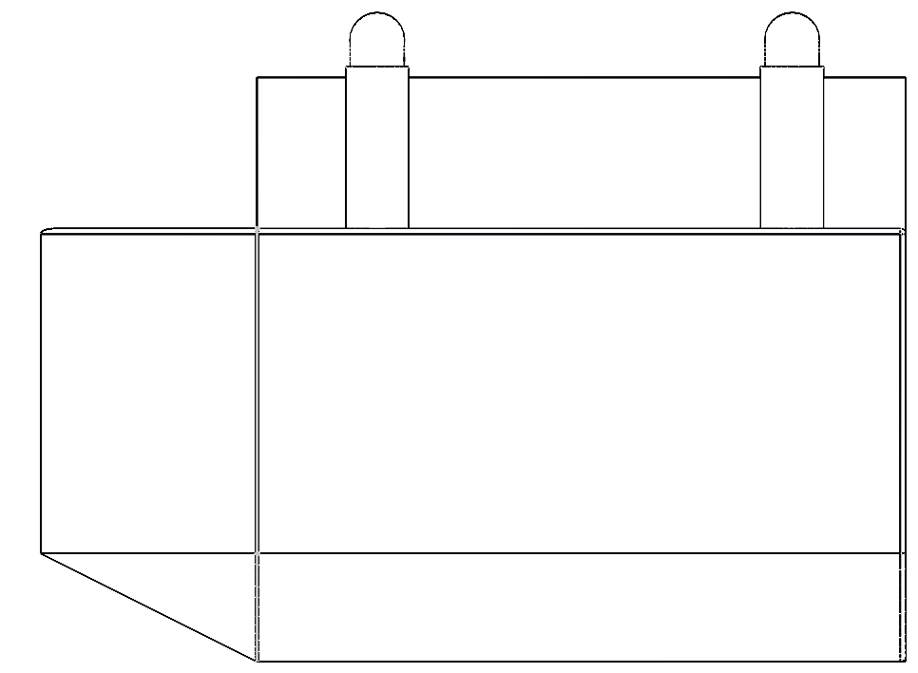

**0.109 meters**

Figure 18 Height of un-displaced pontoon.

Mass and Floating Properties

There are several varying materials used in boat components. However, due to lack of viable options in Solidworks and Inventor, some materials had to change in order to be compatible with the design. The new materials which were chosen are provided below:

|  |  |  |
| --- | --- | --- |
| **Part** | **Material** | **Density (lbs-inch-3)** |
| **Base** | Styrofoam | 0.001301 |
| **Connecting tubes** | PVC | 0.050578 |
| **Container** | Aluminum Plates + Mesh | 0.097544 |
| **Top Mesh** | Aluminum Plates + Mesh | 0.097543 |

1. New Material property

### Implementation of Subtask 4- Calculate the center of mass

Since the density of the Styrofoam is extremely low whereas the volume of the PVC parts are negligible, one can assume that the center of mass of the boat is the one of the container.

The distance between the center of mass of semicircle and the center of mass of the respective circle is the following:

.

One can calculate the x and z coordinates of the center of mass of the cone part as follows:

 

Where,



Hence,

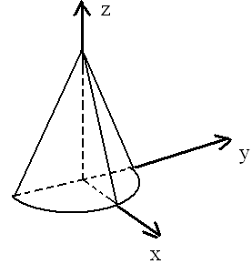

Figure 19 Center of mass cone

In the case of the semi-cylinder, the coordinates of the center of mass are the following:

m, , meters.

Since h<<0.1016 m, one can assume that the center of the mass of the part of the semi-cylinder that is not submerged has the coordinates m, m, and. Hence, for the coordinates of the center of mass of the submerged part of the cone, one can write the following:

,, and  where  and . Hence, m and m.

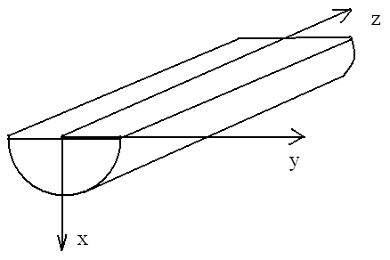

Figure 20 Half cylinder COM

### Implementation of subtask2- Calculate the center of bouyancy

Assuming that the coordinate origin is chosen on the top edge of the bottom part as shown below, one can calculate the coordinates of the center of the buoyancy as follows:

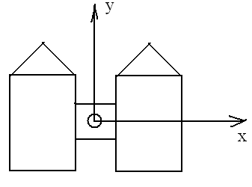

Figure 21 Center of Buoyancy

|  |  |  |  |  |
| --- | --- | --- | --- | --- |
| Part | , cubic meters | , meters | , meters | , meters |
| Left semi-cone | 0.000931 | -0.1396 | 0.4295 | -0.0389 |
| Right semi-cone | 0.000931 | 0.1396 | 0.4295 | -0.0389 |
| Left semi-cylinder | 0.01043 | -0.1396 | 0 | -0.0475 |
| Right semi-cylinder | 0.01043 | 0.1396 | 0 | -0.0475 |
| Center of the buoyancy |  | 0 | 0.035203 | -0.0468 |
|  |  |  |  |  |

1. X, Y, Z coordinates

### Implementation of Subtask 5- Calculate metacentric height

The location of the center of mass (COM) and the center of buoyancy (COB) is shown below:

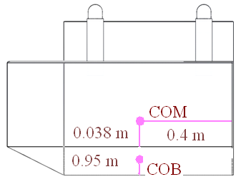

Figure 22 COM, COB

The metacentric radius is the distance between COB and the metacenter. It equals  where  is the second moment of area of the water plane section with respect to the y axis (see the illustration below). As for, it is the total water displacement and equals 0.0227 cubic meters. One can calculate the value of I as follows



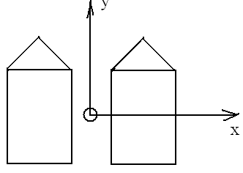

Figure 23 COB

Hence, the metacentric radius equals = 0.336 meters. Since the metacentric height is the distance between the metacenter and COM, it is equal to 0.251 m.

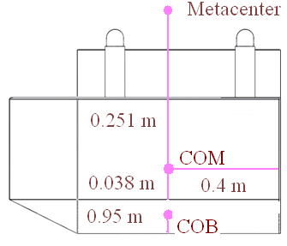

Figure 24 Metacenter

The moment due to the movement of the load equals  where  is the displacement of the load and M is the load mass. Since the load mass equals the one of the boat, the moment due to the shift of the center of mass equals . Hence, the displacement of the load s that corresponds to the tilt angle  has such the value . Thus, if  ranges from 0 to 15°, then the load displacement ranges from 0 m to 0.131 m.

### Implementation of Subtask 6- Stability of the boat

On Figure 1,, M, G, B, and  are respectively the angle of a heel, the metacenter, the center of gravity, the center of buoyance when , and the center of buoyance when the angle of a heel equals . The stability curve is the plot of the dependence  (see Figure 1). For small values of, one can assert that. For this scenario,.

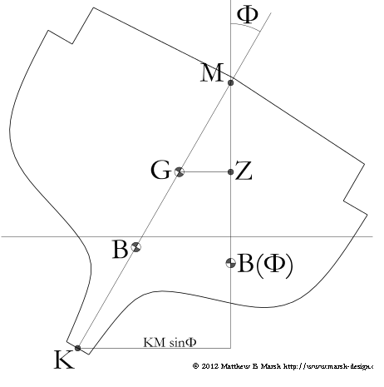

Figure 25 Stability of ship

## Implementation of Task 5- Fluid dynamics

Once the hydrostatic evaluation of the design is completed, the next step is to move on to finding out the Drag and Lift forces that will be applied to the design while moving at the velocity of 5mph.

This will compute the fluid dynamics of the design.

### Implementation of Subtask 1- Calculate drag

Becuase the velocity is very slight, the flow is the creeping flow type. Therefore, one can assert that the shape of the boat is streamlined. Hence, the pressure drag vanishes. As for the viscous drag, one usually ignores it when calculating the speed of the boat. Hence, the drag force equals zero.

On Figure 2, the hydrodynamic side force is the lift. From Figure 2, it follows that under the condition of the zero drag, the directions of the apprent wind and the true one coinside and are opposite to the boat course. Hence, from the symmetry considerations, it follows that the lift equals 0 too.

### Implementation of Subtask 1- Calculate lift

However, because evaluating drag and lift force is an important part of designing a marine vessel, Solidworks was utilized to evaluate drag and lift forces.

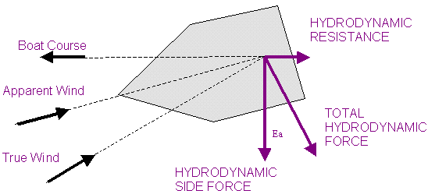

Figure 26 Resistance in boat

## Implementation of Task 6- CAD simulation

### Implementation of Subtask 1- Flow analysis

According to Solidworks: “SOLIDWORKS Flow Simulation. Engineering Fluid Dynamics (EFD) is a new breed of Computational Fluid Dynamics (CFD) software that enables mechanical engineers to simulate fluid flow and heat transfer applications with powerful, intuitive, and accessible 3D tools.”

### Implementation of Subtask 2- FEA Stress analysis

Stress analysis helps us compute our virtual design’s structural analysis. It is used to find the product’s real world physical behavior.

Initially, the plan was to utilize only one computer aided design software in order to demostrate both FEA and flow simulation. The software immediately accessible was Solidworks, and the outdated 2012 version at first was the only software available for use. However, we ultimately determined it was necessary to upgrade our software options and purchased and utilized the 2017 version of Solidworks. The designing of the vessel in Solidworks was simple but time consuming. A primary issue was that many of the systems which were used to run the software could not handle the memory usage. After approximately one month of attempts through trial and error, the flow simulation was able to be successfully run.

Setting up Flow Simulation:

All flow simulation steps used for this project are as follows:

1**: Cut Section and Set-Up Wizard:**

The first step is to cut the vessel assembly right on the computed waterline. This assists in not only lowering the run time, but it also helps ensure that focus is maintained on only the submerged parts of the vessel.

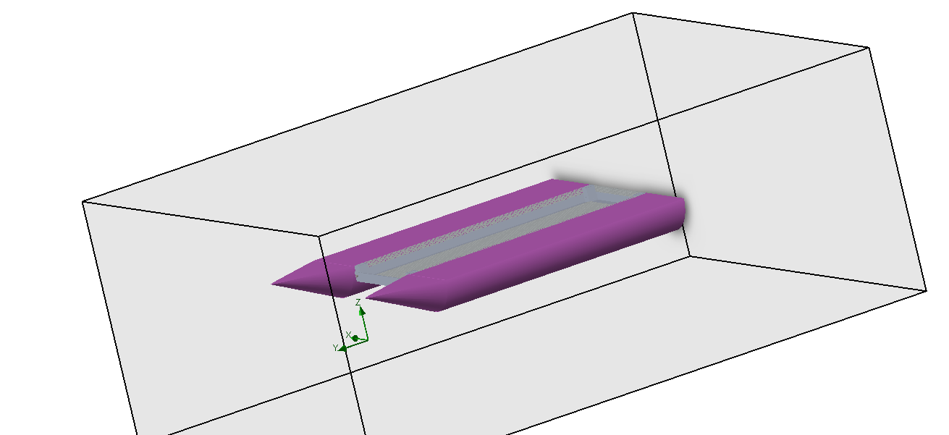

Figure 27 Displaced part of vessel

The body is cut at the water line, the next step is to set-up the wizard for flow simulation. While setting up the wizard, any kind of liquids and/or gases that are present in the library can be applied. The velocity of the vessel at which it will be moving under water is also applied during the Set-Up Wizard.

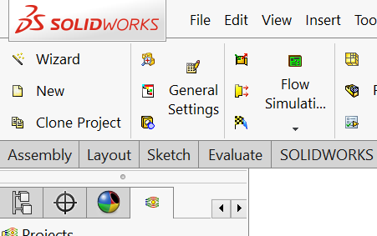

Figure 28 Setting up wizard

**Project setup:**

Once the Solidworks flow simulation wizard is completed, the next step is to focus on the project settings. Project settings include computational domain set-up, fluid subdomain set-up, boundary conditions set-up, goals set-up and, lastly, mesh setup:

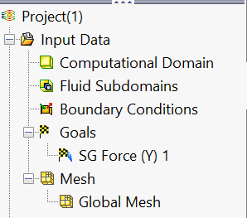

Figure 29 Project setup menu

After the setup of the computational domain was completed, which included all the cut through body submerged, the next step was to provide this project with its unique boundary conditions such as buoyancy, force, etc. These values were calculated previously, as detailed above.

Next, the goal was to find all forces on the conic face of the vessel: this is our drag force, which is being applied to the front of the vessel while it moves at 5 miles per hour.

All the conditions set, we ran the simulation and results are as following:

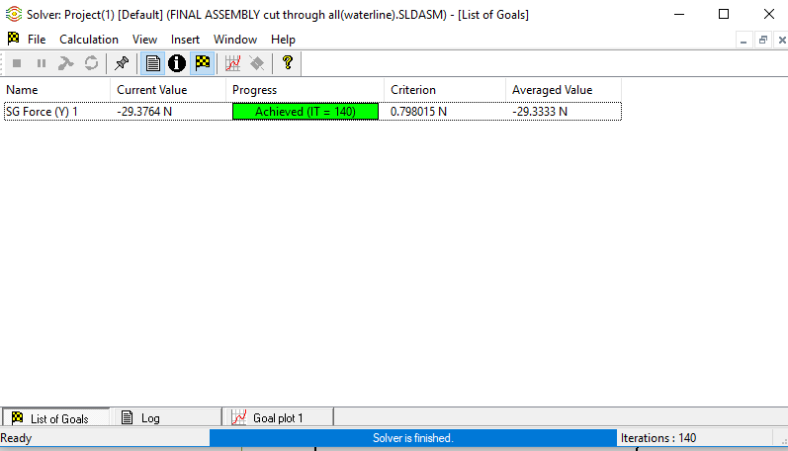

Figure 30 Drag Force

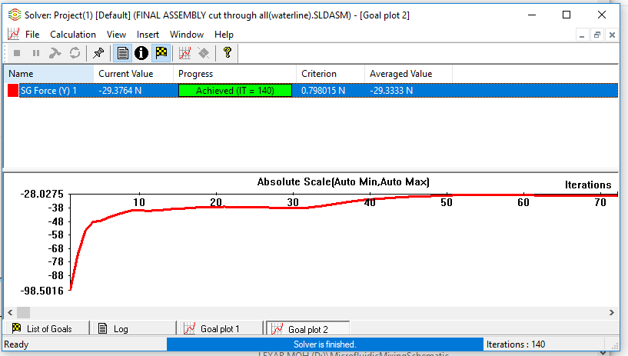

Figure 31 Flow analysis iteration chart

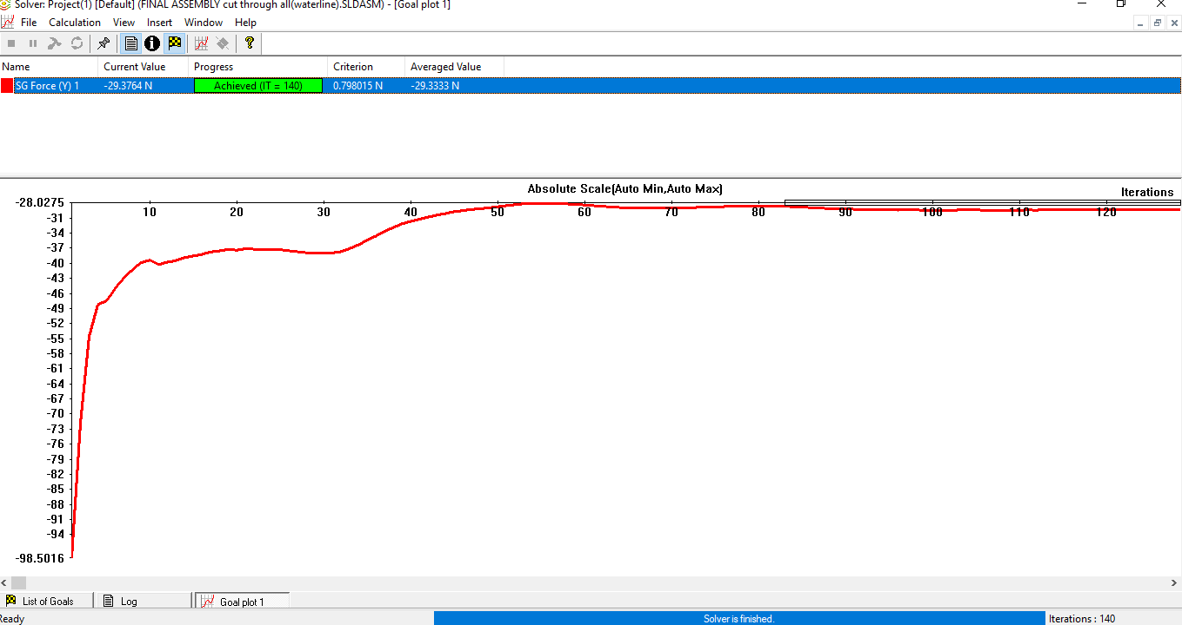

Figure 32 Absolute max

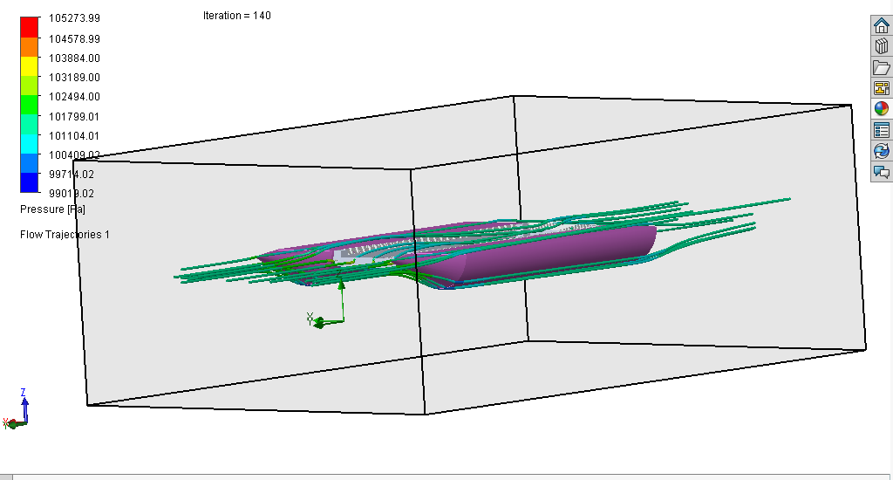

Figure 33 water flow around vessel

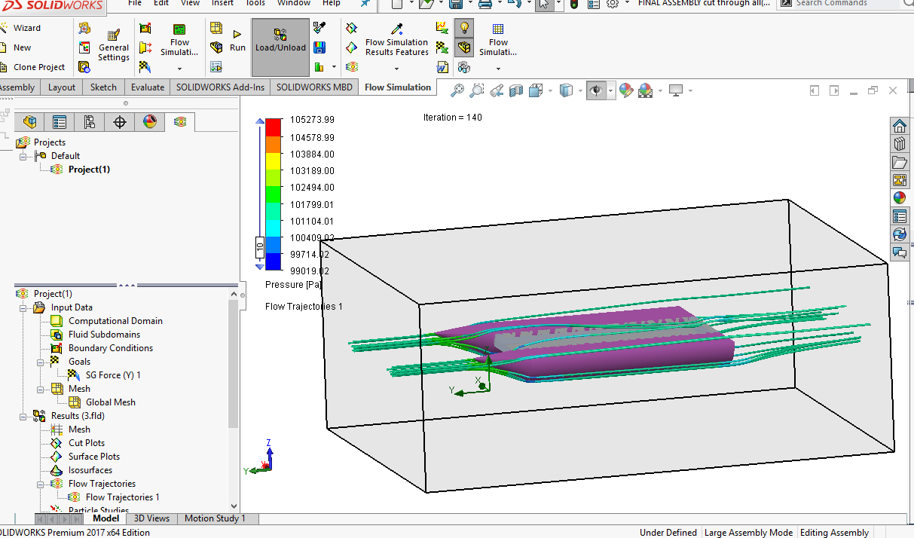

Figure 34 Flow trajectories

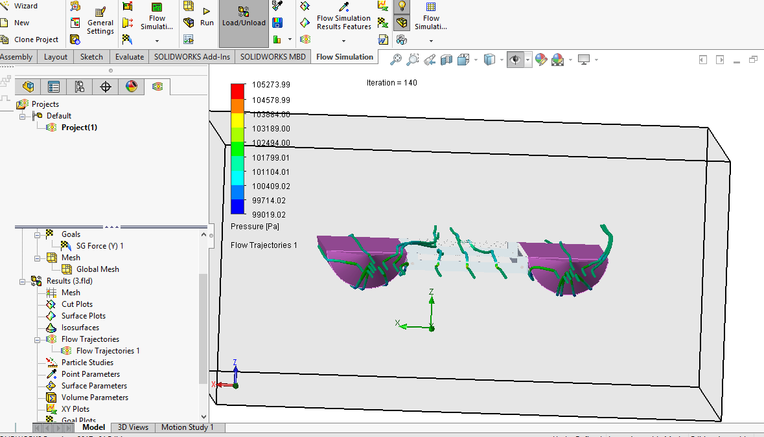

Figure 35 Flow trajectory 2

**Results:**

Through this flow simulation, the flow of water was able to be seen through the vessel itself. In addition, the drag force was able to be determined, which is about 29.37 N. This value will further assist in running the stress analysis. Drag force will also be used to in order to identify the motor and power required to overcome this force.

**FEA analysis:**

Similar to flow simulation, FEA analysis originally was intended to be completed using Solidworks. However, after many failed attempts due to software crashes, the decision was made to use Inventor instead of Solidworks. Inventor meshes the product itself.

The primary issue identified with the vessel itself is the aluminum mesh that surrounds the collection chamber. Because the system is advanced, two different simulations were determined necessary to run: one without the collection chamber and one with the chamber.

The wooden blocks that are supposed to hold the PVC together cannot be identified in Inventor, so silicon with same weight was substituted for purposes of the simulation.

The forces that are applied in this case are the following:

1: Drag Force

2: Weight of electronics and cargo

3: Buoyant force

The results showed only one failure point and that failure point was due to the temperature change in the silicon that was used. The silicon melted and the PVC pipe pulled itself out of the coupling. In the actual vessel, oak wooded blocks are being utilized instead of silicone, eliminating this issue. As noted above, the silicon was only substituted for purposes of identification in Inventor. Also, an epoxy will be utilized to hold the system together, further eliminating this issue. Epoxy and fixing options are not found in Inventor, hence the issues.

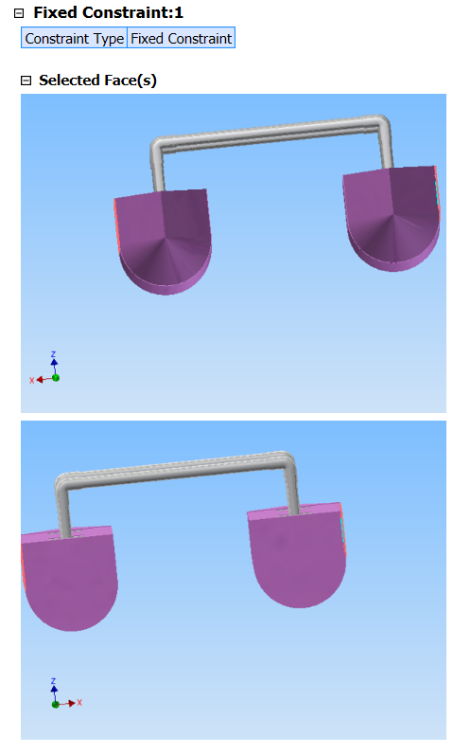

Figure 36 Fixed constraints

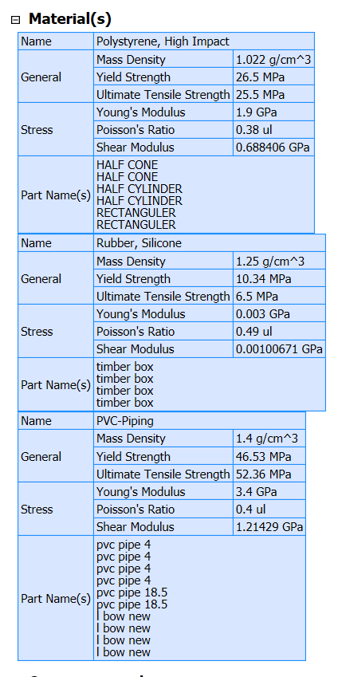

Figure 37 materials

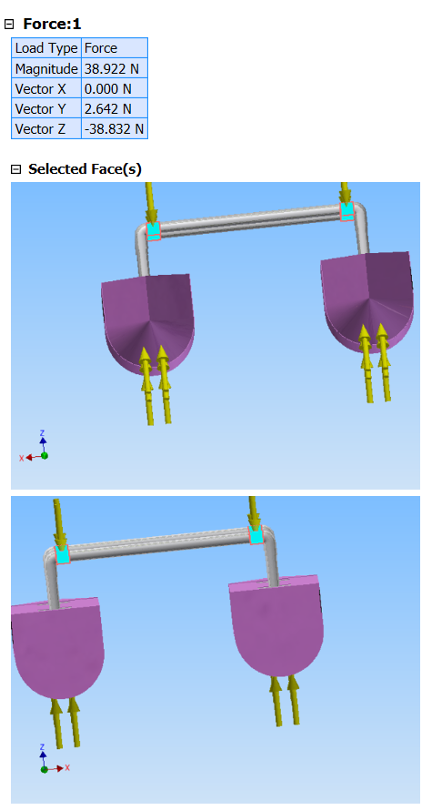

Figure 38 Forces

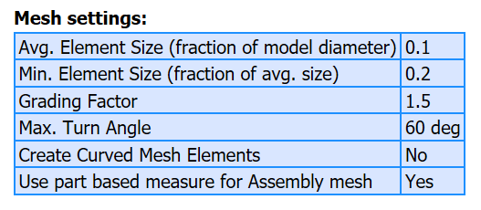

Figure 39 Mesh settings

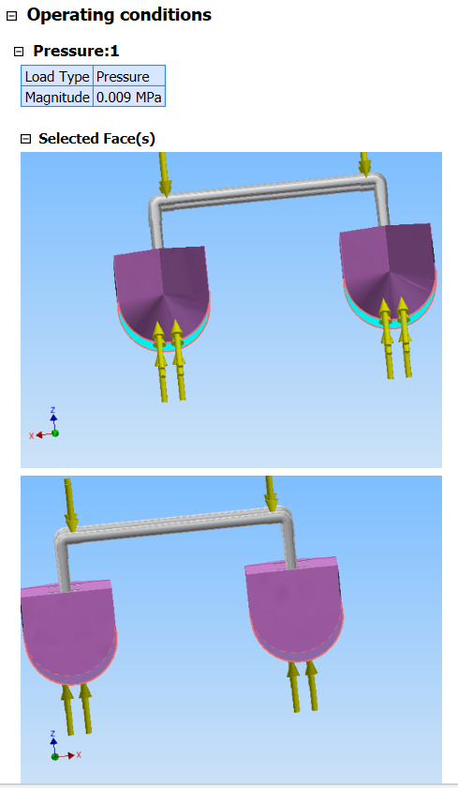

Figure 40 Pressure

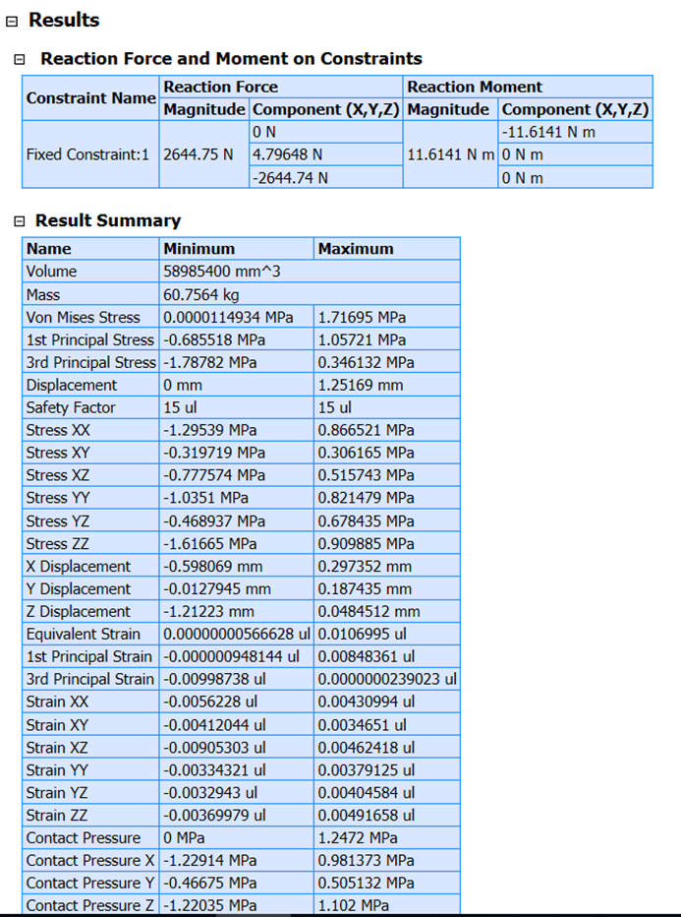

1. Result Summary

**Stress analysis (Whole System)**

The last step is to run stress analysis on the whole system and apply all the materials and fixtures using This sentence isn’t completed …

1. **Physical**

|  |  |
| --- | --- |
| Mass | 65.3553 kg |
| Area | 4.78583 m^2 |
| Volume | 0.0635279 m^3 |
| Center of Gravity | x=-0.0866133 m y=-0.353545 m z=0.21317 m |

1. Physical properties

Note: Physical values could be different from the physical values used by FEA as reported below.

1. **Static Analysis:1**

**General objective and settings:**

|  |  |
| --- | --- |
| Design Objective | Single Point |
| Study Type | Static Analysis |
| Last Modification Date | 11/27/2018, 6:59 PM |
| Detect and Eliminate Rigid Body Modes | No |
| Separate Stresses Across Contact Surfaces | No |
| Motion Loads Analysis | No |

1. General objective

**Mesh settings:**

|  |  |
| --- | --- |
| Avg. Element Size (fraction of model diameter) | 0.1 |
| Min. Element Size (fraction of avg. size) | 0.2 |
| Grading Factor | 1.5 |
| Max. Turn Angle | 60 deg |
| Create Curved Mesh Elements | No |
| Use part based measure for Assembly mesh | Yes |

1. Mesh settings

**Material(s)**

|  |  |  |
| --- | --- | --- |
| Name | Polystyrene, High Impact | |
| General | Mass Density | 1.022 g/cm^3 |
| Yield Strength | 26.5 MPa |
| Ultimate Tensile Strength | 25.5 MPa |
| Stress | Young's Modulus | 1.9 GPa |
| Poisson's Ratio | 0.38 ul |
| Shear Modulus | 0.688406 GPa |
| Part Name(s) | HALF CONE HALF CONE HALF CYLINDER HALF CYLINDER RECTANGULER RECTANGULER | |

|  |  |  |
| --- | --- | --- |
| Name | PPS Plastic | |
| General | Mass Density | 1.637 g/cm^3 |
| Yield Strength | 68.9 MPa |
| Ultimate Tensile Strength | 82.7 MPa |
| Stress | Young's Modulus | 2.7 GPa |
| Poisson's Ratio | 0.4 ul |
| Shear Modulus | 0.964286 GPa |
| Part Name(s) | timber box timber box timber box timber box electric box | |

|  |  |  |
| --- | --- | --- |
| Name | PVC-Piping | |
| General | Mass Density | 1.4 g/cm^3 |
| Yield Strength | 46.53 MPa |
| Ultimate Tensile Strength | 52.36 MPa |
| Stress | Young's Modulus | 3.4 GPa |
| Poisson's Ratio | 0.4 ul |
| Shear Modulus | 1.21429 GPa |
| Part Name(s) | pvc pipe 4 pvc pipe 4 pvc pipe 4 pvc pipe 4 pvc pipe 18.5 pvc pipe 18.5 l bow new l bow new l bow new l bow new | |

|  |  |  |
| --- | --- | --- |
| Name | Aluminum 6061 | |
| General | Mass Density | 2.7 g/cm^3 |
| Yield Strength | 275 MPa |
| Ultimate Tensile Strength | 310 MPa |
| Stress | Young's Modulus | 68.9 GPa |
| Poisson's Ratio | 0.33 ul |
| Shear Modulus | 25.9023 GPa |
| Part Name(s) | part middle case all aluminum | |

1. Materials

**Operating conditions**

**Pressure:1**

|  |  |
| --- | --- |
| Load Type | Pressure |
| Magnitude | 0.009 MPa |

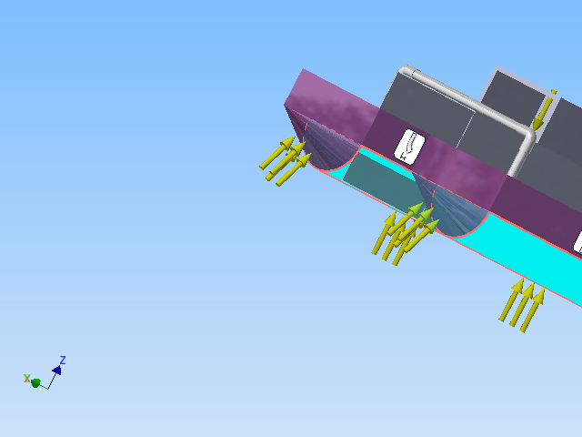

Figure 43 Selected faces

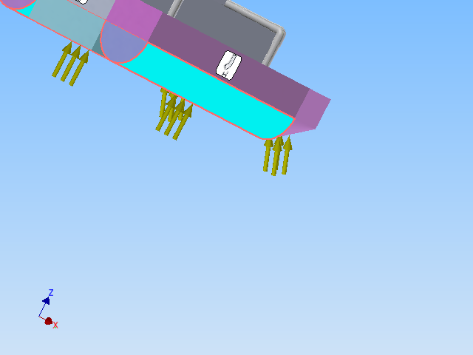**Pressure:2**

|  |  |
| --- | --- |
| Load Type | Pressure |
| Magnitude | 0.001 MPa |

 Selected Face(s)

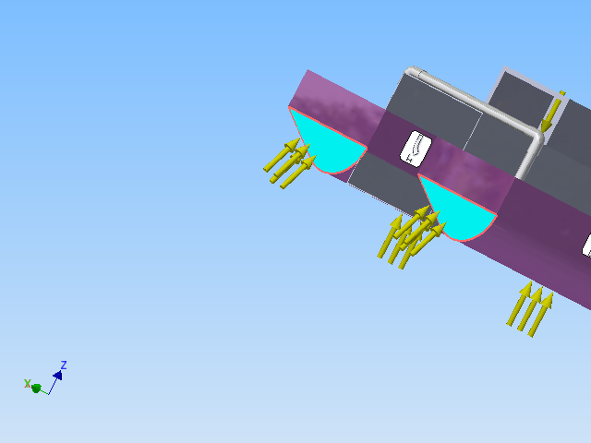

Figure 45 Pressure 2

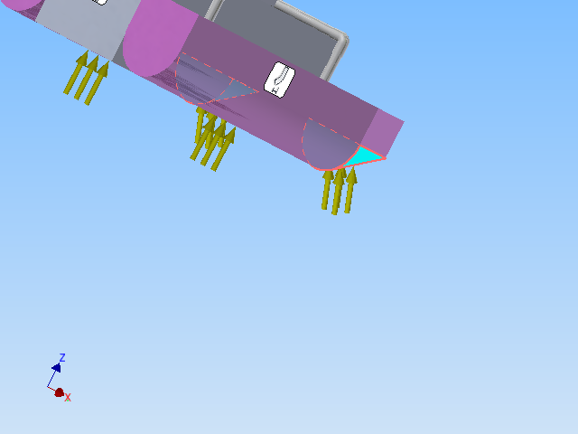

1. Pressuer 2

**Force:1**

|  |  |
| --- | --- |
| Load Type | Force |
| Magnitude | 44.480 N |
| Vector X | 0.000 N |
| Vector Y | 0.000 N |
| Vector Z | -44.480 N |

1. Force 1

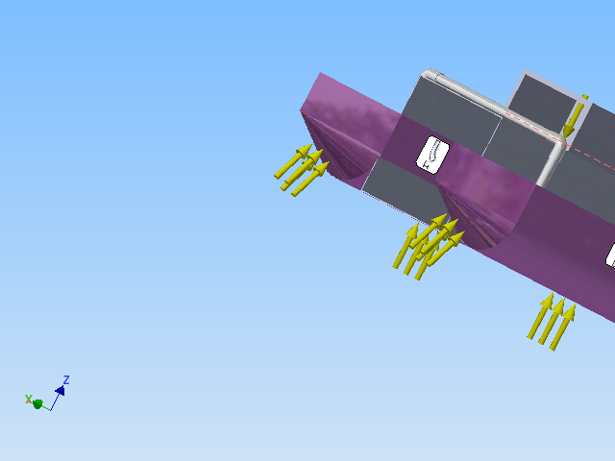

1. Force 1

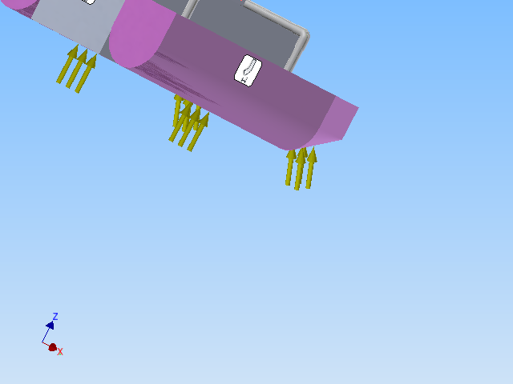

1. Force 1

|  |  |
| --- | --- |
| Load Type | Force |
| Magnitude | 111.207 N |
| Vector X | 0.000 N |
| Vector Y | -0.000 N |
| Vector Z | -111.207 N |

1. Force 2

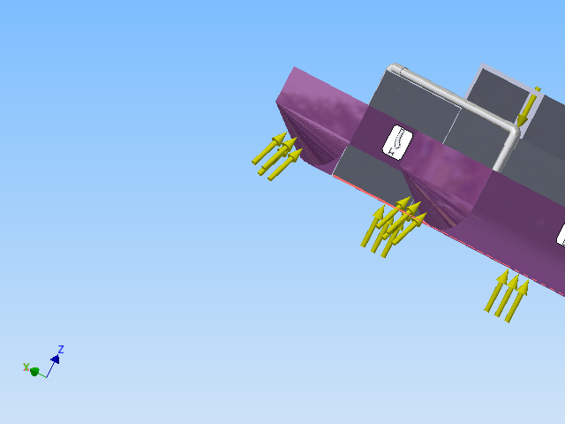

1. Selected faces

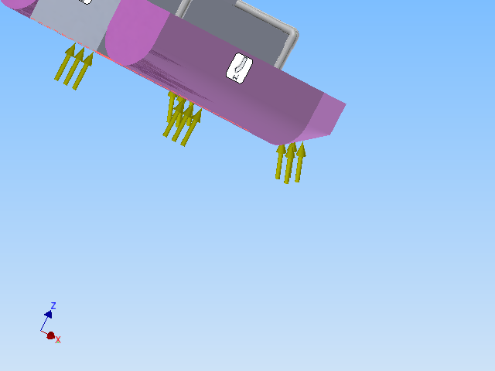

1. Force 2

|  |  |
| --- | --- |
| Constraint Type | Fixed Constraint |

**Selected Face(s)**

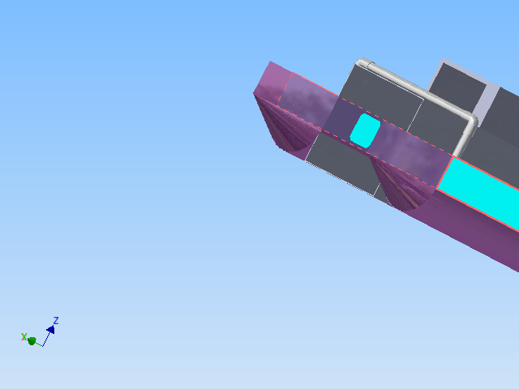

1. Selected faces

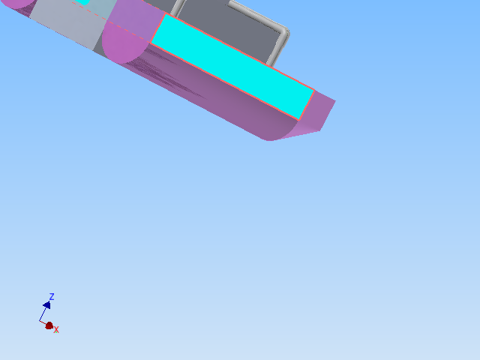

1. Selected faces fixture

**Contacts (Bonded)**

|  |  |
| --- | --- |
| Name | Part Name(s) |
| Bonded:1 | RECTANGULER:2 timber box:4 |
| Bonded:2 | RECTANGULER:1 timber box:1 |
| Bonded:3 | RECTANGULER:1 timber box:1 |
| Bonded:4 | RECTANGULER:2 timber box:4 |
| Bonded:5 | RECTANGULER:1 timber box:1 |
| Bonded:6 | RECTANGULER:2 timber box:4 |
| Bonded:7 | RECTANGULER:2 timber box:4 |
| Bonded:8 | RECTANGULER:1 timber box:1 |
| Bonded:9 | RECTANGULER:1 timber box:1 |
| Bonded:10 | RECTANGULER:2 timber box:4 |
| Bonded:11 | RECTANGULER:1 timber box:2 |
| Bonded:12 | RECTANGULER:2 timber box:3 |
| Bonded:13 | RECTANGULER:2 timber box:3 |
| Bonded:14 | RECTANGULER:1 timber box:2 |
| Bonded:15 | RECTANGULER:1 timber box:2 |
| Bonded:16 | RECTANGULER:2 timber box:3 |
| Bonded:17 | timber box:1 pvc pipe 4:3 |
| Bonded:18 | RECTANGULER:1 timber box:2 |
| Bonded:19 | RECTANGULER:2 timber box:3 |
| Bonded:20 | timber box:2 pvc pipe 4:2 |
| Bonded:21 | timber box:3 pvc pipe 4:4 |
| Bonded:22 | timber box:4 pvc pipe 4:1 |
| Bonded:23 | timber box:1 pvc pipe 4:3 |
| Bonded:24 | RECTANGULER:1 timber box:2 |
| Bonded:25 | RECTANGULER:2 timber box:3 |
| Bonded:26 | timber box:2 pvc pipe 4:2 |
| Bonded:27 | timber box:3 pvc pipe 4:4 |
| Bonded:28 | timber box:4 pvc pipe 4:1 |
| Bonded:29 | pvc pipe 4:2 l bow new:2 |
| Bonded:30 | pvc pipe 4:3 l bow new:4 |
| Bonded:31 | pvc pipe 4:4 l bow new:1 |
| Bonded:32 | pvc pipe 18.5:2 l bow new:3 |
| Bonded:33 | RECTANGULER:1 part middle case all aluminum:1 |
| Bonded:34 | part middle case all aluminum:1 electric box:1 |
| Bonded:35 | pvc pipe 4:1 l bow new:3 |
| Bonded:36 | pvc pipe 18.5:1 l bow new:1 |
| Bonded:37 | HALF CONE:2 RECTANGULER:1 |
| Bonded:38 | HALF CONE:1 RECTANGULER:2 |
| Bonded:39 | HALF CONE:1 HALF CYLINDER:1 |
| Bonded:40 | HALF CONE:2 HALF CYLINDER:2 |
| Bonded:41 | HALF CYLINDER:2 RECTANGULER:1 |
| Bonded:42 | HALF CYLINDER:1 RECTANGULER:2 |
| Bonded:43 | HALF CYLINDER:2 part middle case all aluminum:1 |
| Bonded:44 | HALF CYLINDER:1 part middle case all aluminum:1 |
| Bonded:45 | RECTANGULER:2 part middle case all aluminum:1 |

1. Bonds

**Results**

**Reaction Force and Moment on Constraints**

|  |  |  |  |  |
| --- | --- | --- | --- | --- |
| **Constraint Name** | **Reaction Force** | | **Reaction Moment** | |
| **Magnitude** | **Component (X,Y,Z)** | **Magnitude** | **Component (X,Y,Z)** |
| Fixed Constraint:1 | 2527.93 N | 0 N | 11.6762 N m | -11.6762 N m |
| 14.9663 N | 0 N m |
| -2527.89 N | 0 N m |

1. Reaction Forces

**Result Summary**

|  |  |  |
| --- | --- | --- |
| **Name** | **Minimum** | **Maximum** |
| Volume | 63527900 mm^3 | |
| Mass | 71.4218 kg | |
| Von Mises Stress | 0.00000066323 MPa | 3.333 MPa |
| 1st Principal Stress | -0.840666 MPa | 2.82522 MPa |
| 3rd Principal Stress | -3.2432 MPa | 1.257 MPa |
| Displacement | 0 mm | 0.160998 mm |
| Safety Factor | 15 ul | 15 ul |
| Stress XX | -2.7084 MPa | 2.63936 MPa |
| Stress XY | -0.54475 MPa | 0.548962 MPa |
| Stress XZ | -1.4552 MPa | 1.3929 MPa |
| Stress YY | -1.09942 MPa | 1.25918 MPa |
| Stress YZ | -0.339979 MPa | 0.773526 MPa |
| Stress ZZ | -3.23762 MPa | 2.82242 MPa |
| X Displacement | -0.00946153 mm | 0.00953897 mm |
| Y Displacement | -0.00114884 mm | 0.0154656 mm |
| Z Displacement | -0.160998 mm | 0.018783 mm |
| Equivalent Strain | 0.00000000019701 ul | 0.0000436901 ul |
| 1st Principal Strain | -0.000000202602 ul | 0.0000369209 ul |
| 3rd Principal Strain | -0.0000454897 ul | 0.000000775057 ul |
| Strain XX | -0.0000354651 ul | 0.0000341433 ul |
| Strain XY | -0.0000172027 ul | 0.0000127968 ul |
| Strain XZ | -0.0000280902 ul | 0.0000268876 ul |
| Strain YY | -0.0000138316 ul | 0.0000134103 ul |
| Strain YZ | -0.00000656272 ul | 0.00001764 ul |
| Strain ZZ | -0.0000453819 ul | 0.0000367485 ul |
| Contact Pressure | 0 MPa | 1.05001 MPa |
| Contact Pressure X | -1.01768 MPa | 0.786651 MPa |
| Contact Pressure Y | -0.254685 MPa | 0.298772 MPa |
| Contact Pressure Z | -0.151817 MPa | 0.289182 MPa |

1. Results

**Von Mises Stress**

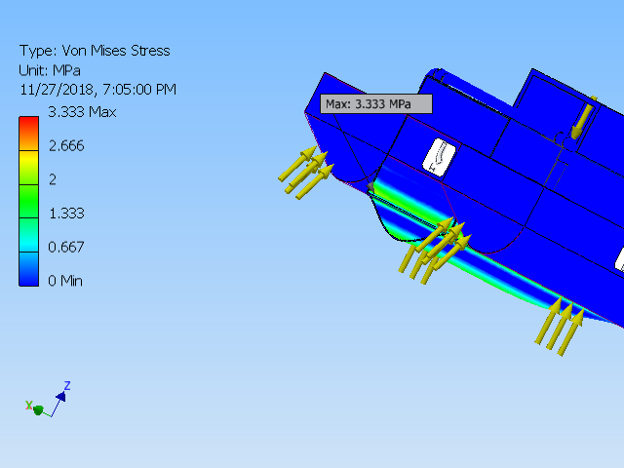

1. Von Mises Stress

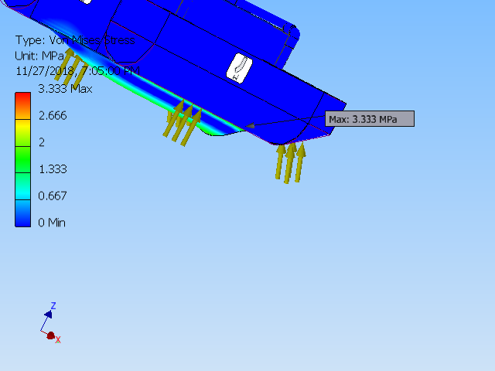

1. Min to Max Von mises stress

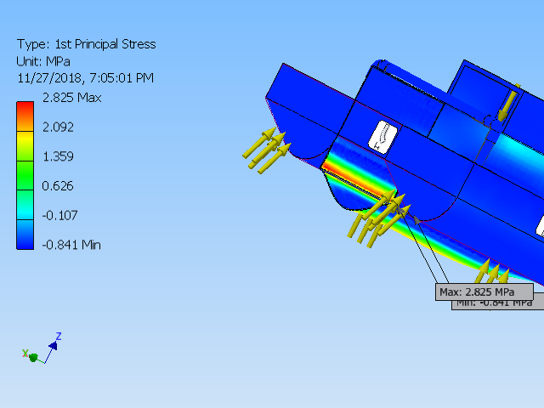

1. principle stress

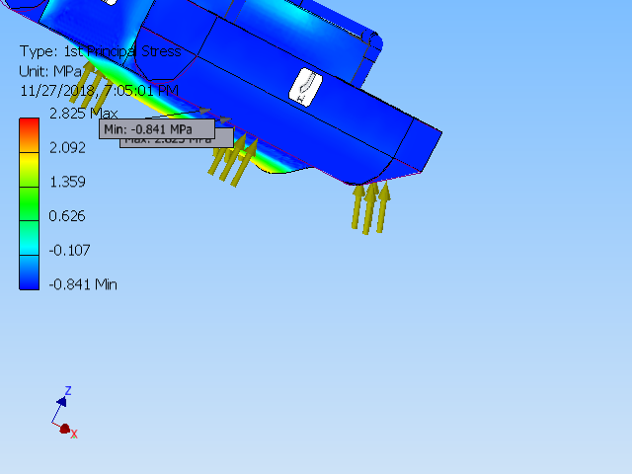

1. Max and Min principle stress

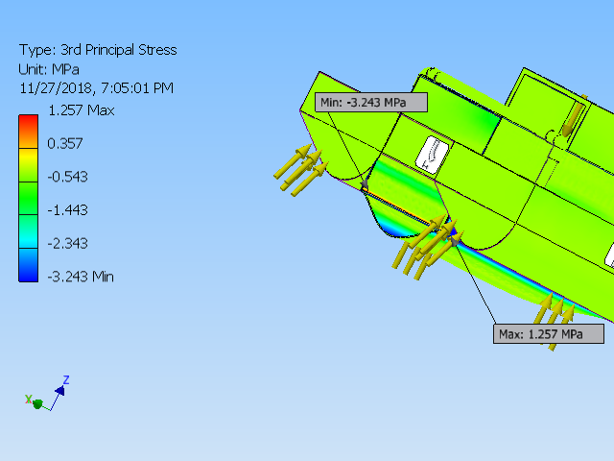

1. 3rd principle stress

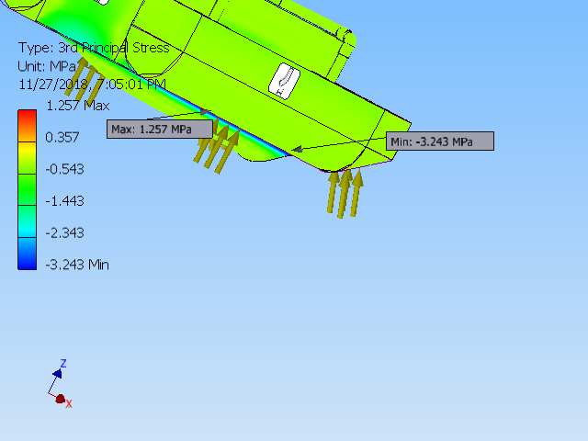

1. Displacement

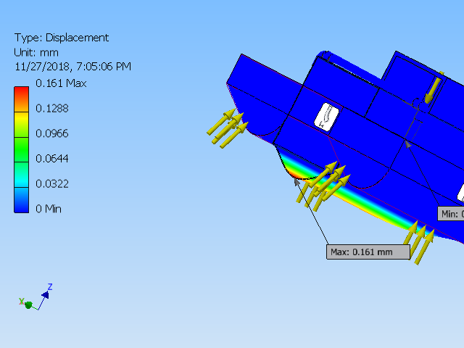

1. Max and Min Displacement

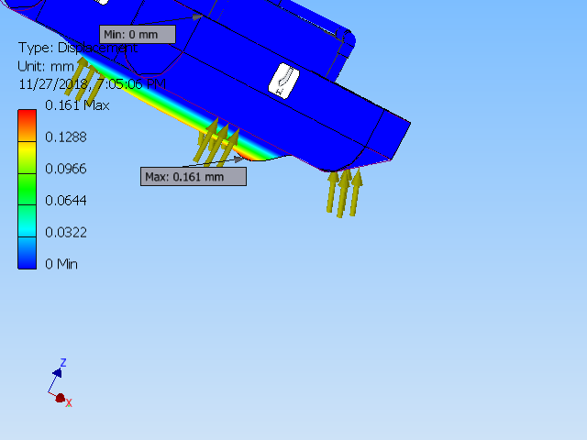

1. Displacement Max point

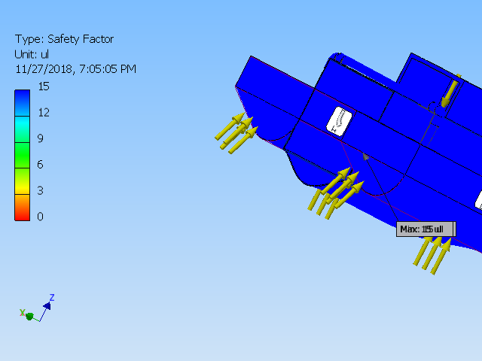

1. Safety Factor

## Implementation of task 7- Building the prototype

Last task for mechanical implementation was to build the prototype. The steps are as following:

* Buying the parts:
* Shaping the pontoons
* Making the middle collection chamber:
* Applying paint to make it water-proof:

For this step the parts ordered are as following:

* pink foam
* aluminum square bars
* aluminum L bars
* aluminum mesh
* spray paint
* door hinge
* various nuts and bolts
* Pvc pipes (schedule 40)
* PVC 90 couplings

The links for each of these except the aluminum bars are as following:

[https://www.lowes.com/pd/Krylon-High-](https://www.lowes.com/pd/Krylon-High-Heat-Satin-Black-Spray-Paint-Actual-Net-Contents-12-oz/1000462633)

[Heat-Satin-Black-Spray-Paint-Actual-Net-Contents-12-oz/1000462633](https://www.lowes.com/pd/Krylon-High-Heat-Satin-Black-Spray-Paint-Actual-Net-Contents-12-oz/1000462633)

Spray paint black

Price 3.88

Need it to make the boat submerged parts waterproof

<https://www.lowes.com/pd/Krylon-Gloss-Red-Orange-Fluorescent-Spray-Paint-Actual-Net-Contents-11-oz/1000462639>

Spray paint red

Price 3.88

Need it to make the boat submerged parts waterproof

<https://www.homedepot.com/p/Owens-Corning-FOAMULAR-150-1-in-x-4-ft-x-8-ft-R-5-Scored-Square-Edge-Rigid-Foam-Board-Insulation-Sheathing-20WE/207179253>

Foam board

Price 19.55

Required to make pontoons

Quantity required 1 board

<https://www.amazon.com/Devcon-20445-Flow-Mix-5-Minute-Epoxy/dp/B00C3Z9TTS?th=1>

Epoxy

24.99 for pack of 6

Required to make the system more rigid

<https://m.lowes.com/pd/Blue-Hawk-Actual-10-ft-x-2-ft-Rolled-wire-Galvanized-Welded-Wire-Garden-Hardware-Cloth-Rolled-Fencing/4780937?cm_mmc=SCE_PLA-_-LumberAndBuildingMaterials-_-WireFence-_-4780937:Blue_Hawk&CAWELAID=&kpid=4780937&CAGPSPN=pla&store_code=1538&k_clickID=go_625667893_34613739070_111132546670_pla-258795389990_m_9059726&gclid=EAIaIQobChMI4vHx5s-M4AIVUV8NCh2eyQgMEAQYASABEgK0J_D_BwE>

Aluminum mesh sheet

12.98

Required to make the middle assembly

<https://www.lowes.com/pd/Gatehouse-4-in-Oil-Rubbed-Bronze-5-8-in-Radius-Mortise-Door-Hinge/4772783>

Door hinges

Price for two 6.96

Required to make rudders

<https://www.lowes.com/pd/Hillman-200-Piece-Steel-Zinc-Plated-Combo-Fastener-Kit-Case-Included/3024351>

Various size nuts and bolts

Price 4.10

Required to fasten the system

Pvc couplings most of which are either a dollar or under a dollar and we will require at least 24, this is something that we cannot order and we will need to purchase from a local hardware store but the cost can be up to 20-25$

Based on all the building materials given above the total price comes up to 117.34$

Assembly:

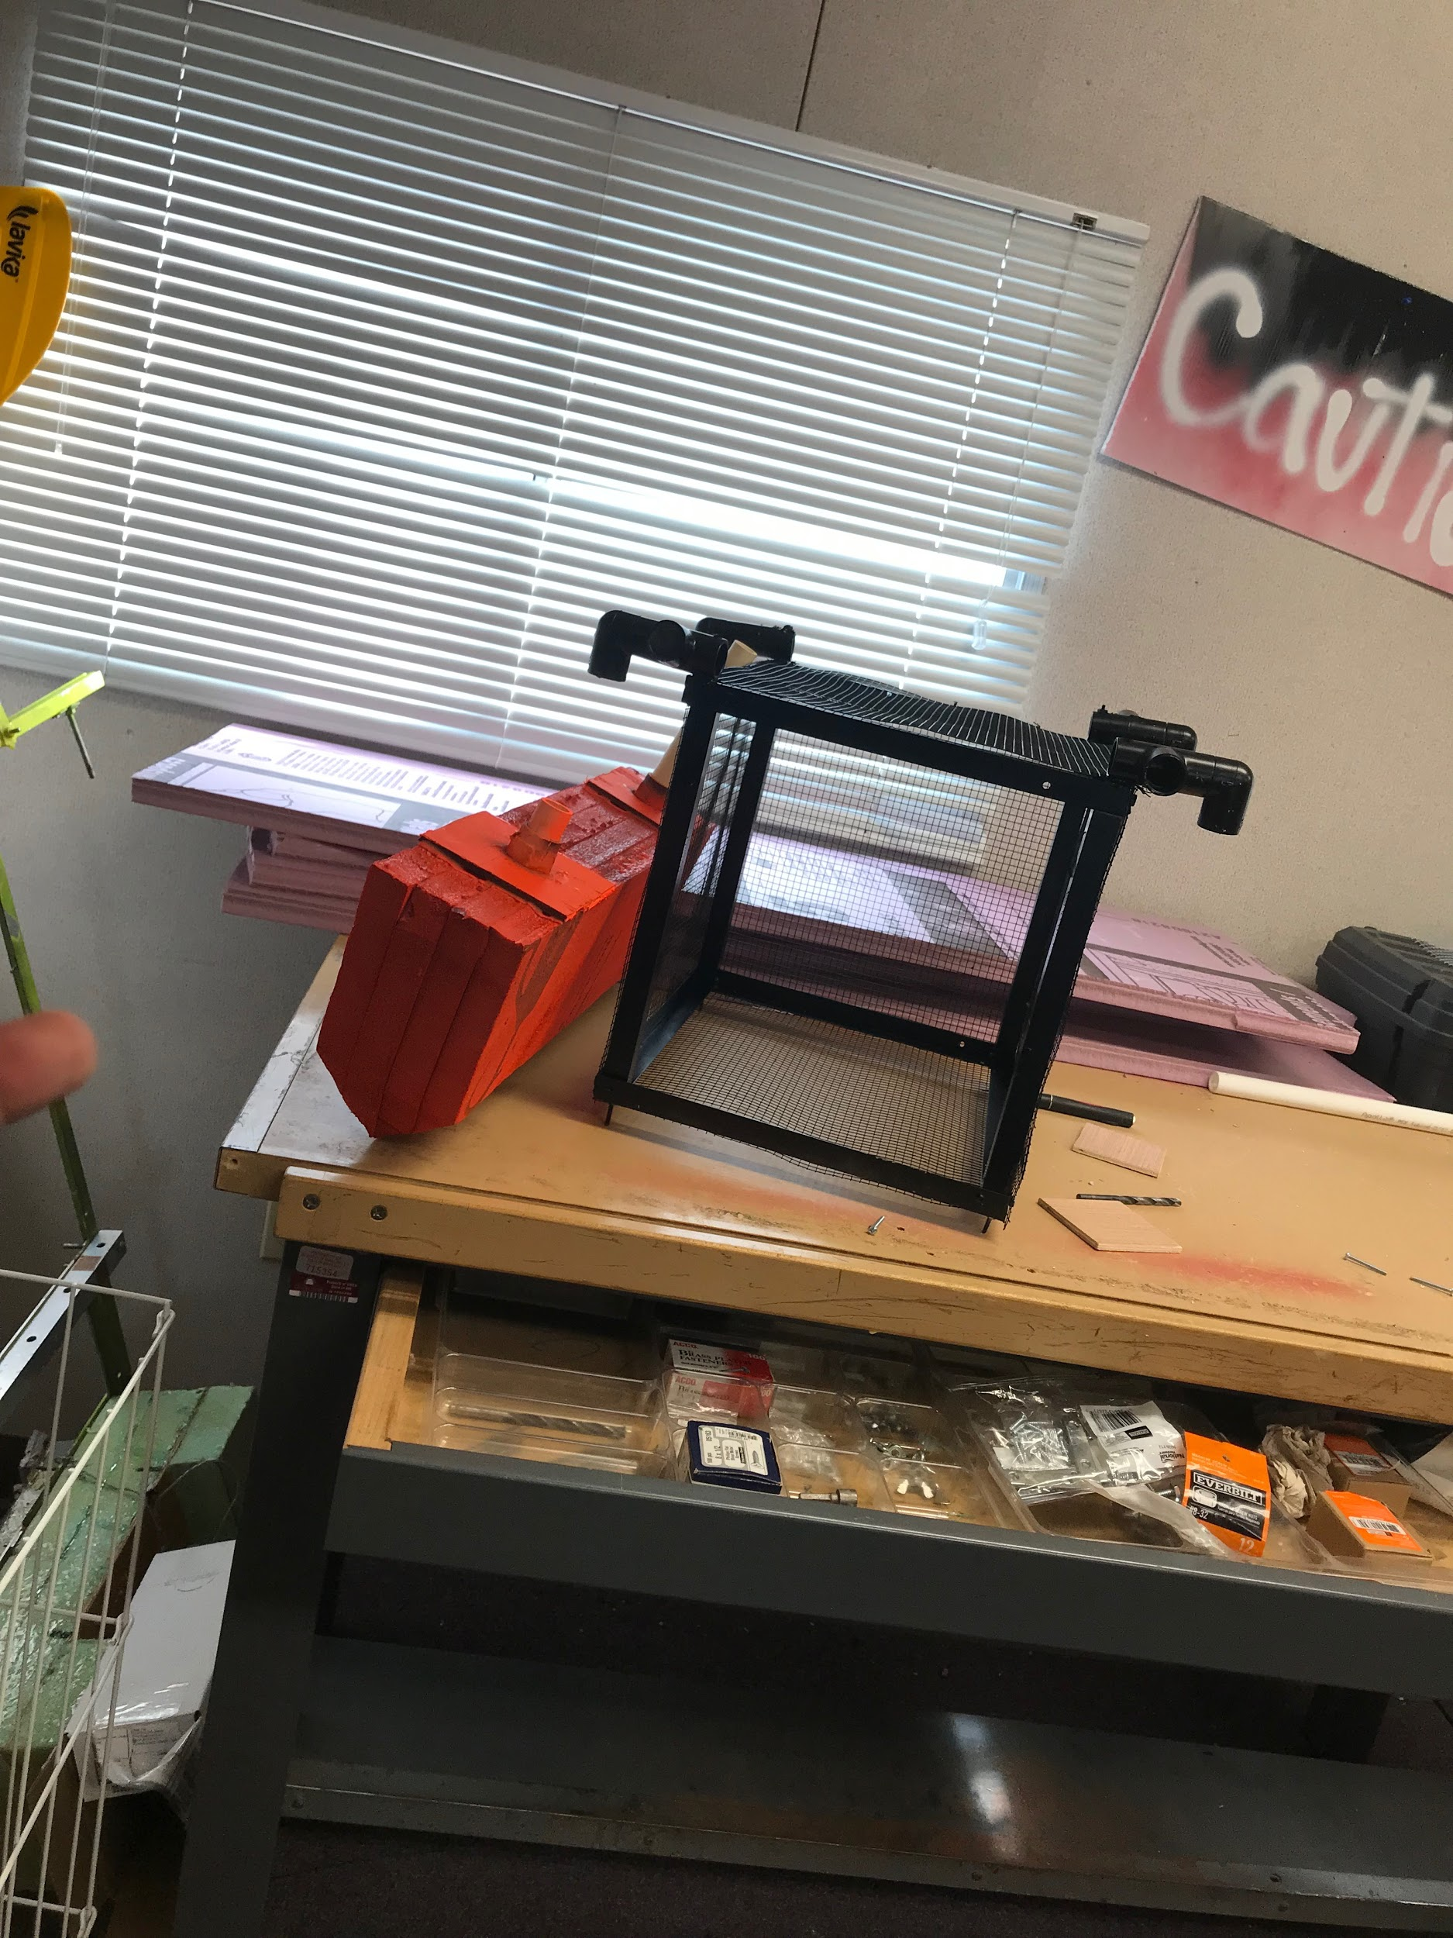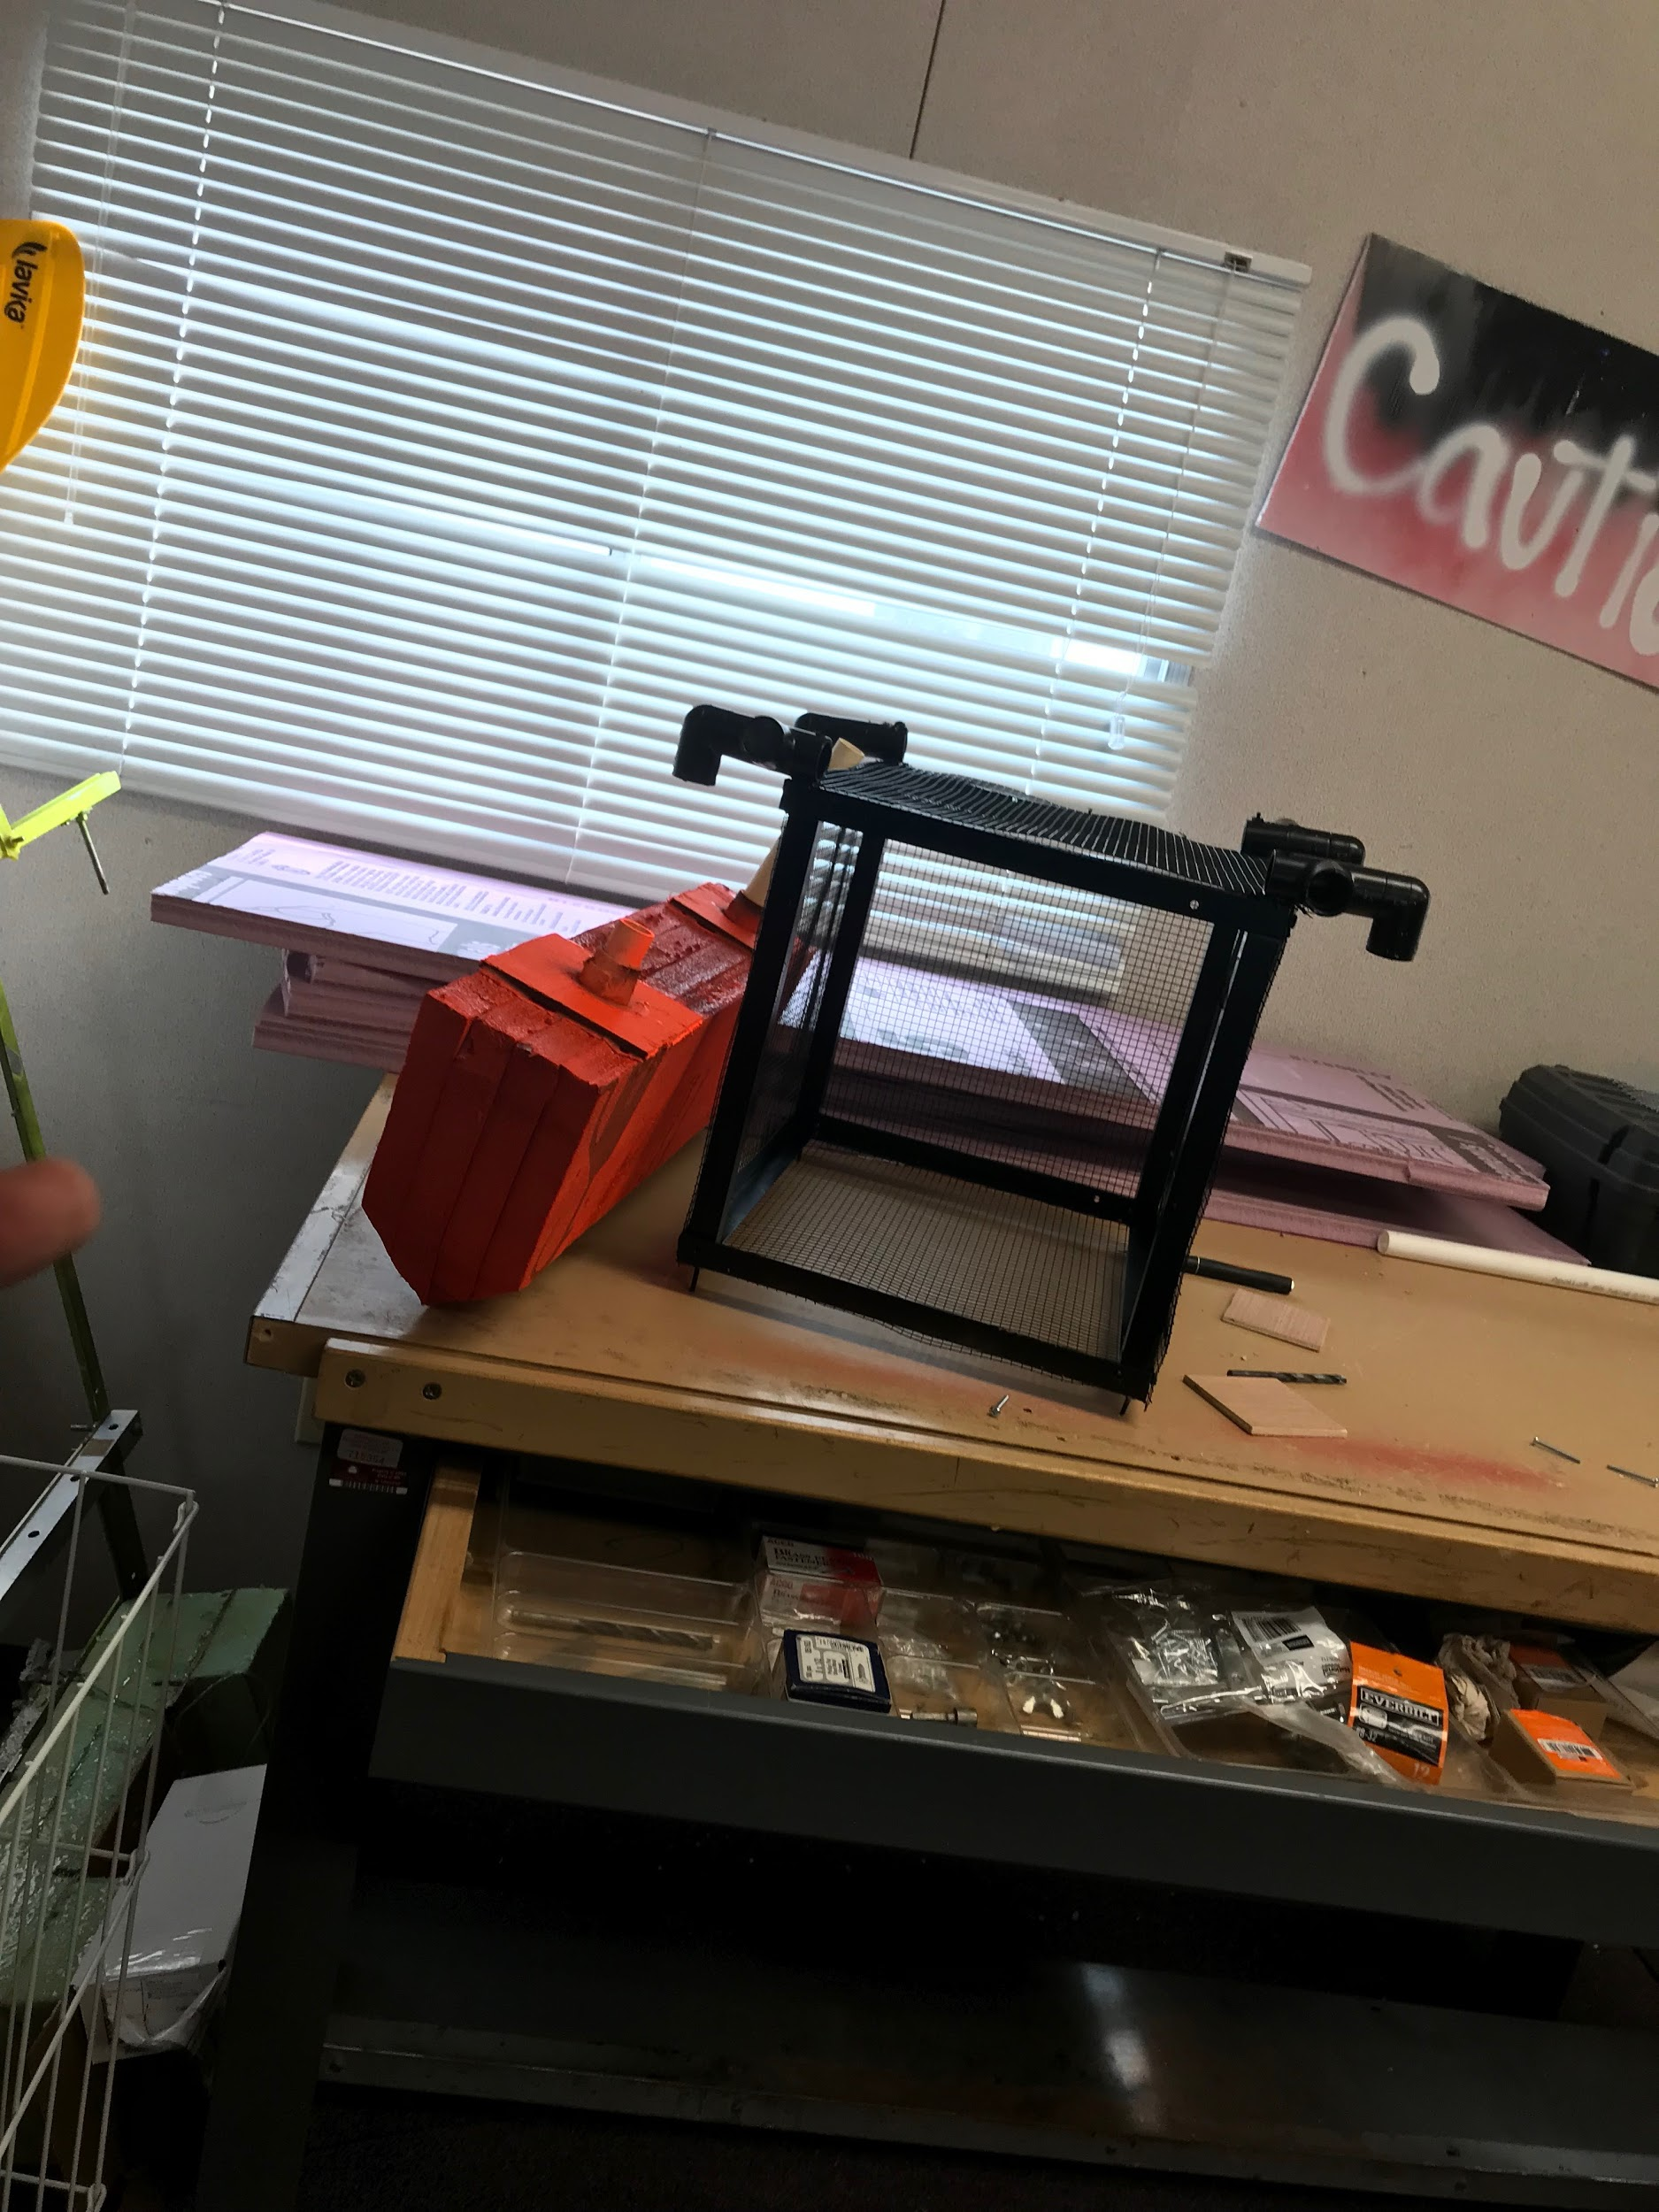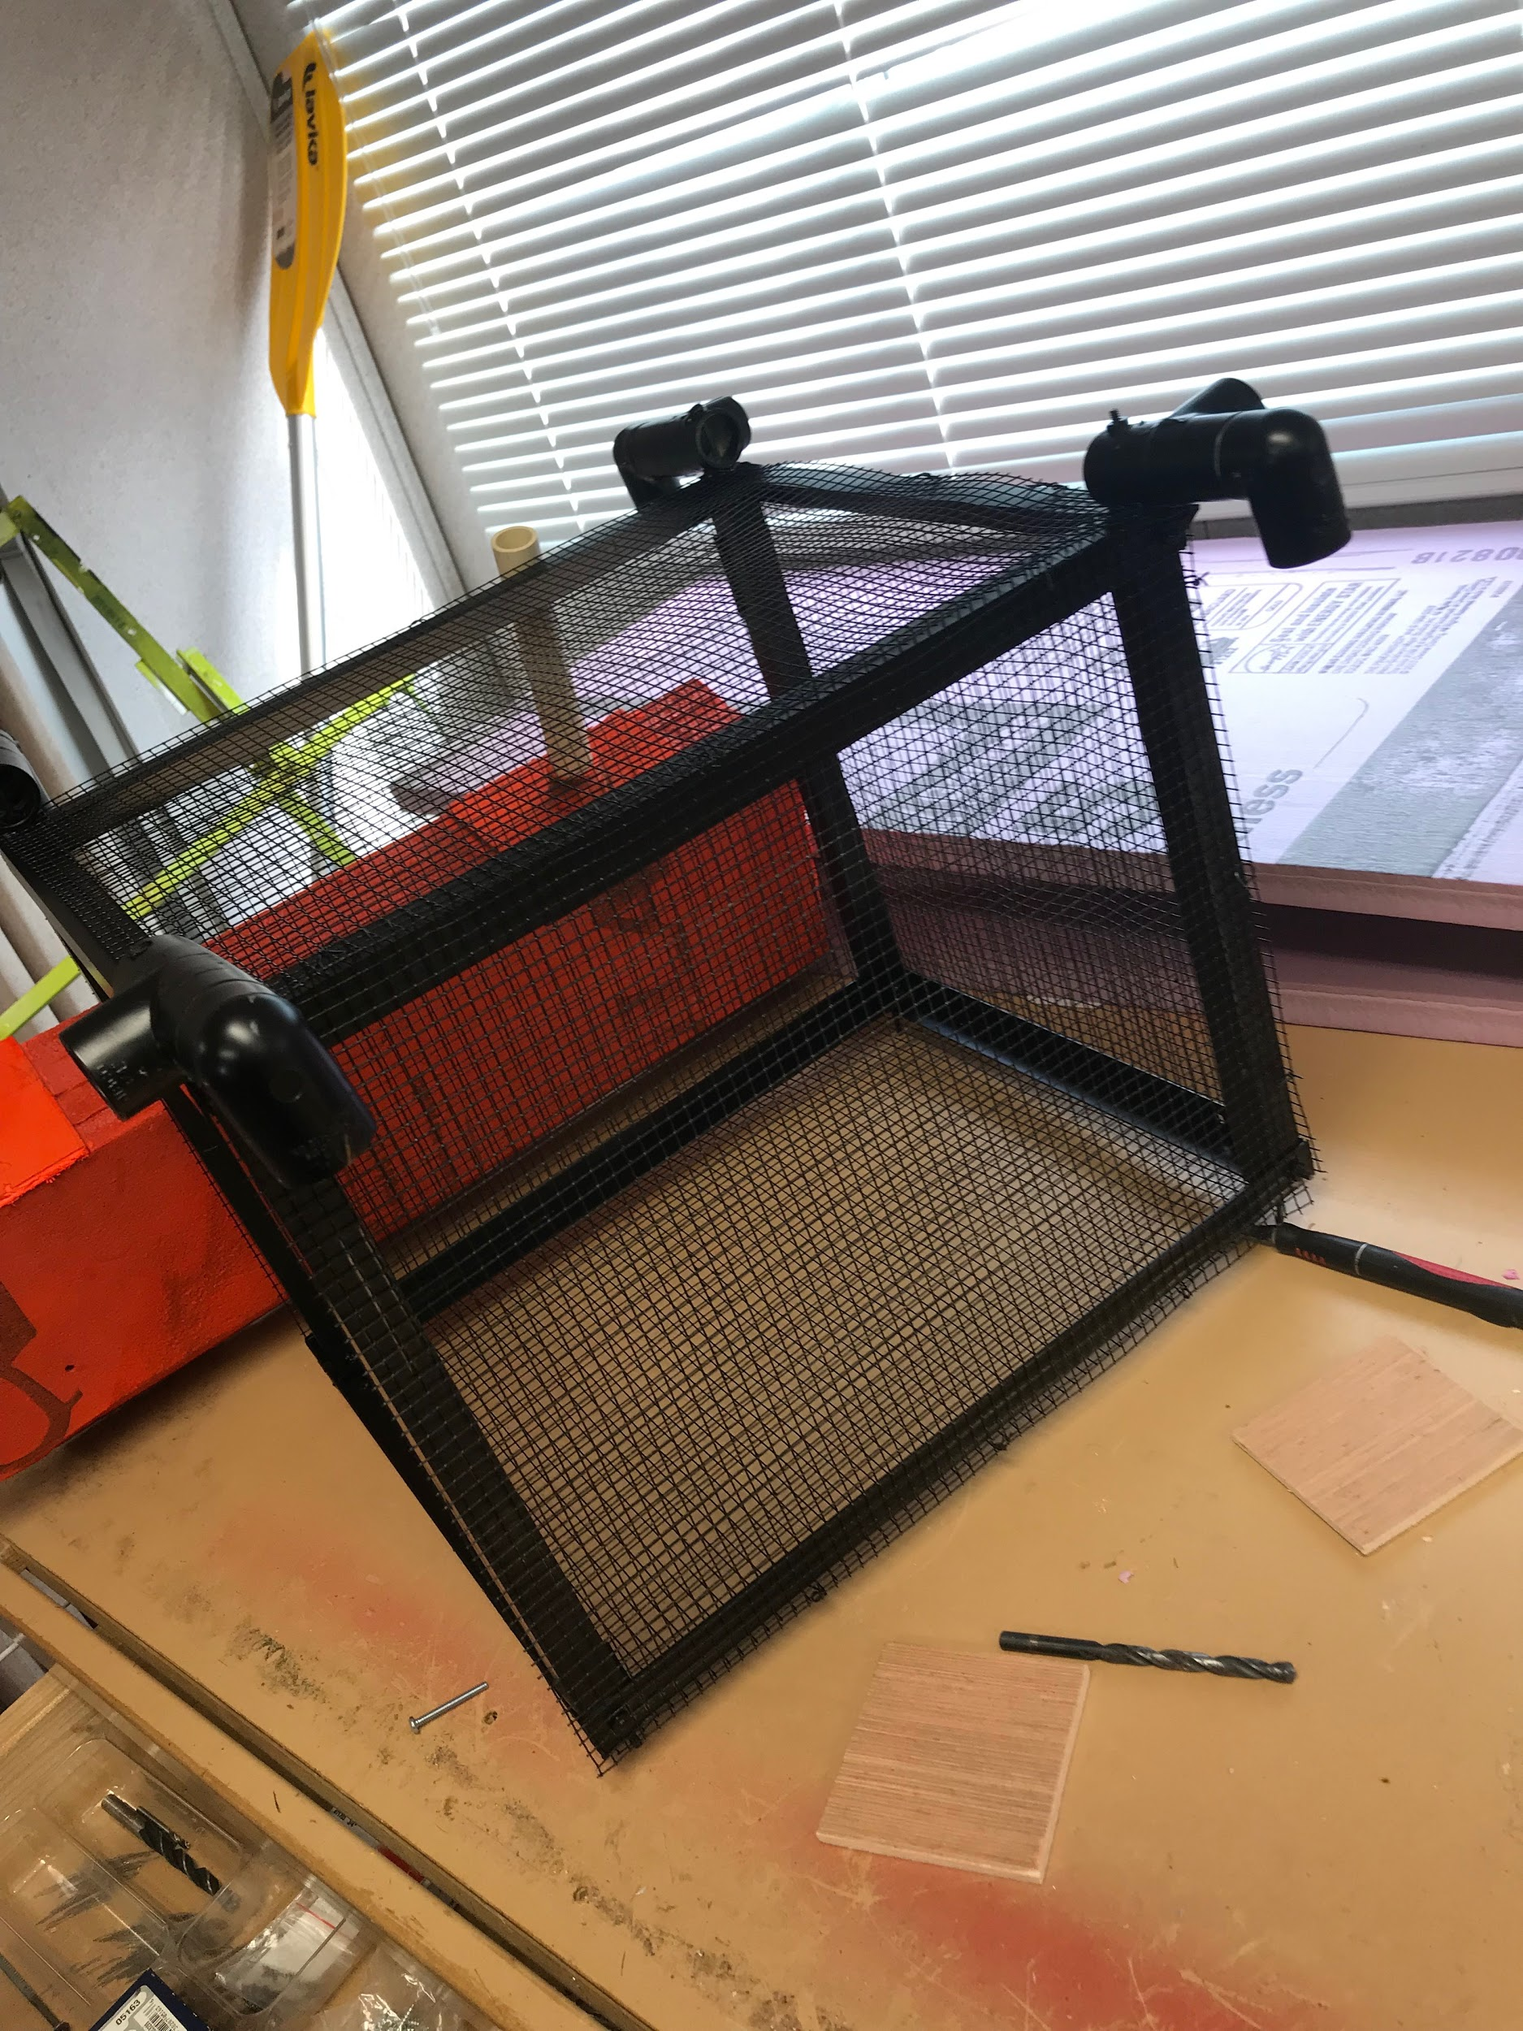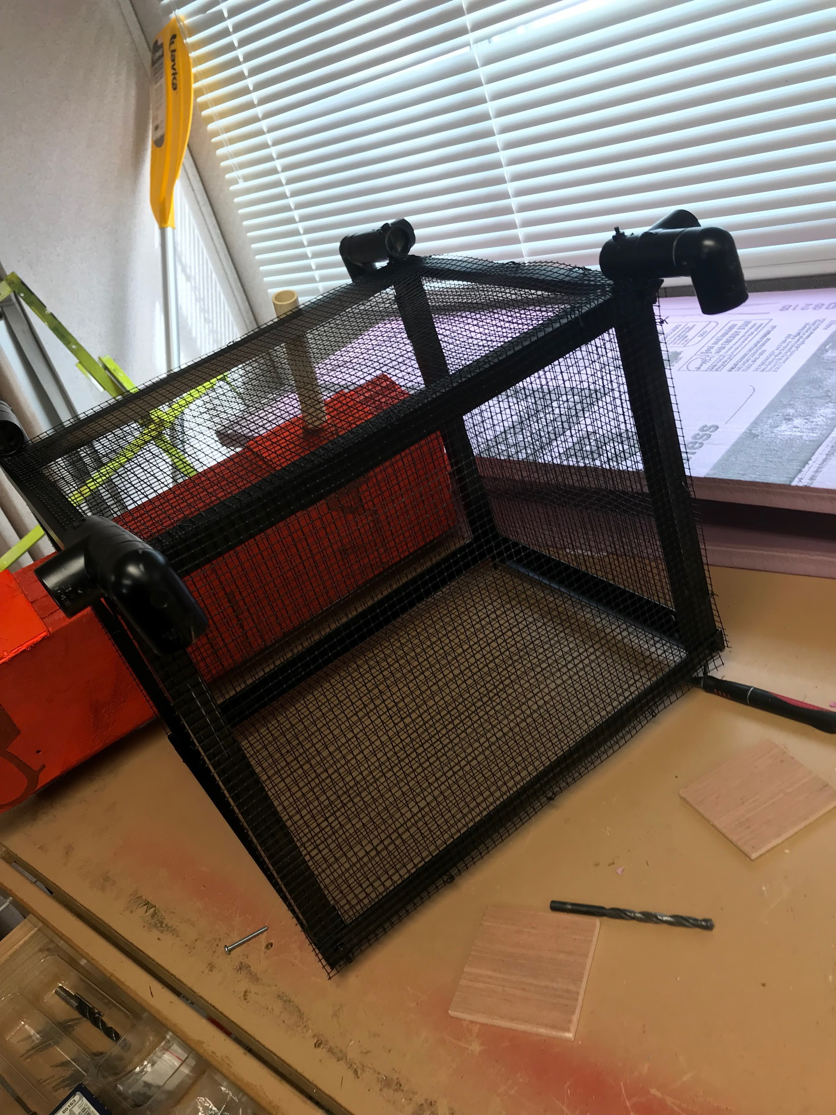

Fig 62. Diagrams of the vessel

As seen in the images above, the middle collection chamber is painted black and it is enclosed by using aluminum mesh. There is also PVC couplings and pipes that can be seen which connect the middle frame with the pontoons (Colored red). Most of the time was spent in shaping teh pontoons which is made of pink foam. To make it more secure we used wooden plank pieces to further secure the pvc pipes to the pontoons.

**Power Calculation:**

The power calculation is required in order to determine the motor and propeller for this vessel to achieve the velocity at the acceleration according to design requirements. For this calculation, the process is as follows:

1: Calculate acceleration first

2: Calculate thrust force required.

3: Calculate power based on thrust force.

4: Choose a propeller and calculate the RPM required based on speed and the radius of the prop.

4: Use the RPM and Power to find a motor.

1. **Results:**

Based on the thrust force required, the vessel was determined to require 80W power in order to successfully overcome drag force.

Based on this information, we could then determine the motor and do power analysis.

## Implementation of Task 8:

### Implementation of Subtask 1-Setting up the image recognition API

HARDWARE

Before we can have an image recognition system, we must first determine which platform to use. Image recognition can be implemented on various operating systems and devices but due to the mobility of the boat and flexibility, the Raspberry pi3 was determined to be the best option to meet the vessel’s needs. The model will be trained on a Windows operating system desktop computer, but the recognition will be implemented on the field with a Raspberry pi3. Below are the list of deceives required:

* Raspberry pi3
* Webcam / pi cam
* Micro SD card {containing the Rasbian OS}
* A personal computer
* Portable Power Supply
* Wireless Wi-Fi dongle
* Mouse
* Keyboard

SOFTWARE

Certain steps and configurations have to be accomplished before the Raspberry pi3 can be operational. These steps and configurations are listed and then explained comprehensively below:

* Update the Raspberry pi3
* Install TensorFlow
* Install openCV
* Compile and install Protobuf
* Set up Tensor flow directory Structure and the PYTHONPATH variable
* Test the system

1. Update the Raspberry pi3

sudo apt-get update

sudo apt-get dist-upgrade

The first line command updates the pi while the second one upgrades it. Note that dist-upgrade should be used instead of just upgrade in other to avoid errors in future coding operations. The time taken will vary based upon the version of pi being used.

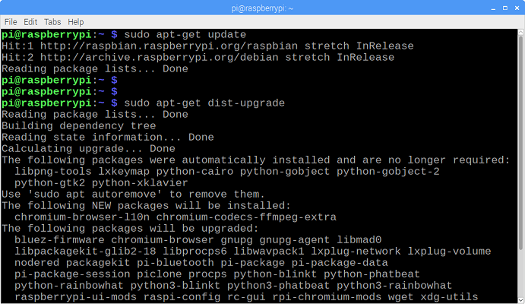

Figure 62 pi graphic interface during update

1. Install TensorFlow

Tensor flow is the optimizer and it is very important in the recognition process. To install TensorFlow, in the /home/pi directory, create a folder called “tf”, which will be used to hold all of the installation files for TensorFlow.

mkdir tf

cd tf

wget <https://github.com/lhelontra/tensorflow-on-arm/releases/download/v1.8.0/tensorflow-1.8.0-cp35-none-linux_armv7l.whl>

install TensorFlow by issuing:

sudo pip3 install /home/pi/tf/tensorflow-1.8.0-cp35-none-linux_armv7l.whl

TensorFlow also needs the LibAtlas, pillow, lxml, jupyter, matplotlib, cython packages

sudo apt-get install libatlas-base-dev

sudo pip3 install pillow lxml jupyter matplotlib cython

sudo apt-get install python-tk

1. Install OpenCV

In order to ensure that OpenCV works properly on the Raspberry Pi, there are quite a few dependencies that need to be installed through apt-get. If any of the following commands do not work, issue “sudo apt-get update” and then try again. Issue:

sudo apt-get install libjpeg-dev libtiff5-dev libjasper-dev libpng12-dev

sudo apt-get install libavcodec-dev libavformat-dev libswscale-dev libv4l-dev

sudo apt-get install libxvidcore-dev libx264-dev

sudo apt-get install qt4-dev-tools

Once those are all installed, install OpenCV. Issue:

pip3 install opencv-python

1. Compile and Install Protobuf

The TensorFlow object detection API uses Protobuf, a package that implements Google’s Protocol Buffer data format. First, obtain the packages necessary to compile Protobuf from source. Issue:

sudo apt-get install autoconf automake libtool curl

Then download the protobuf release from its GitHub repository by issuing:

wget https://github.com/google/protobuf/releases/download/v3.5.1/protobuf-all-3.5.1.tar.gz

Configure the build by issuing the following command:

./configure

Build the package by issuing:

make

make check

make install

Export the library path:

cd python

export LD_LIBRARY_PATH=../src/.libs

Next, issue:

python3 setup.py build --cpp_implementation

python3 setup.py test --cpp_implementation

sudo python3 setup.py install --cpp_implementation

Then issue the following path commands:

export PROTOCOL_BUFFERS_PYTHON_IMPLEMENTATION=cpp

export PROTOCOL_BUFFERS_PYTHON_IMPLEMENTATION_VERSION=3

Finally, issue:

sudo ldconfig

Verify it is installed correctly by issuing the command below and making sure it puts out the default help text:

protoc

The Raspberry Pi needs to be restarted after this process, or TensorFlow will not work.

sudo reboot now

1. Set up TensorFlow Directory Structure and PYTHONPATH Variable

mkdir tensorflow1

cd tensorflow1

Download the tensorflow repository from GitHub by issuing:

git clone --recurse-submodules https://github.com/tensorflow/models.git

Next, modify the PYTHONPATH environment variable to point at some directories inside the TensorFlow repository downloaded

sudo nano ~/.baser

Move to the end of the file, and on the last line, add:

export PYTHONPATH=$PYTHONPATH:/home/pi/tensorflow1/models/research:/home/pi/tensorflow1/models/research/slim

Use Protoc to compile the Protocol Buffer (.proto) files used by the Object Detection API. The .proto files are located in /research/object_detection/protos

cd /home/pi/tensorflow1/models/research

protoc object_detection/protos/*.proto --python_out=.

This command converts all the "name".proto files to "name_pb2".py

cd /home/pi/tensorflow1/models/research/object_detection

1. Test the System

The raspberry pi is ready to accept a trained cnn model in order to start recognition.

### Implementattion of Subtask2-Research on Convolution Neural Network

During the course of designing this bottle collection system, several different methods of making this machine intelligent in different ways were considered. For example, consideration was given to methods such as using a thermal camera, or by using a sonar sensor in identifying objects. Unfortunately, however, none of the methods considered were efficient enough to meet the vessel’s intended purpose except for the use of image recognition. By implementing image recognition with the aid of artificial intelligence, the vessel will be able to identify specific objects which will then be collected, and avoid unwanted obstacles at the same time. Although a fairly complicated method of intelligent design, it is practical for the purpose of the vessel.

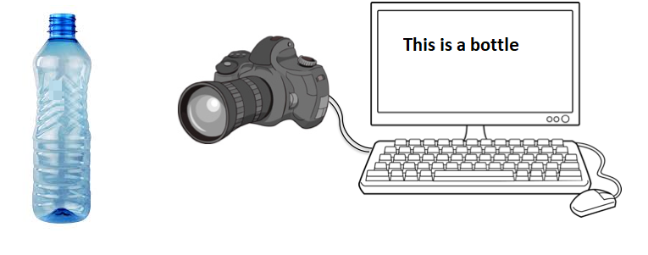

Figure 63 overview

Image recognition is a tremendous task in developing and testing machine learning approaches. Vision is debatably our most powerful sense and comes naturally to most humans. Image recognition can be implemented as either supervised learning or unsupervised learning. For this project, because our objective is well-defined, we will utilize supervised learning. In supervised learning, we supply the computer with a dataset of images and specify a general process of how the computer should be able to evaluate the images. The system then will be able learn by working with a defined mathematical model which links the input image to the output model. With the use of Artificial Intelligence during the training stage, the system learns and corrects its parameters until a high degree of accuracy is established. The entire implemntation results in an optimizing problem.

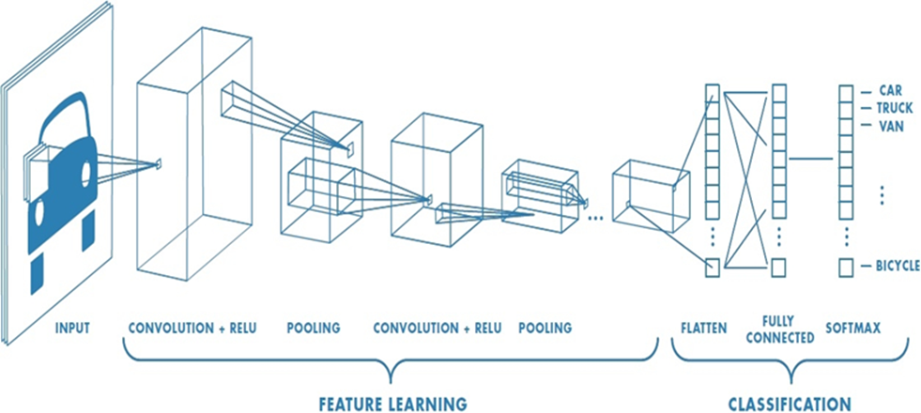

Figure 64 pictorial representation of CNN

In every cnn, there are two stages: the feature stage and the classification stage. At the classification stage, the input (picture or video feeds broken down in frames) is converted to pixel values. These values are passed through filters and these filters have specific values in matrix form which are convoluted with the pixel values and the output is convoluted again with more filters. The more filters, parameters, and layers, the more precise the cnn tends to be. However, the speed will be affected negatively. As such, when choosing a cnn, speed and accuracy also must be taken into consideration depending upon the use. Operations such as pooling and striding are employed to manipulate the size of the convolution matrix. The arrays of the parameters are aligned to form a single in the classification section then compared to the softmax.

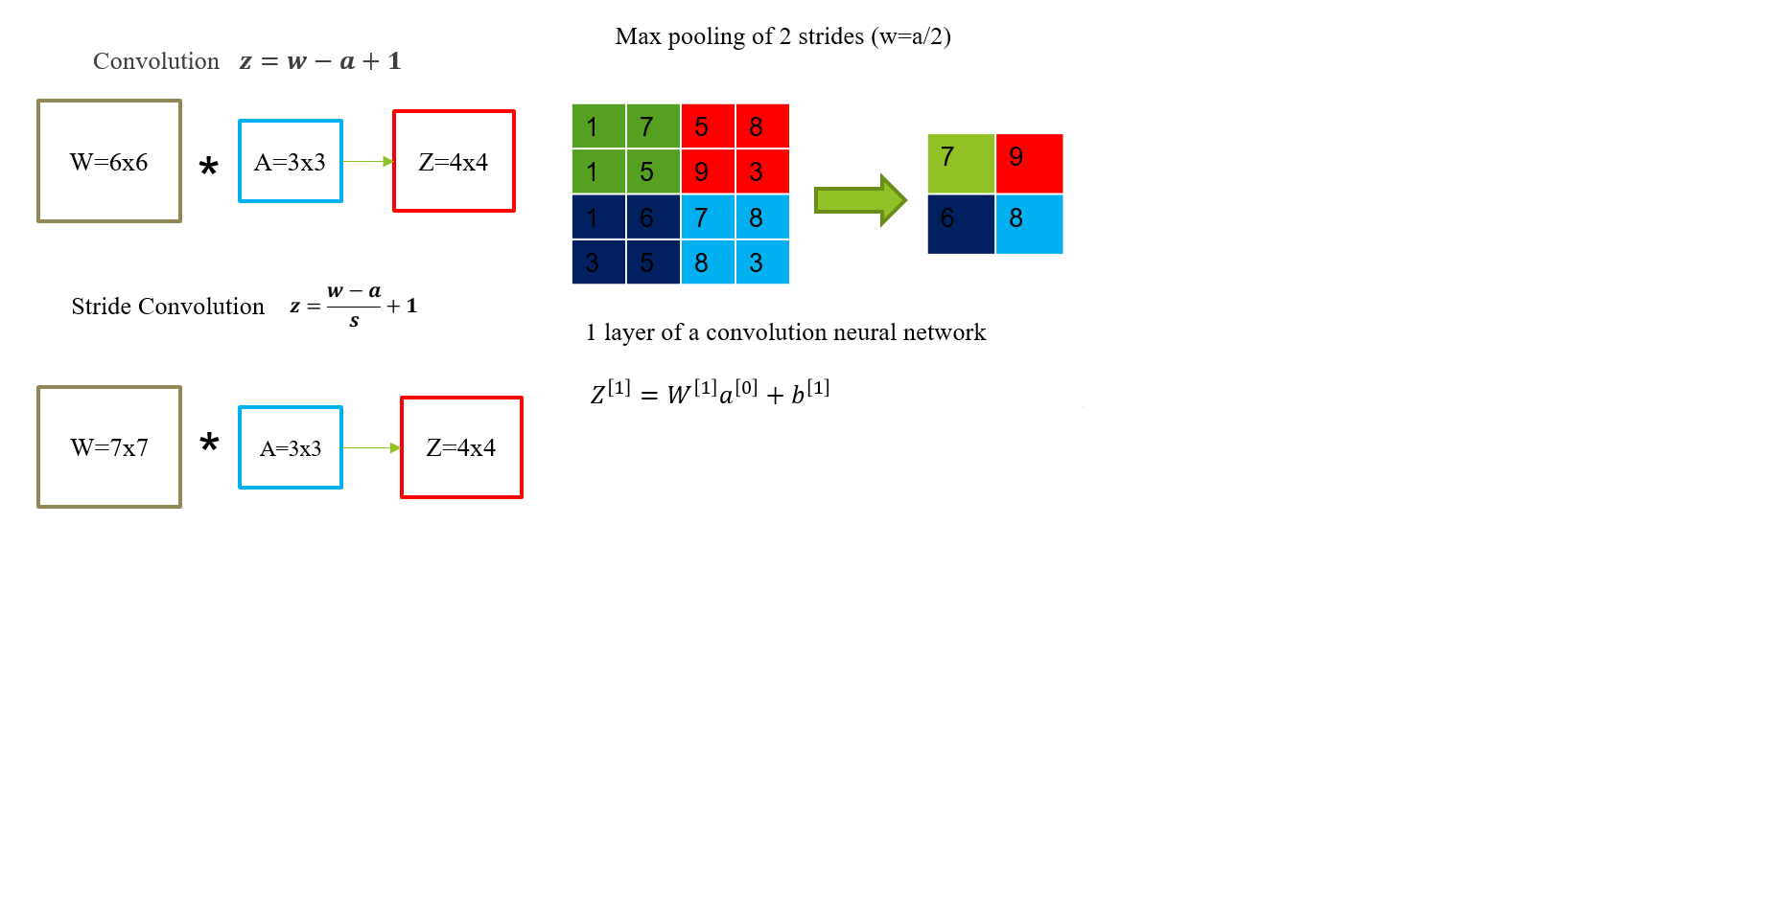

Figure 65 neural network modification methods

In order to develop or comprehend a cnn, some manipulations processes must be understood. These manipulations are used to move from one layer to another while refining the parameters in the feature learning stage. The diagram above, Figure 67, exhibits three of these manipulations.

Convolution is the method of combining the pixel values and the filter. For every single convolution process, a patch is generated in the next layer*. $z=w-a+1$*  is the equation used to determine the matrix size of the output parameters.

Strided convolution is similar to plain convolution. It varies depending on the number of stride: the more the stride, the lesser the number of parameters in the matrices. Output matrix size can be derived by

$$z=\frac{w-a}{s}+1$$

Max pooling does not involve the use of a filter; it is a process of shrinking a matrix. Max pooling is implemented above in a stride of 2. The max value is selected and that forms a patch in the output matrix.

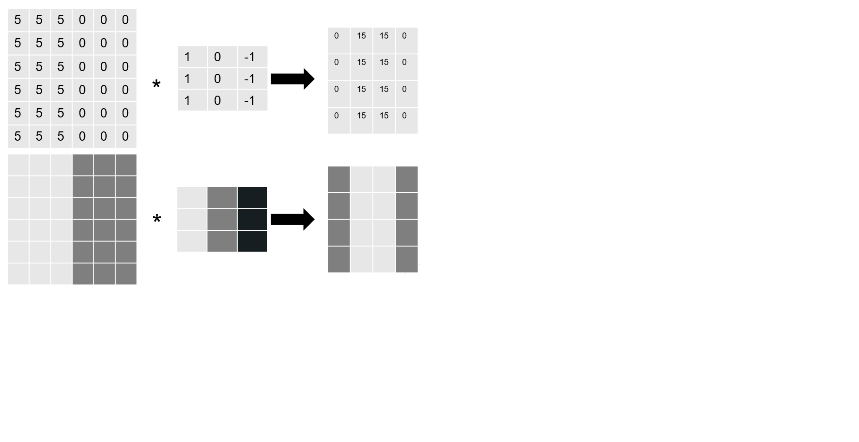

Figure 66 edge detection

The above diagram, Figure 68, is a pictorial representation of how a vertical edge detection filter works. When a random pixel value is convoluted with the filter above, it gives a specific pattern. If a clearly defined pattern as shown above is acquired where the light and dark regions are aligned, a vertical edge will be detected.

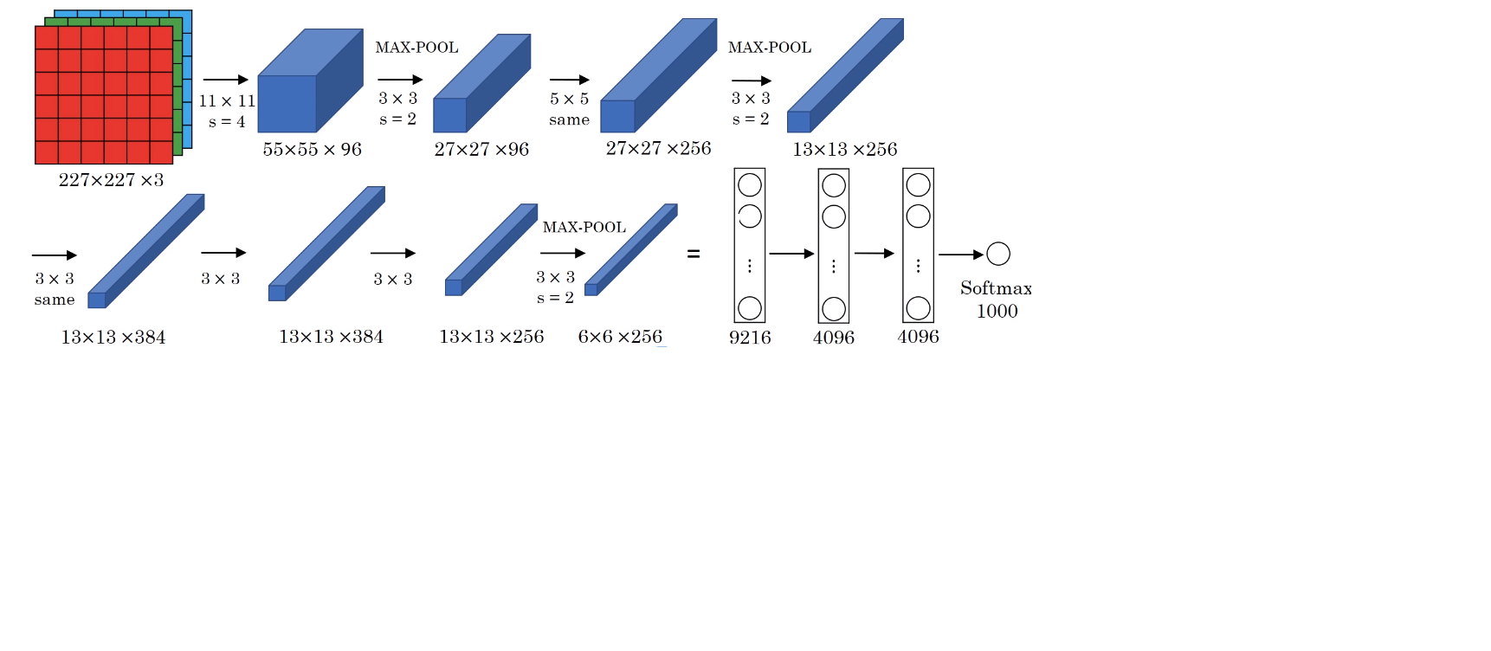

Figure 67 Example of an Inception Neural Network Image Processing

Figure 69 above is the inception neural network which will be used for implementing the training. The cnn above has 8 layers, 1984 nodes and is above 6 million. The networks have already been pre-trained by Google and by applying transfer learning, the cnn will be able to adapt to the training necessary for the vessel by introducing the prepared dataset to the network. Above is 227x227x3 RGB image convoluted with a 11x11x3 filter with a stride of 3 to get a second layer 55x55x96. Max pooling was also used between layers.

* The convolution layers have different parameter vales weight(w) and biases(b) from the equation $Z^{\left[1\right]}=W^{\left[1\right]}a^{\left[0\right]}+b^{\left[1\right]}$
* Cost function $j=\frac{1}{m}\sum_{i=1}^{m}{L({\hat{y}}^{\left(i\right)},y^{(i)}) }$
* w, b are randomly initialized. J is the sum of losses
* To train the neuro-network, the gradient decent is used. Tensor flow is employed to optimize all the parameters in the neuro-network with the aim of reducing the cost function J

TensorFlow is an open source software library for machine learning, which was released by Google in 2015 and has quickly become one of the most popular machine learning libraries being used by researchers and practitioners all over the world. It is used to do the numerical heavy lifting for our image classification model. During training, the model's predictions are compared to their true values. This information is then used to update the parameters. During testing there is no feedback anymore; the model simply generates labels.

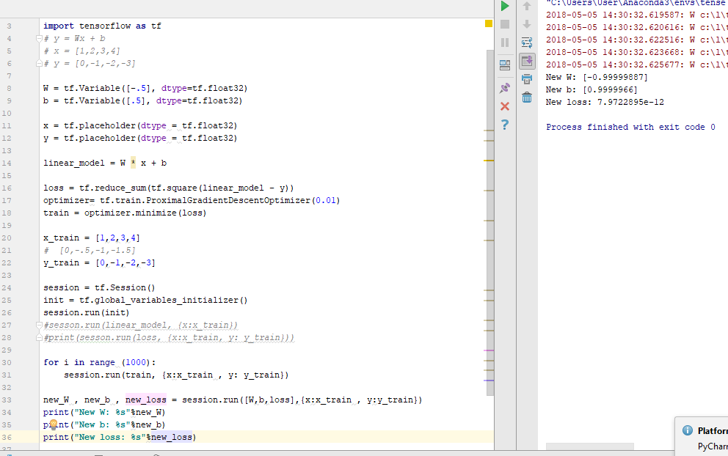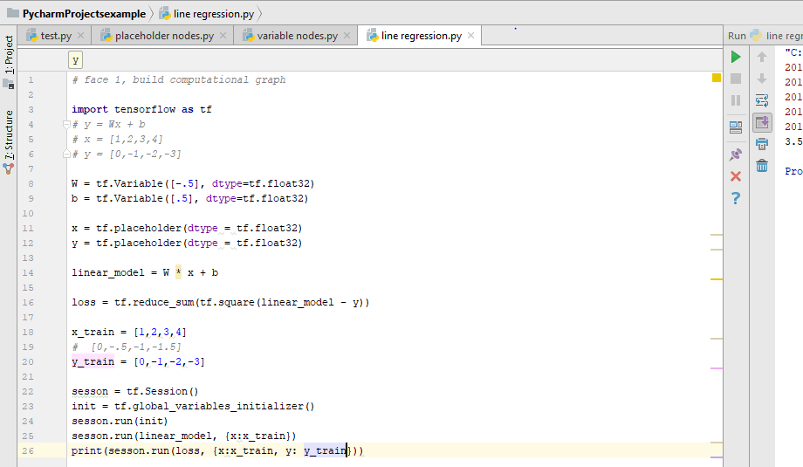

Figure 68 finding the error&Figure 69 optimized process

𝑦_2=𝑤𝑥+𝑏

Error = $\sum_{0}^{3}{{(y_{2}-y_{1})}^{2}}$

The error in the value obtained which is 3.5 using out assumed values for w and b. The point is to train the code to minimize the error as much as possible.

Training of a line regression, error is reduced to 7.9722𝑒^(−12). New value for w = -1, New value for b = 1.

### Implementation of Subtask 3-Training the model

Below are the steps required to successfully train a working model

* Installing Tensorflow-GPU
* Setting up anaconda Virtual Environment and the Object Detection directory structure
* Gathering and labeling pictures
* Generating training data
* Creating a label map and configuring training
* Training
* Exporting the inference graph
* Upload into the raspberry pi3 and test.

1. Installing Tensorflow-GPU :

In order to install Tensorflow, installing some dependencies required by the GPU is required. A desktop with GPU GeForce GTX 1050 is being used. Tensorflow requires CUDA 9.0 and cuDNN 7.1.

Unfortunately, they are not compatible with a newer version of Tensorflow so a downgrade to version 1.5 is necessary.

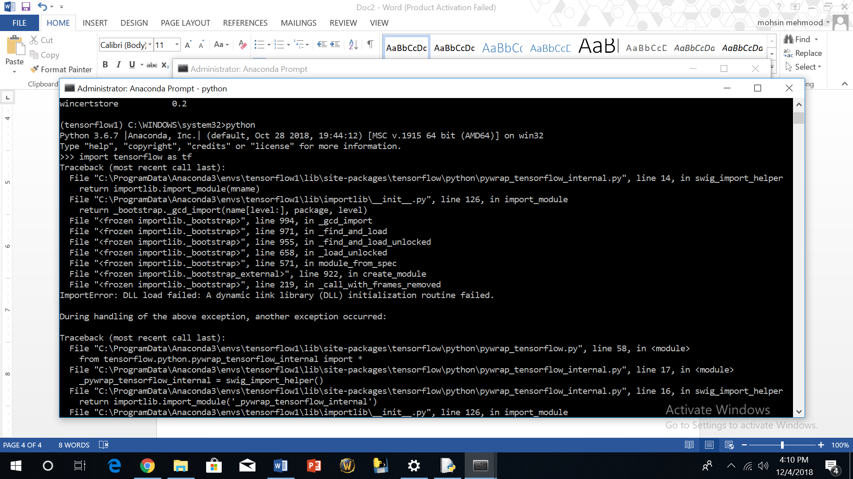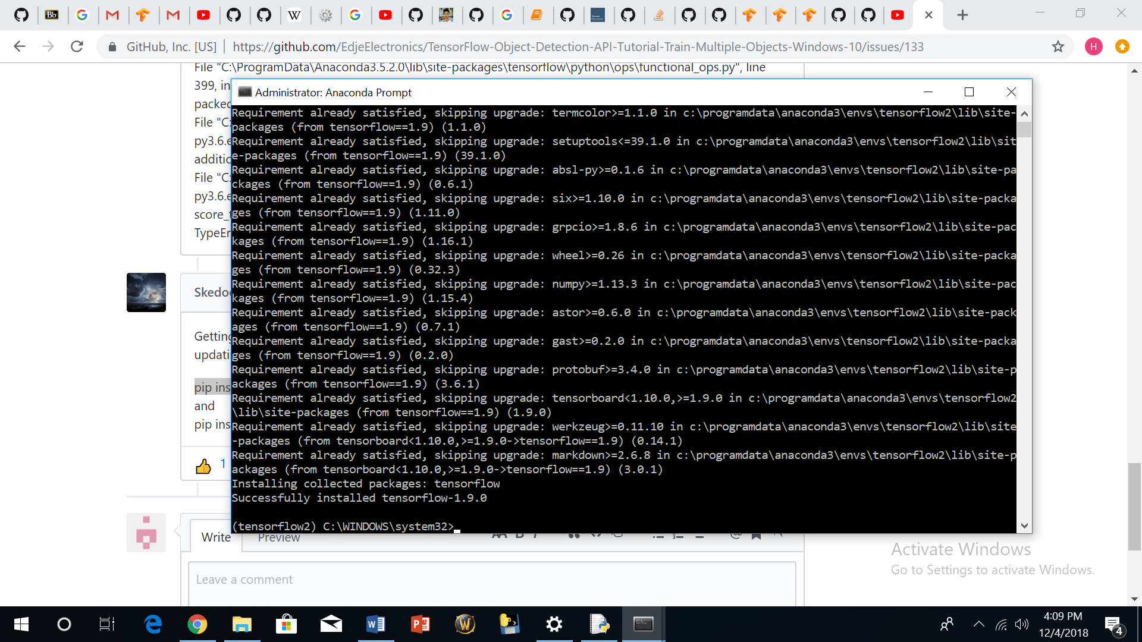

Figure 70 installing tf 12.0 & Figure 71 failed installation

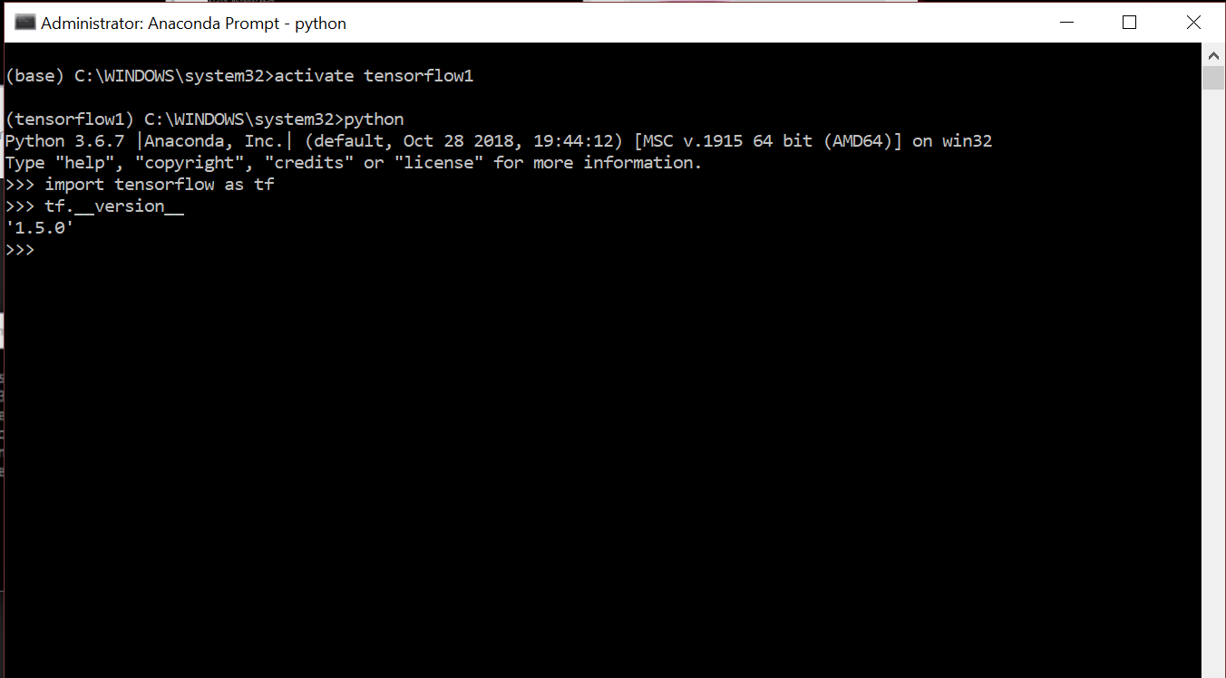

Figure 72 successful installation

1. Setting up Anaconda Virtual Environment and the Object Detection directory structure

Training will the done with the ssd-Mobilenet model, which has the same structure as the inception neural network but with fewer parameters. Due to the weak processing power of the Raspberry pi3, a neural network is required that would also be fast enough. Unfortunately, accuracy will be a trade-off.

Then an environment on anaconda must be created:

C:\> conda create -n tensorflow1 pip python=3.5

Then activate the environment by:

C :\> activate tensorflow1

Other dependencies are required and they will be installed by issuing:

(tensorflow1) C:\> conda install -c anaconda protobuf

(tensorflow1) C:\> pip install pillow

(tensorflow1) C:\> pip install lxml

(tensorflow1) C:\> pip install Cython

(tensorflow1) C:\> pip install jupyter

(tensorflow1) C :\> pip install matplotlib

(tensorflow1) C:\> pip install pandas

(tensorflow1) C:\> pip install opencv-python

We need to configure the PYTHONPATH environmental variable by issuing:

(tensorflow1)C:\>setPYTHONPATH=C:\tensorflow1\models;C:\tensorflow1\models\research;C:\tensorflow1\models\research\slim

Next, compile protobuf:

protoc--python_out=..\object_detection\protos\anchor_generator.proto .\object_detection\protos\argmax_matcher.proto.\object_detection\protos\bipartite_matcher.proto.\object_detection\protos\box_coder.proto.\object_detection\protos\box_predictor.proto.\object_detection\protos\eval.proto.\object_detection\protos\faster_rcnn.proto .\object_detection\protos\faster_rcnn_box_coder.proto.\object_detection\protos\grid_anchor_generator.proto.\object_detection\protos\hyperparams.proto.\object_detection\protos\image_resizer.proto.\object_detection\protos\input_reader.proto.\object_detection\protos\losses.proto.\object_detection\protos\matcher.proto.\object_detection\protos\mean_stddev_box_coder.proto.\object_detection\protos\model.proto.\object_detection\protos\optimizer.proto .\object_detection\protos\pipeline.proto.\object_detection\protos\post_processing.proto .\object_detection\protos\preprocessor.proto.\object_detection\protos\region_similarity_calculator.proto.\object_detection\protos\square_box_coder.proto.\object_detection\protos\ssd.proto.\object_detection\protos\ssd_anchor_generator.proto.\object_detection\protos\string_int_label_map.proto.\object_detection\protos\train.proto.\object_detection\protos\keypoint_box_coder.proto.\object_detection\protos\multiscale_anchor_generator.proto.\object_detection\protos\graph_rewriter.proto

To test if the Tensorflow set up is functional, run a jupyter script. If there is no error and the pictures below are identified, everything is fine.

(tensorflow1) C:\tensorflow1\models\research\object_detection> jupyter notebook object_detection_tutorial.ipynb

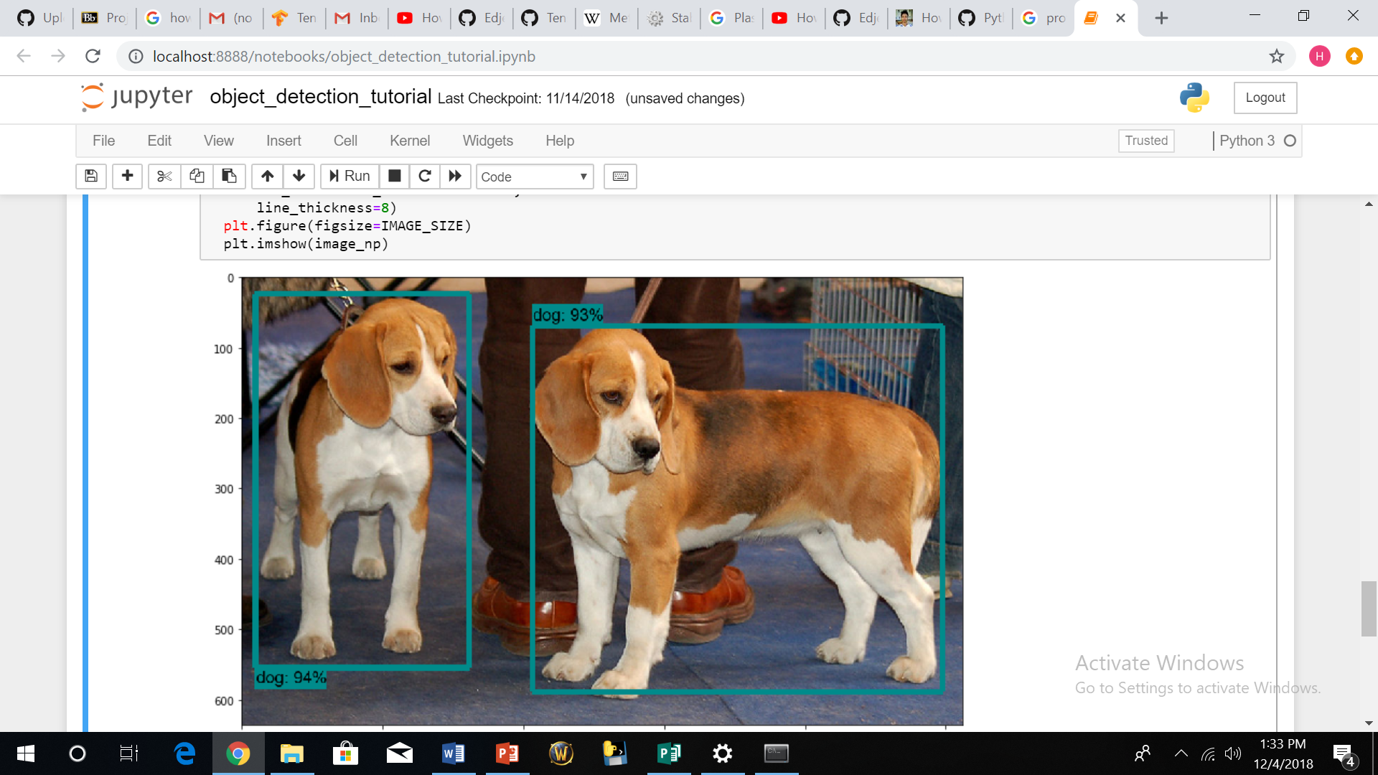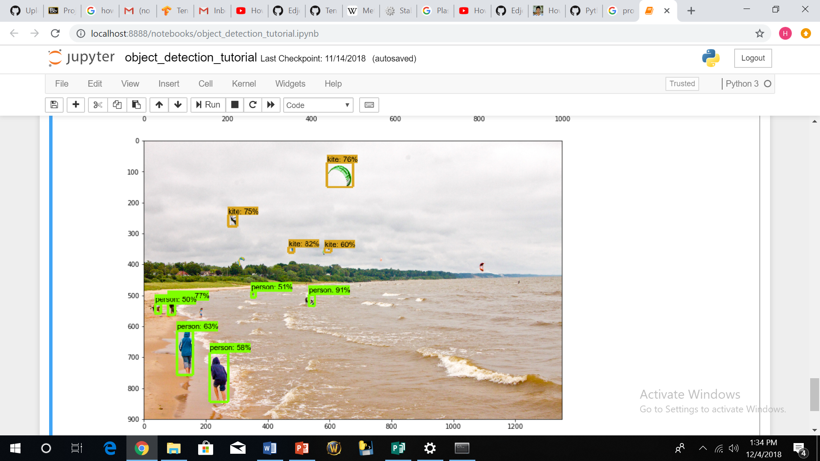

Figure 73 jypiter script tensorflow active

When running the script, modifications had to be made. The condition of the code had to be changed from tensorflow < 1.8 to tensorflow < 1.4 in order for it to run successfully. The result is shown above in Figure 75, which demonstrates the setup is ready for training.

1. Gathering and labeling pictures

For this project, approximately 245 pictures were taken in different terrain and lighting conditions, and then divided into two groups. Approximately 20 percent of the pictures were placed in the testing folder, and the remaining pictures were placed in the training folder. The more diverse the pictures are, the more efficient the model will be in recognizing the object.

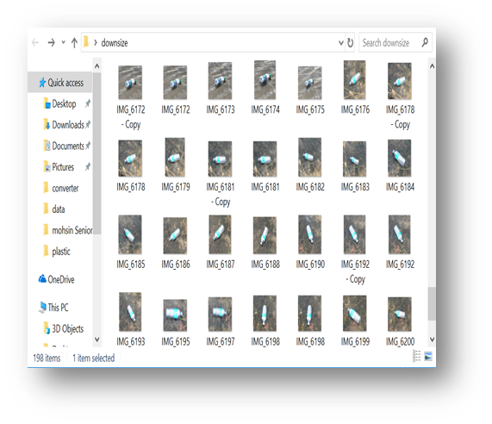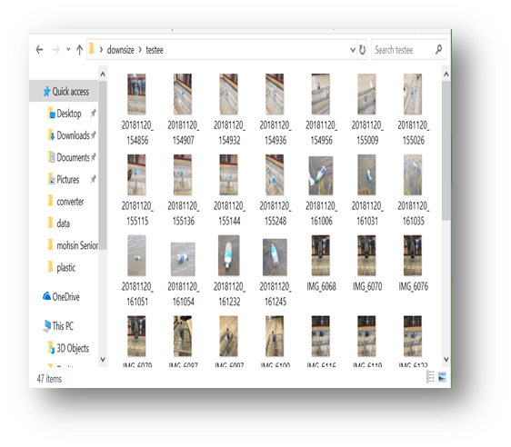

Figure 74 dataset of pictures used to train the system

The pictures were labeled using the llabelmg software, and then xml files which contains the co-ordinate values of all the pictures were generated.

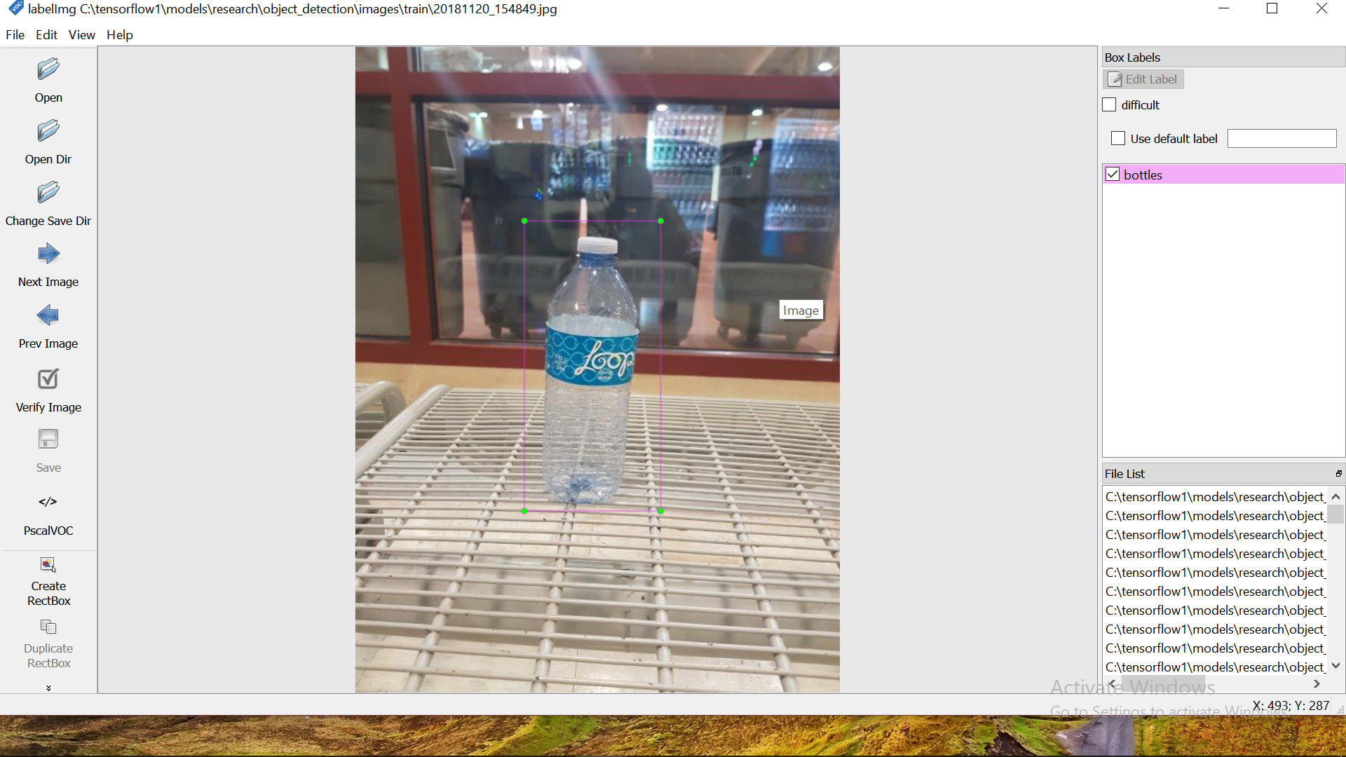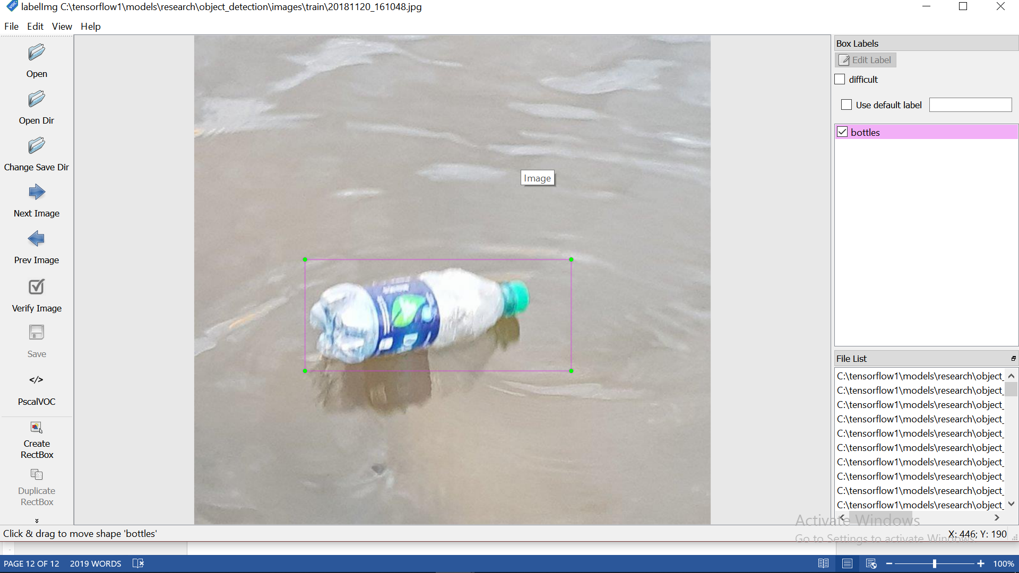

Figure 75 image labelling

1. Generate training data

(tensorflow1) C:\tensorflow1\models\research\object_detection> python xml_to_csv.py

After running that, csv file is generated in the object detection folder:

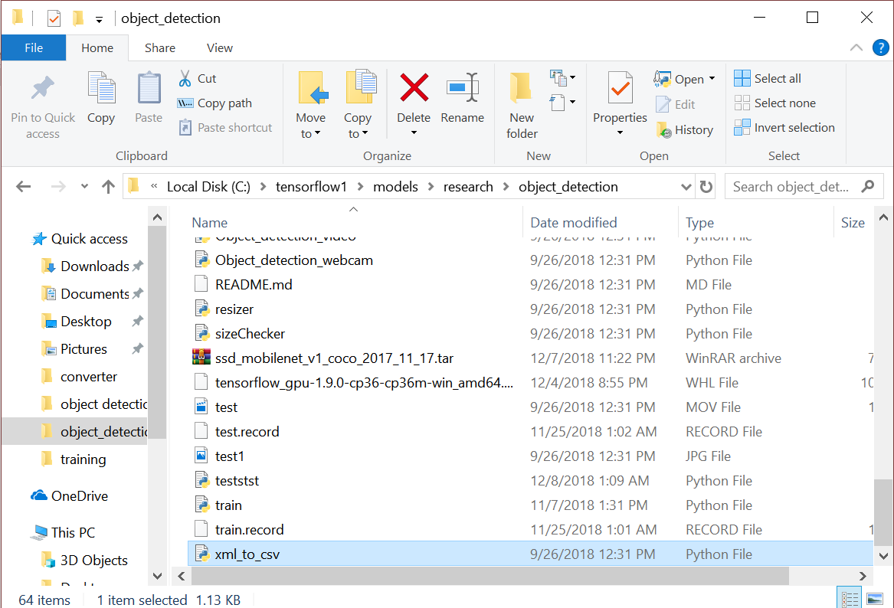

Figure 76 file generated

1. Create Label Map and Configure Training

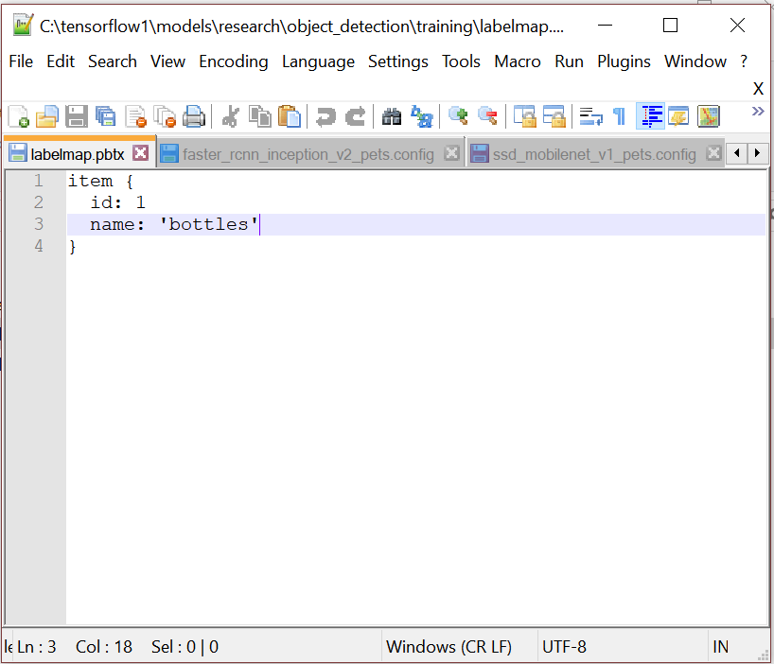

Figure 77 label map

The labelmap.pbtx must be saved in the training folder.

1. Run the training

Run the code:

python.pylogtostderrtrain_dir=training/pipeline_config_path=training/ssd_mobilenet_v1_pets.config

The training commenced as follows:

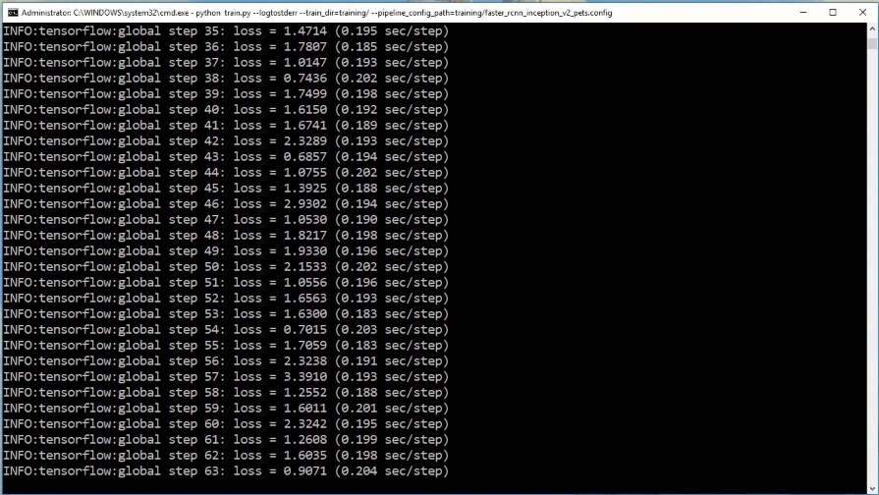

Figure 78 training interface

After obtaining a very low error, quit the process and generate an inference graph.

1. Export the inference graph

python export_inference_graph.py --input_type image_tensor --pipeline_config_path training/ ssd_mobilenet_v1_pets.config--trained_checkpoint_prefixtraining/model.ckpt-1--output_directory inference_graph

This creates a frozen_inference_graph.pb file in the \object_detection\inference_graph folder. The .pb file contains the object detection classifier

This frozen inference graph is uploaded into the raspberry pi and tested.

### Implementation of Subtask 4-Result

After uploading the trained cnn into the raspberry pi, the training was tested by going into the object detection folder and running the code below.

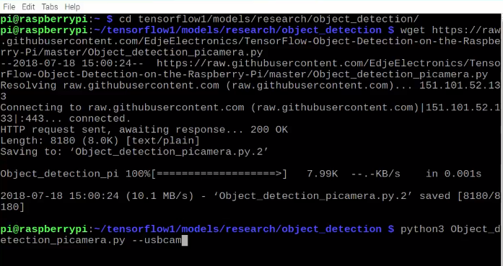

Figure 79 image recognition start up interface

After pressing enter, the web cam comes on and within seconds, the video is shown on the screen. The results obtained are below in Figure 82:

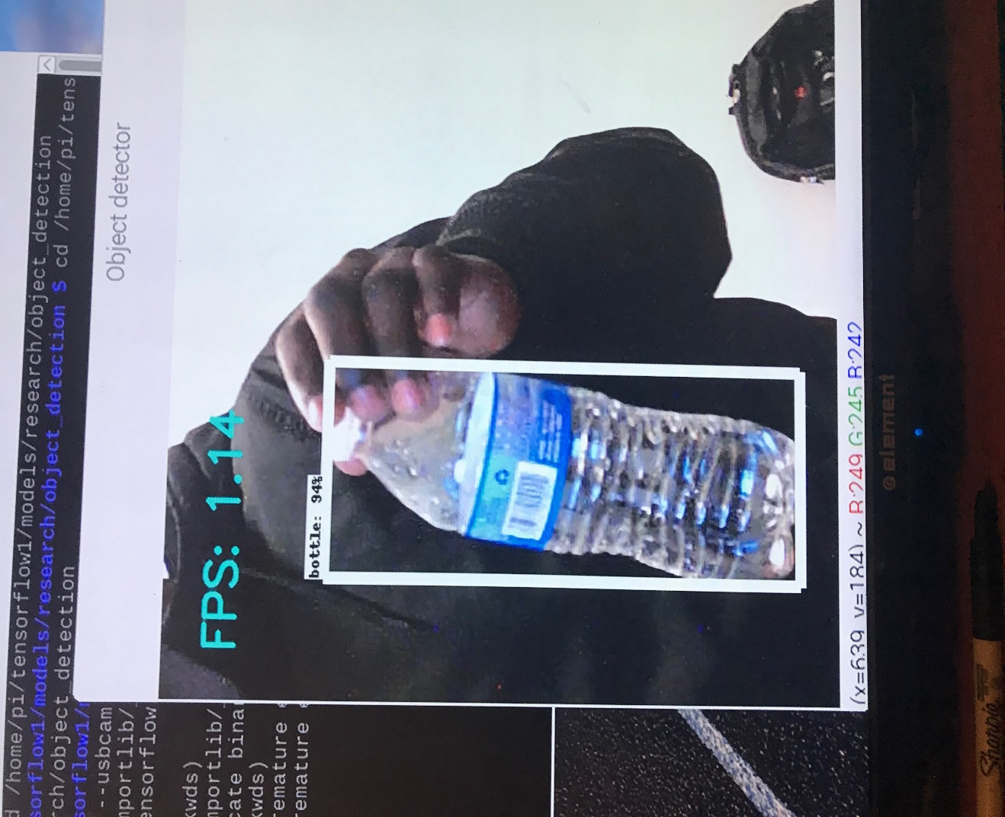

Figure 80 Successful Trial 1

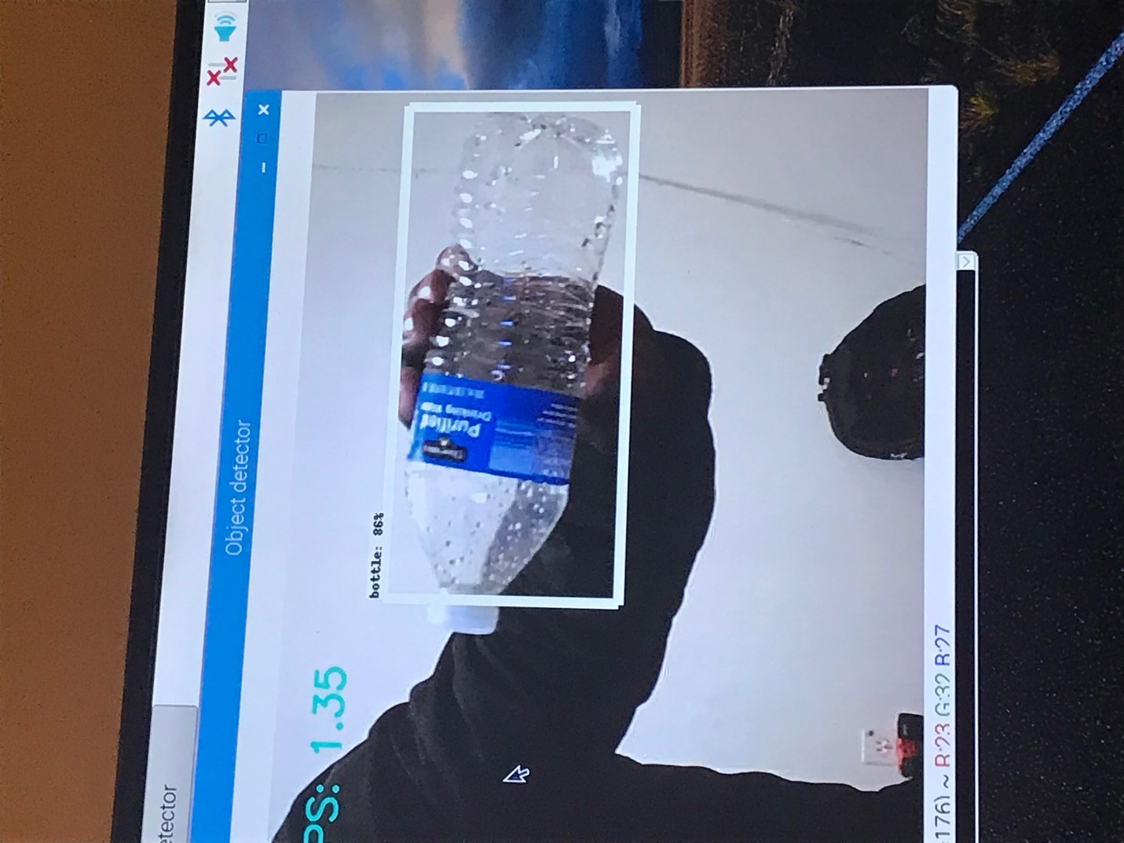

Figure 81 Successful Trial 2

Figures 82 and 83 are examples of two pictures out of all the testing completed. A frame rate of 1.35 and 1.14 was achieved with 94% and 86% of success.

### Implementation Runtime for Image Recognition Unit

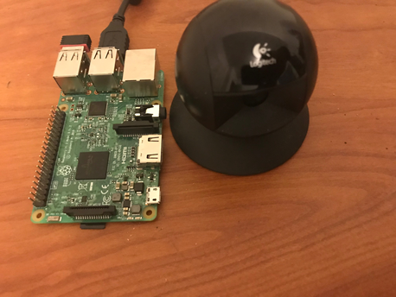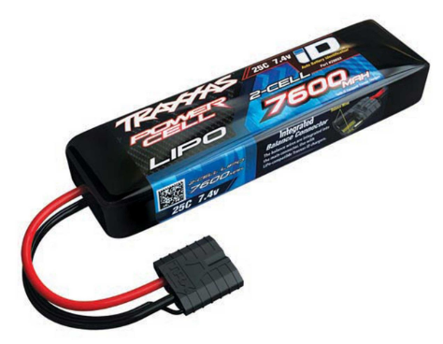

Figure 82 2s battery&Figure 83 image recognition set up

The image recognition unit includes a raspberry pi3, a webcam, and 2-cell 7600mAh battery. Because the Raspberry pi requires a 5v and 2.25A battery to operate, a ubec must be introduced to help regulate the voltage 7.4v coming out of the battery.

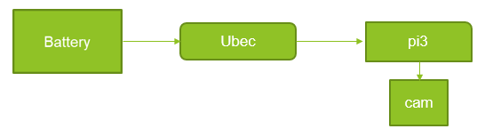

Figure 84 power connection layout for raspberry pi

Therefore, the runtime for the image recognition unit will be 7.4Ahr / 2.25A =3hr 17mins.

## Implementation of Task 9- Navigation System

### Implementation of Subtask 1- Research on pixhawk configuration

Implementing autonomy is one of the primary objective in this project. In other to achieve autonomy, the use of pixhawk is required. A pixhawk is a high-performance autopilot-on-module suitable for fixed wing, multi rotors, helicopters, cars, boats and any other robotic platform that can move. It is targeted towards high-end research, amateur and industry needs and combines the functionality of the PX4FMU + PX4IO. It is a further evolution of the PX4 flight controller system. Pixhawk consists of a PX4-FMU controller and a PX4-IO integrated on a single board with additional IO, Memory and other features.

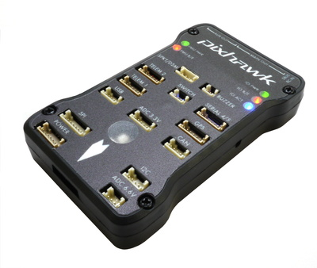

Figure 85 pixhawk

Step1: Install the Mission Planner

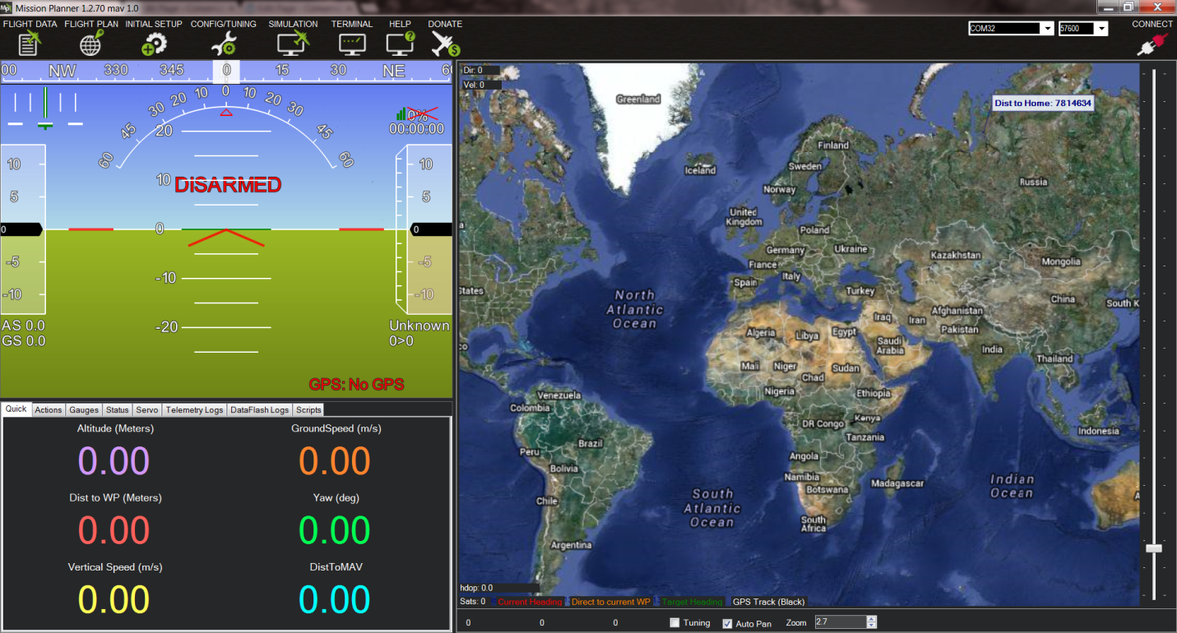

Figure 86 mission planner interface

The figure above shows the interface of the mission planner software on the computer. Mission Planner is a full-featured ground station application for the ArduPilot open source autopilot project. Mission Planner is a ground control station for Plane, Copter and Rover. It is compatible with Windows only. Mission Planner can be used as a configuration utility or as a dynamic control supplement in our autonomous vessel.

Step2: Connect the pixhawk to the mission planner.

[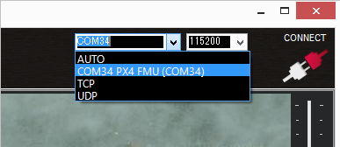](http://ardupilot.org/rover/_images/Pixhawk_ConnectWithMP.png)

Figure 87 connection to mission planner through port

To connect the two together, open the Mission Planner and select the COM port drop-down on the upper-right corner of the screen (near the Connect button). Select AUTO or right COM in Mission Planner board (PX4 FMU or Arduino Mega 2560). Set the Baud rate to 115200 as shown. Don’t hit Connect just yet. Click the correct COM port as shown below.

Step 3: Download and install Ardurover onto the Pixhawk

Although we are working on a water vessel, we need to work with the rover configuration and try as much as possible to manipulate it to requirement. On the Mission Planner’s Initial Setup, install the firmware screen and select the appropriate icon that matches the frame. For this case, the rover will be selected. Answer “yes” when asked, “Are you sure?” Figure 90 below shows the different selections the user can choose. In this instance, because it’s the Ardurover, the image of the car is chosen.

[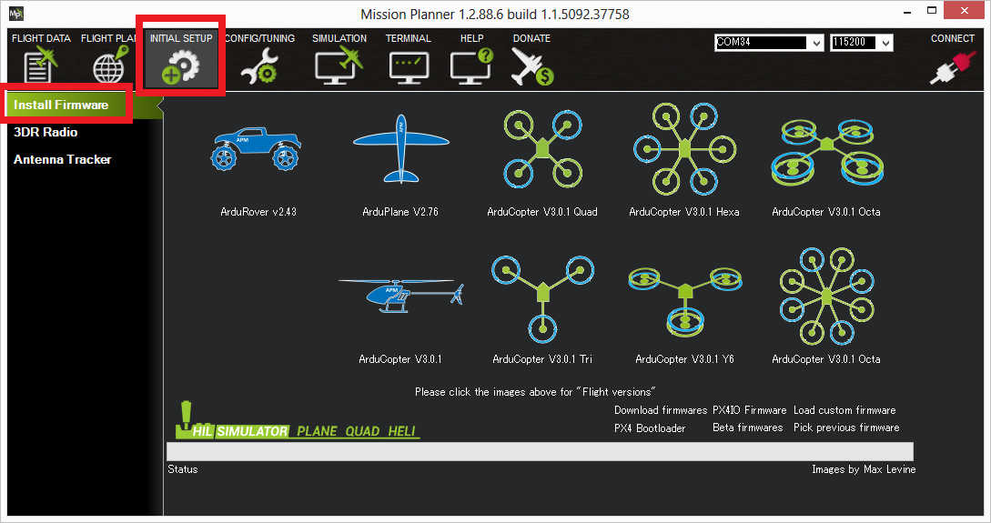](http://ardupilot.org/rover/_images/Pixhawk_InstallFirmware.jpg)

Figure 88 Select the right firmware

For navigation, certain changes must be made to adapt the rover setting for a water vessel. The throttle setting for motion is the same in both cases, but the servo used for changing the rover will be used to control the servo connected to the rudder. Note must be taken of the difference in the direction, and the rudder must be set accordingly since it is the reverse when compared to the rover.

For separate steering and throttle vehicles, these parameters values should be set (and should be set by default):

SERVO1_FUNCTION = 26 (GroundSteering)

SERVO3_FUNCTION = 70 (Throttle)

If using the mission planner, the Initial Setup >> Mandatory Hardware >> Servo Output page is a convenient way to complete this step.

[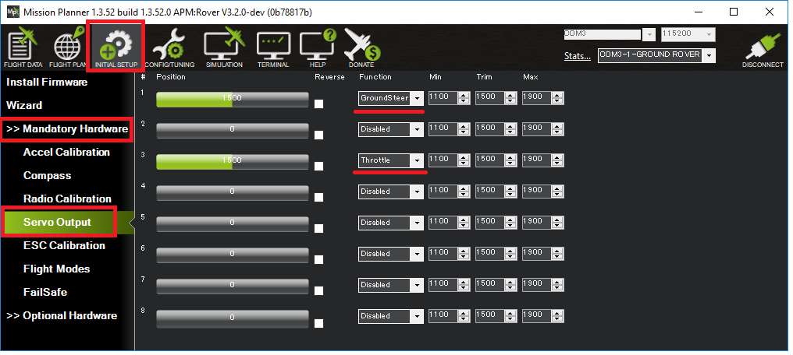](http://ardupilot.org/rover/_images/rover-motor-and-servo-config1.png)

Figure 89 motor and servo control set up

Due to the differences in terrain, autonomous navigation is more challenging in light of physical factors such as tide and wind. Therefore, the PID tuning is especially important in maintaining balanced movement and staying on course. Recently, new improvement have been made to the autonomous sailing technology, and new features have been introduced.

The special features for boats include:

* Boats appear as boats on the ground station (version 3.3.0 and higher)
* In Auto, Guided, RTL and SmartRTL modes, the vehicle will attempt to maintain its position even after it reaches its destination (version 3.2.0 and higher)
* Vectored Thrust can be enabled to improve steering response on boats which use the steering servo to aim the motors (version 3.3.1 and higher)
* Loiter mode for holding position
* Echosounders for underwater mapping.

### Implementation of Subtask 2- Layout of the Navigation System

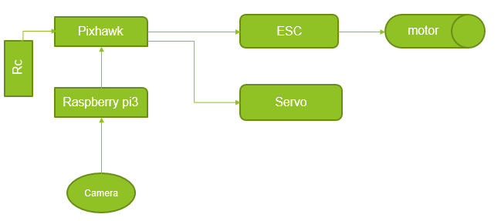

Figure 90 navigation layout

In the above layout, the pixhawk is the primary navigating micro controller. A receiver is connected to the pixhawk to allow the user to take control manually at any point in time. Raspberry pi is able to communicate with the pixhawk using the MAV link protocol over a serial port connection. When an object has been detected, the Raspberry pi sends signals to the pixhawk through the RX & TX ports, and then guides it to the object depending on the X and Y coordinates that communicate how far left or right the object is. In turn, the pixhawk interrupts its mission for collection of the object. After the target has been acquired, the pixhawk goes back to its mission and the Raspberry pi continues its search.

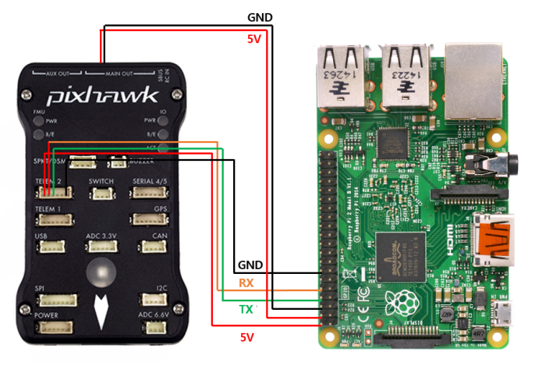

Figure 91 MAV connection between PI and Pixhawk

When setting up the pixhawk, some adjustments have to be made on the mission planner. For example, these parameters have to be set.

* SERIAL2_PROTOCOL = 1 (the default) to enable MAVLink on the serial port.
* SERIAL2_BAUD = 921 so the Pixhawk can communicate with the RPi at 921600 baud.
* LOG_BACKEND_TYPE = 3 if you are using APSync to stream the dataflash log files to the RP

The pixhawk compatibility packages have to be downloaded on the raspberry pi board, the commands are listed below

sudo apt**-**get update

sudo apt**-**get install screen python**-**wxgtk2**.**8 python**-**matplotlib python**-**opencv python**-**pip python**-**numpy python**-**dev libxml2**-**dev libxslt**-**dev python**-**lxml

sudo pip install future

sudo pip install pymavlink

sudo pip install mavproxy.

When the raspberry pi captures an image, the co-ordinates of the picture can be achieved from the screen. This co-ordinates are very vital in tracking the bottle for collection. The x and y midpoint position is shown at the bottom left position of the screen. The size of the coordinates ranges from 0 to 1000 in both x and y axis. With the midpoint of the screen as (500,500). We must understand that as the object gets closer it gets bigger, the position of the camera is at the middle of the boat so we should be aiming for the midpoint. When x<500, steer left and x> 500, steer right but when x=500 maintain a forward momentum till collection. It has to keep moving till y = 0 .

### Implementation of Subtask 3- Runtime of the Navigation System

Two 2-cell batteries will be used for the setup. Using two batteries allows for managing weight distribution, and makes it easier to troubleshoot if problem arises. Additionally, it is a more affordable option. One battery is used to power the motor and the other battery is used for the micro controllers.

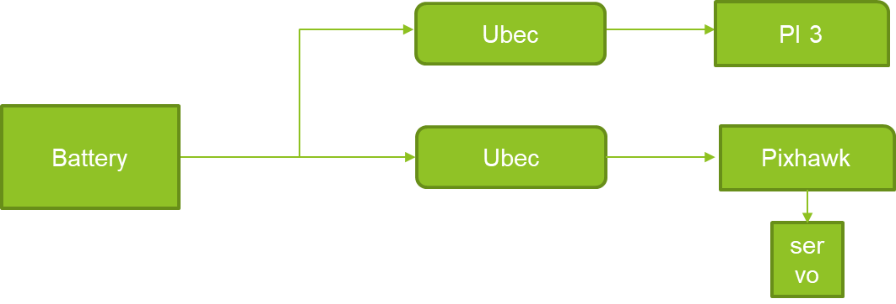

Figure 91 power connection for microcontrollers

* The battery is connected in parallel to two ubec which are connected to the Raspberry pi and pixhawk
* The current required by the microcontroller are 2.5 and 2.25
* Total current drawn = 4.75 A
* Battery amp per hour rating = 7600mAh
* Operation time: 7.6Ah / 4.75A = 1.6
* Which is 1hr 36 mins

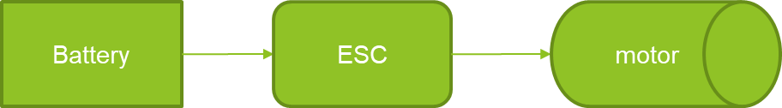

Figure 92 power connection for motors

* Current required for the operation of the motor = 10A
* Battery amp per hour rating = 7600mAH
* Operation time: 7.6/10 = 0.76 hours
* 0.76 * 60 = 45.6 mins

1. Conclusion (Discussion and Future Plans)

At the end of this project, the execution of the concept of image recognition was fulfilling. It included the use of manual tools and machineries in building the boat. It was an eye opening experience.

Acknowledgment

* Yuanwei Jin, Ph.D.
* Virginia C. Heath
* Ibibia K. Dabipi, Ph.D.

REFERENCES

[1] https://pixhawk.org/modules/pixhawk

[2] “Multistar High Capacity 20000mAh 6S 10C Multi-Rotor Lipo Pack.” Hobbyking, hobbyking.com/en_us/multistar-high-capacity-6s-20000mah-multi-rotor-lipo-pack.html.

[3] “Kinexsis 1/10 4-Pole ESC/Motor Combos.” Big Squid RC - RC Car and Truck News, Reviews, Videos, and More!, 3 Nov. 2015, www.bigsquidrc.com/kinexsis-110-4-pole-escmotor-combos/.

[4] “Onyx 2S Hard Case LiPo 25C Battery Pack w/Deans (7.4V/5000mAh) by DuraTrax [DTXC1864] | Cars & Trucks.” HobbyTown, www.hobbytown.com/onyx-2s-hard-case-lipo-25c-battery-pack-w-deans-7.4v-5000mah-by-duratrax-dtxc1864/p211388.

[5] “Pixhawk Overview¶.” Introducing Copter - Copter Documentation, ardupilot.org/copter/docs/common-pixhawk-overview.html.

[6] http://ardupilot.org/planner/docs/mission-planner-overview.html

[7] <https://medium.com/@tifa2up/image-classification-using-deep-neural-networks-a-beginner-friendly-approach-using-tensorflow-94b0a090ccd4>

[8] Dasgupta, Soumyajit, and Zequek Estrada. “A Guide to Different Types of Boats.” *Marine Insight*, Marine Insight, 24 Jan. 2018, [www.marineinsight.com/types-of-ships/a-guide-to-different-types-of-boats/](http://www.marineinsight.com/types-of-ships/a-guide-to-different-types-of-boats/).

[9] [www.marineinsight.com/boating-yachting/boats-with-a-difference-the-high-speed-crafts/](http://www.marineinsight.com/boating-yachting/boats-with-a-difference-the-high-speed-crafts/).

[10] “{{::Og.title}}.” *ThisIsWhyImBroke*, [www.thisiswhyimbroke.com/electric-hydrofoil-boat/](http://www.thisiswhyimbroke.com/electric-hydrofoil-boat/).

[11] “Catamaran.” *Wikipedia*, Wikimedia Foundation, 17 May 2018, [en.wikipedia.org/wiki/Catamaran](http://en.wikipedia.org/wiki/Catamaran).

[12] “E-Cat 24.” *Bateau.com - Boat Plans Online since 1993*, [bateau.com/proddetail.php?prod=EC24](http://bateau.com/proddetail.php?prod=EC24).

[13] Harmer, Jim. “Beginner Info.” *BetterBoat Boating Blog*, 12 Sept. 2014, [betterboat.com/pontoon/advantages-pontoon-boat/](http://betterboat.com/pontoon/advantages-pontoon-boat/).

[14] “DIY Standamaran Stand Up Paddleboard Plans.” *Fly-Carpin*, [www.flycarpin.com/p/diy-standamaran-stand-up-paddleboard.html](http://www.flycarpin.com/p/diy-standamaran-stand-up-paddleboard.html).

[15] “PVC Pipes - Plastic PVC Pipes Manufacturer from Indore.”[*Http://Www.pipesmanufacturer.com/Pvc-Pipes.html#Pvc-Plumbing-Pipes*](http://www.pipesmanufacturer.com/Pvc-Pipes.html#Pvc-Plumbing-Pipes), [www.pipesmanufacturer.com/pvc-pipes.html](http://www.pipesmanufacturer.com/pvc-pipes.html).

[16] “XPS Foam Board / Extruded Polystyrene Foam Thermal Insulation Board.” *China Glass Wool Board Manufacturer*,

[17] [ec91093670.sell.everychina.com/p-100152739-xps-foam-board-extruded-polystyrene-foam-thermal-insulation-board.html](http://ec91093670.sell.everychina.com/p-100152739-xps-foam-board-extruded-polystyrene-foam-thermal-insulation-board.html).

[18] “Building Insulation Materials.” *Wikipedia*, Wikimedia Foundation, 12 May 2018, [en.wikipedia.org/wiki/Building_insulation_materials](http://en.wikipedia.org/wiki/Building_insulation_materials).

[19] “Volume Formulas Review.” *Khan Academy*, Khan Academy, [www.khanacademy.org/math/basic-geo/basic-geo-volume-sa/volume-cones/a/volume-formulas-review](http://www.khanacademy.org/math/basic-geo/basic-geo-volume-sa/volume-cones/a/volume-formulas-review).

[20] “Ships and Boats | How Do They Float? | History of Ships.” *Explain That Stuff*, 8 Jan. 2018, [www.explainthatstuff.com/how-ships-work.html](http://www.explainthatstuff.com/how-ships-work.html).

[21] “What Is Buoyant Force?” *Khan Academy*, Khan Academy, [www.khanacademy.org/science/physics/fluids/buoyant-force-and-archimedes-principle/a/buoyant-force-and-archimedes-principle-article](http://www.khanacademy.org/science/physics/fluids/buoyant-force-and-archimedes-principle/a/buoyant-force-and-archimedes-principle-article).

[22] “Explore Scientific, Technical, and Medical Research on ScienceDirect.” *Egyptian Journal of Medical Human Genetics*, Elsevier, [www.sciencedirect.com/](http://www.sciencedirect.com/).

[23] “Products.” *Charlotte Pipe*, [www.charlottepipe.com/pl_pvc_sch40_dwv.aspx](http://www.charlottepipe.com/pl_pvc_sch40_dwv.aspx).

[24] <https://theponddigger.com/product/pvc-cement/>

[25] “Z-Poxy Epoxy Resin - 30 Minute 235ml(8 Fl.oz).” *Axminster Tools & Machinery*, [www.axminster.co.uk/z-poxy-epoxy-resin-30-minute-235ml-8-fl-oz-990120](http://www.axminster.co.uk/z-poxy-epoxy-resin-30-minute-235ml-8-fl-oz-990120).

[26][www.bing.com/cr?IG=37EEB5C5BB25473F88706655992104D4&CID=14630546BAA66E9C21F00EB0BB5B6F68&rd=1&h=nG3BMh6lT1Db9ldOy3XDrtFguiIWwwUVwJkGLFo2yw&v=1&r=https%3a%2f%2fwww.3m.com%2f3M%2fen_US%2fcompany-us%2fall-3m-products%2f%7e%2fAll-3M-Products%2fAdhesives-Tapes%2fIndustrial-Adhesives-and-Tapes%2f%3fN%3d5002385%2b8710676%2b8710815%2b8711017%2b3294857497%26rt%3dr3&p=DevEx.LB.1,5222.1](http://www.bing.com/cr?IG=37EEB5C5BB25473F88706655992104D4&CID=14630546BAA66E9C21F00EB0BB5B6F68&rd=1&h=nG3BMh6lT1Db9ldOy3XDrtFguiIWwwUVwJkGLFo2yw&v=1&r=https%3a%2f%2fwww.3m.com%2f3M%2fen_US%2fcompany-us%2fall-3m-products%2f%7e%2fAll-3M-Products%2fAdhesives-Tapes%2fIndustrial-Adhesives-and-Tapes%2f%3fN%3d5002385%2b8710676%2b8710815%2b8711017%2b3294857497%26rt%3dr3&p=DevEx.LB.1,5222.1).